Nexus between Energy, Environment and Economic Growth Dynamics in the United States: A Holistic Analysis of CO2 Emissions

Naga Sai Prudhvi Balam

Data Engineer

**Table of Contents**

List of Figures 8

List of Acronyms 10

List of Tables 11

1. INTRODUCTION 12

1.1 BACKGROUND 12

1.2 AIMS AND OBJECTIVES: 14

1.2.1 Objectives 14

1.2.2 Research Questions: 14

2. LITERATURE REVIEW 16

2.1 Causality Analysis on Nexus of Energy, Economy, and CO2: 16

2.1.1 Nexus of Socio-economic, Uncertainties, and Carbon Emissions: 17

2.1.2 Nexus of Energy, Economic Growth, and Carbon Emissions: 18

2.2 Machine Learning for CO2 Predictions: 19

2.2.1 Related Works on Carbon Emissions Forecasting: 19

2.2.2 Related Works CO2 Emissions Forecasting in USA: 21

3. Methodology Overview 23

4. Data Preprocessing Tasks: 24

4.1 Data Understanding: 25

4.1.1 State Level Datasets: 25

4.1.2 National Level Dataset: 28

4.2 Data Pipeline Using Azure: 29

4.3 Data Preprocessing: 32

4.3.1 Statewide datasets: 32

4.3.2 National datasets: 33

5. Exploratory Data Analysis 38

5.1.1 CO2 emissions Analysis 38

5.1.2 Energy Analysis 41

6. Time series Analysis 46

6.1 Time series decomposition 46

6.2 Correlation Analysis: 49

7. Causation Analysis 51

7.1 Stationary test 51

7.1.1 ADF Test Results: 52

7.2 Cointegration Test: 53

7.2.1 Cointegration Results: 53

7.3 Granger Causality Test: 54

7.3.1 Causality Test Findings: 55

8. Time Series Models 56

8.1 SARIMAX 56

9. Machine Learning Models 57

9.1 Lasso Regression: 58

9.2 Xgboost: 60

9.3 Random Forest Regression 61

9.4 Support Vector Machine 63

9.5 LSTM (DEEP Learning) 64

10. Evaluation of Results 66

10.1 Evaluation Metrics: 66

10.2 Experimentation Outcome: 67

10.2.1 Lasso Regression 68

10.2.2 XGboost: 70

10.2.3 Random Forest 72

10.2.4 Support Vector Machine 73

10.2.5 SARIMAX 75

10.2.6 LSTM 78

10.2.7 Comparing Various Machine Learning Models: 79

11. Conclusion and Future Work 81

11.1 Conclusion 81

11.2 Future Work 82

12. Project Management: 82

13. References: 84

14. Appendix: 92

14.1 Retrieve data from EIA using API 92

14.2 Best order Selection in SARIMAX: 93

14.3 Tabular format of Studies Related to Influencing Factors for CO2 Emissions: 94

14.4 How does Cointegration work? 94

14.5 What is AIC? 95

# List of Figures

Figure 3.1: Project Workflow

Figure 4.1: Data Preprocessing Steps (V7labs)

Figure 4.2: Data Description for CO2 emissions Dataset (State Level)

Figure 4.3: Data Description for Energy Dataset (State Level)

Figure 4.4: Data Description for Climate Dataset (State Level)

Figure 4.5: Data Description for USA Monthly Dataset (National Level)

Figure 4.6: Data Pipeline Using Azure

Figure 4.7: List of Azure Resources Utilized

Figure 4.8: Illustration of Data Pipeline Created in Data Factory

Figure 4.9: Azure Data Lake Storage Gen 2 (Raw and Transformed folders in Blob Container)

Figure 4.10: How to mount ADLS within Data Bricks

Figure 4.11: Unique Unit per KPI

Figure 4.12: Creation of Data Aggregation Columns

Figure 4.13: Linear Interpolation Formula

Figure 4.14: Result after Filling Missing Values with Linear Interpolation

Figure 4.15: Quarterly to Monthly GDP using Cubic Spline Interpolation

Figure 4.16: Box Plots to Identify Extreme Outliers

Figure 4.17: Time Series Plots Comparing before and after Capping Outliers

Figure 4.18: Final Data frame

Figure 4.19: Statistical Description of National Level Data used for Machine Learning

Figure 5.1: CO2 Emissions by Region

Figure 5.2: Interactive Workbook for Top CO2 Emitting States by Sector and Fuel

Figure 5.3: Interactive Workbook for Overall CO2 Emissions by Sector and Fuel

Figure 5.4: Total RE/NRE Share (2021)

Figure 5.5: Comparison of Renewable and Non-Renewable Energy share over 50 years

Figure 5.6: Various Climate Zones of USA

Figure 5.7: Most Populated States in USA (2021)

Figure 5.8: Interactive Dashboard to Highlight Top States in Fossil Fuels Usage (2021)

Figure 5.9: Interactive Dashboard to Highlight Adoption of Renewable Energy Sources (2021)

Figure 5.10: Adoption of Clean Energy Sources in Various Sectors

Figure 6.1: Time Series Plot of CO2 Emissions

Figure 6.2: Time Series Decomposition

Figure 6.3: Variables Highlighting Clear Trend and Seasonality

Figure 6.4: Variables with No Clear Trend but with Seasonality

Figure 6.5: Correlation Heatmap for All Features

Figure 6.6: Features Correlating with Total CO2 Emissions

Figure 7.1: ADF Test Results

Figure 7.2: Engle-Granger Cointegration Results

Figure 7.3: VAR Order Selection

Figure 7.4: Granger Causality Test Results

Figure 9.1: Time Series Split in Expanding Window

Figure 9.2: Model Fitting Scenarios (Lasso vs Ridge vs Elastic Net | ML, 2020)

Figure 9.3: Variance/Bias vs Error (Lasso vs Ridge vs Elastic Net | ML, 2020)

Figure 9.4: Flowchart of XGBoost Model (Guo et al., 2020)

Figure 9.5: Flow Chart of Random Forest Regressor (Research Gate)

Figure 9.6: Schematic Illustration SVM for Regression

Figure 9.7: LSTM Architecture

Figure 10.1 : MAE

Figure 10.2: MSE

Figure 10.3: RMSE

Figure 10.4: R Squared

Figure 10.5: Lasso Regression Plot before parameter tuning

Figure 10.6: Lasso Regression Plot after parameter tuning

Figure 10.7: Lasso Regression Residual Analysis

Figure 10.8: Feature Importance for Lasso Regression

Figure 10.9: XGboost Plot after parameter tuning

Figure 10.10: XGboost Residual Analysis

Figure 10.11: Random Forest Plot after parameter tuning

Figure 10.12: Random Forest Residual Analysis

Figure 10.13: SVM Plot before parameter tuning

Figure 10.14: SVM Plot after parameter tuning

Figure 10.15: SVM Residual Analysis

Figure 10.16: Best Order using AIC for SARIMAX

Figure 10.17: ACF and PACF Plot for CO2 Emissions

Figure 10.18: SARIMAX Plot after parameter tuning

Figure 10.19: SARIMAX Residual Analysis

Figure 10.20: LSTM Plot after parameter tuning

Figure 10.21: Evaluation for Best Model

Figure 12.1 Project Management using Gantt Chart

# List of Acronyms

IPCC - Intergovernmental Panel on Climate Change

EIA - Energy Information Administration

FRED - Federal Reserve Economic Data

NOAA - National Oceanic and Atmospheric Administration

SEDS - State Energy Data System

GHG - Greenhouse Gases

CO2 - Carbon Dioxide

NRE - Non-Renewable Energy

REC - Renewable Energy Consumption

BTU - British Thermal Unit

KPI - Key Performance Indicator

CDD - Cooling Degree Days

HDD - Heating Degree Days

GDP - Gross Domestic Product

CPI - Consumer Price Index

EPU - Economic Policy Uncertainty

ML - Machine Learning

VAR - Vector Autoregression

ARIMA - Autoregressive Integrated Moving Average

ARDL - Autoregressive Distributed Lag

VECM - Vector Error Correction Model

LSTM - Long Short-Term Memory

SARIMAX - Seasonal Autoregressive Integrated Moving Average with Exogenous Factors

ACF – Auto Correlation Function

PACF - Partial Auto Correlation Function

LASSO - Least Absolute Shrinkage and Selection Operator

RFR - Random Forest Regression

SVM - Support Vector Machine

AIC - Akaike Information Criterion

BIC - Bayesian Information Criterion

FPE - Final Prediction Error

MAE – Mean Absolute Error

MSE - Mean Squared Error

RMSE – Root Mean Squared Error

# List of Tables

Table 6.1: Additive and Multiplicative Decomposition Techniques

Table 9.1: Lasso Regression Hyperparameters

Table 9.2: Xgboost Hyperparameters

Table 9.3: Random Forest Hyperparameters

Table 9.4 : SVM Hyperparameters

Figure 9.7: LSTM Architecture

Table 10.1: Lasso Regression Results

Table 10.2: XGboost Results

Table 10.3: Random Forest Results

Table 10.4: SVM Results

Table 10.5: SARIMAX Results

Table 10.6: LSTM Results

Table 10.7: Comparison of Various Model Results

# INTRODUCTION

## BACKGROUND

Undoubtedly, global warming poses an enormous threat, potentially the most significant we have ever faced endangering both our planet and societies. The certainty of climate change for sure increases the danger of more heatwaves, rising sea levels, and increased air pollution which will therefore pave the path to major crisis for our communities and societies (Vafeidis, Wolff and Santamaria-Aguilar, 2021). According to the latest report from IPCC (Pörtner, 2022), it emphasizes that the impact of climate change varies significantly across regions and within communities and is influenced by various factors such as socio-economic development, unsustainable use of land and oceans and the governance of countries. A large percentage of species (approximately 3.3 to 3.6 billion people) live in an environment that is likely to be vulnerable to climate change by 2050. McKinsey believes this situation will also cause an impact on global [geopolitics](https://www-sciencedirect-com.uow.idm.oclc.org/topics/earth-and-planetary-sciences/geopolitics), businesses, and economy. Hence the reduction of key greenhouse gases such as carbon dioxide (CO2) has become a primary goal for individuals, companies, and governments to protect not only the people, but also the economy (Woetzel, 2020). The responsibility in facing this substantial challenge lies notably with the world's largest economies, raising concerns about their ability to confront this issue. Undoubtedly, climate change is poised to profoundly influence societies, including both economic and social dimensions. Human capital, entailing public awareness and technical expertise, additionally contributes positively to reducing CO2 emissions. These emerging challenges necessitate the formulation of an adjusted policy framework to effectively address these shifts.

Carbon dioxide (CO2) emissions from using non-renewable energy sources have made it hazardous for the globe. The burning of coal and oil for power generation releases gases that trap heat into the atmosphere, contributing to global warming and climate change (US EPA, 2016). Economic measures like Gross Domestic Product (GDP), coupled with fossil fuel consumption, show a strong correlation with CO2 emissions (Mardani et al., 2020). There's a critical need for a substantial shift towards financial development that favors renewable energy production (Deyi Xu et al., 2022). Economic indicators are likely to be affected by the consequences of climate change, urging countries to prepare for these impacts(Duan et al., 2022).The relationship between Non-renewable Energy Consumption (NREC) and CO2 emissions is well-established(Boontome, Therdyothin and Chontanawat, 2017) in the Literature. Recent findings from the Intergovernmental Panel on Climate Change (Pörtner, 2022) warn that if emissions continue unchecked by 2040, global warming could exceed 1.5 degrees Celsius from pre-industrial levels, posing a severe threat to life. Transitioning to renewable energy sources is crucial in reducing CO2 emissions and it emerges as a more favorable alternative, capable of decreasing CO2 emissions. Innovative technologies now offer cost-effective ways to harness wind and solar energy. Consequently, there's a growing global trend towards adopting renewable energy sources. For instance, in the USA, around 83 million households and businesses have shifted to 100% pollution-free power, representing half of the country's electricity market in 2019. This shift has led to increased production of wind and solar energy(NRDC, 2020).

However, transitioning to clean energy is not just costly and time-consuming; it demands substantial government-led capital and investment strategies. Some researchers' analyses emphasize the need for policy suggestions, highlighting the crucial role of government spending on research and development for investing in renewable energy worldwide (Adebayo, 2023). Developing emission-reducing technologies and enforcing stringent environmental regulations are vital steps toward reducing our ecological footprint(Adebayo, 2023). Moreover, governments should adopt effective and sustainable approaches to optimize energy consumption while ensuring economic growth (Ullah et al., 2023).

Various methods have been suggested for removing CO2 from the atmosphere (Williamson, 2016). These include Bioenergy with Carbon Capture and Storage (BECCS), afforestation, reforestation, restoration of "blue carbon" habitats, biochar production from biomass pyrolysis, enhanced ocean productivity, enhanced weathering, Direct Air Capture (DAC), and methods to increase alkalinity in clouds when building with biomass. To prevent or decrease CO2 emissions from human activities like electricity consumption, industrial manufacturing, transportation, and deforestation, many strategies can be employed (Jane Goodall, 2021) : reducing air travel, enhancing fuel efficiency in transportation, planting trees, transitioning to clean energy sources like solar panels, wind turbines, and geothermal energy, reducing meat consumption, and improving the energy efficiency of buildings. Presently, there is a growing trend in utilizing AI models for predicting and optimizing solutions for both CO2 capture from the atmosphere (Yao et al., 2023) and the reduction of CO2 emissions from human activities (Basso, Kulcsár and Sanchez-Diaz, 2021).

AI and data science offer promising solutions to support the goals outlined in the Paris Agreement for reducing CO2 emissions by 2050 (Chen et al., 2022). A 2020 report by PwC U.K. and Microsoft identifies additional challenges for AI to address environmental protection and combat the repercussions of climate change (Gillham, 2020). There are already existing AI tools focusing on mitigating CO2 emissions, particularly in energy production (Ahmad et al., 2021) and agriculture (Woetzel, 2020).For instance, AI predictive techniques like machine learning and deep learning have direct applications in reducing CO2 emissions from energy production systems and industrial processes(Fahdi, Elkhechafi and Hachimi, 2021; Safaei-Farouji et al., 2022).Furthermore, these techniques can provide valuable inputs, highlighting factors influencing high or low CO2 emissions, aiding policymakers in formulating more efficient policies to meet predetermined greenhouse gas reduction targets, such as carbon neutrality goals (Chen et al., 2022).French climate expert Jean-Marc Jancovici suggests that achieving a 5% annual reduction in CO2 emissions is crucial to fulfill the objectives outlined in the Paris Agreement. Digital technologies and AI serve as valuable tools in attaining such targets.

## AIMS AND OBJECTIVES:

The research project aims to focus on two main things: first, to figure out what factors influence CO2 emissions, and second, to understand how energy use (both renewable and non-renewable), CO2 emissions, climate variations and the economy in the USA are interconnected from 1973 to 2023. The goal is to find patterns and predictors for CO2 emissions over time. By looking at energy, the economy, social factors, and the environment, using statistical and machine learning methods, this study aims to provide insights for better understanding and predicting CO2 emissions.

### **O**bjectives

* **Identification of Influential Factors**: To identify and analyze the principal drivers significantly influencing CO2 emissions aiming to provide valuable insights for formulating sustainable strategies, particularly within the context of the USA's economic growth.
* **Identification of Primary Contributors and Regional Hotspots**: To ascertain the primary contributors to CO2 emissions within specific energy sources or sectors.
* **Exploration of Correlations and Causality:** To explore the correlations and relationships between energy consumption patterns, socio economic and climate variables, and resultant CO2 emissions over the defined period, specifically focusing on the USA from 1970 to 2023.
* **Evaluation of Machine learning models over Traditional Statistical Models**: To evaluate the effectiveness of machine learning models in accurately forecasting future CO2 emissions based on historical energy consumption, climate data, and other pertinent factors within the US context and comparing them with traditional statistical methods.

### Research Questions:

1. What are the primary drivers influencing CO2 emissions within a specific region or sector?

**Methodology**: Literature review

**Motivation**: By conducting a thorough review of existing studies and research on various direct and indirect influencing factors across multiple nations, this approach allows for a deep exploration of the various reasons behind CO2 emissions and include them in the research.

1. Which specific energy sources or sectors contribute the most to CO2 emissions, and how might this information inform sustainability strategies within the context of the USA's economic growth?

**Methodology:** BI Solution using Azure Data Pipeline and Visualization

**Motivation:** Employing a Business Intelligence (BI) solution via Azure Data Pipeline and Visualization offers a structured approach to uncover the pivotal energy sources or sectors responsible for significant CO2 emissions and a visual representation of temporal patterns and spatial differences.

1. How do energy, socio-economic and climate variables correlate with CO2 emissions over time, specifically within the context of the USA from 1970 to 2023?

**Methodology**: Time Series Analysis

**Motivation**: Using Time Series Analysis, particularly utilizing the Granger Causality Test, one of various tests used in existing literature that helps to explore the inter connections among these variables.

1. Which is the most effective machine learning algorithm and has the most accuracy in predicting CO2 emissions based on historical energy consumption, climate data, and other relevant factors?

**Methodology:** Experimentation

**Motivation:** Experimentation is adopted for this research objective as it involves building models by training various algorithms to evaluate their performance. The primary goal of this study is to identify the most efficient and precise machine learning algorithm for predicting CO2 emissions.

The research will be structured as follows: a literature review on the links between energy consumption, socio-economic variables, and CO2 emissions, followed by the data and methodology section presenting the preprocessing steps, timeseries analysis and econometric models used for Granger-causality analysis and various predictive methods implemented for CO2 emissions. Subsequently, the results and discussion section will provide insights derived from the analysis, culminating in concluding comments summarizing key findings and implications for policy and future research.

# LITERATURE REVIEW

To analyze the existing studies and research on causation between various socio economic, energy variables and CO2 emissions, to investigate how ML helps in forecasting CO2 emissions and to identify the predictive algorithms for carbon emissions. I used below Literature review research method.

* Identified specific keywords mainly related to my research, such as GHG emissions, CO2 emissions, forecasting, prediction, ML algorithms, time series analysis, energy consumption, economic growth (GDP), socio-economic factors, climate action, SARIMAX, LSTM, Holt-Winter's, Dickey-Fuller Test, causality among others.
* Conducted an extensive search across diverse platforms including ResearchGate, Google Scholar, IEEE, Science Direct, University Library and more to gather relevant literature on the subject.
* Refined the collected research by employing below inclusion and exclusion criteria.

Inclusion criteria:

* Studies related to both the causality analysis and machine learning models related to CO2 emissions were included.
* Only published papers were considered, taking into account the number of citations for each paper.

Exclusion criteria:

* Non-scientific research papers were excluded from the review.
* Research papers lacking proper guidelines or essentials like an abstract were also excluded from consideration.

## Causality Analysis on Nexus of Energy, Economy, and CO2:

Numerous studies conducted by researchers have delved into the connections among economic, energy variables, and environmental pollution. They identified growing concerns regarding energy security, the diminishing availability of conventional energy sources, escalating greenhouse gas emissions, and other environmental challenges, necessitating a shift from conventional to renewable energy sources. Therefore, there is a critical need to grasp the correlation between the usage of renewable and non-renewable energy, CO2 emissions, and economic activities. This understanding is pivotal for unveiling the economy's reliance on energy and formulating effective energy policies.Top of Form

The research conducted by (Mendonça et al., 2020) investigated the factors affecting greenhouse gas emissions in the world's 50 largest economies between 1990 and 2015. The study concentrated on how Gross Domestic Product (GDP), population growth, and the integration of renewable energies influenced carbon dioxide (CO2) emissions, using hierarchical regression modeling. The findings emphasized the significant impact of economic and population growth on the observed rise in CO2 emissions across these nations. Specifically, a 1% increase in GDP corresponded to a 0.27% elevation in CO2 emissions, while a comparable rise in population led to a substantial 1.67% surge in emissions. Conversely, the study highlighted the potential of renewable energy (RE), illustrating that a 1% growth in RE's share within the countries' electricity frameworks resulted in a noteworthy 0.13% decrease in CO2 emissions. Moreover, the analysis pointed out China as the world's foremost emitter of CO2, while Denmark notably expanded its use of renewable energy sources and exhibited a trend toward reduced CO2 emissions. In their analysis of China's carbon dioxide emissions, (Ahmad et al., 2018) examined the multifaceted causes, emphasizing the implications of financial development and energy utilization as pivotal factors influencing environmental quality. Their findings revealed a sustained positive relationship over the long term between CO2 emissions, financial development, economic growth, and energy use.

### Nexus of Socio-economic, Uncertainties, and Carbon Emissions:

(Alola and Adebayo, 2023) noted the significant impact of economic growth on CO2 emissions, particularly observing its role in increasing environmental degradation in Nordic nations. Comparable findings were evident in (Awosusi et al., 2022) research in Colombia and (Dace Xu et al., 2022) study in Brazil, both reporting that economic growth contributes to environmental degradation. Similarly,(Agboola, Bekun and Joshua, 2021) identified such outcomes in Saudi Arabia, and (Du et al., 2022) in MINT nations.

The study conducted by (He et al., 2014) has examined the interrelation between electricity and natural gas price fluctuations, the Consumer Price Index (CPI), energy consumption, and environmental aspects like CO2 and SO2 emissions in the context of Beijing. The analysis focuses on understanding the impact of pricing mechanisms on energy consumption patterns and emissions, aiming to assess the rationality of energy price ratios within an imperfect competitive energy market setting. Also, (de Bruin and Yakut, 2023) underscores the significant role of fossil fuel subsidies in reducing CO2 emissions, emphasizing that their removal could parallel the impact of carbon taxation on emissions reduction without negatively impacting producers and consumers. When investigating the relationship between CO2 emissions per capita and their main drivers such as economic growth, industrial production, and energy consumption by (Puntoon, Tarkhamtham and Tansuchat, 2022), it was highlighted that Industrial production shows a decisive positive effect on CO2 emissions per capita.

(Bhowmik et al., 2023), examining the USA, discovered that energy consumption negatively influences monetary policy uncertainty from 1990 to 2020 using the bootstrap ARDL method. In a separate study focused on the USA, their dynamic ARDL model revealed that while fiscal policy uncertainty reduces emissions, monetary policy uncertainty increases emissions in both the short and long run. However, trade policy uncertainty was found to have no impact on CO2 emissions (Bhowmik et al., 2022).Moreover, (Syed and Bouri, 2022a) concluded from their bootstrap ARDL analysis in the USA that high levels of Economic Policy Uncertainty (EPU) may lead to short-term environmental degradation by increasing CO2 emissions. Paradoxically, EPU was seen to reduce CO2 emissions in the long run, suggesting that elevated EPU might enhance environmental quality over time.

### Nexus of Energy, Economic Growth, and Carbon Emissions:

The research conducted by (Halicioglu, 2009) examined Turkey's carbon emissions, energy consumption, income, and foreign trade dynamics from 1960 to 2005 which employed bounds testing to cointegration, revealing the presence of two distinct long-term relationships among these variables. An augmented form of Granger causality analysis is conducted amongst the variables where empirical results suggest that income is the most significant variable in explaining the carbon emissions in Turkey which is followed by energy consumption and foreign trade.

Menyah and Rufael, 2010 examined CO2 emissions, renewable and nuclear energy consumption, and real GDP in the US from 1960 to 2007 using a modified Granger causality test. It revealed a one-way causal relationship from nuclear energy consumption to CO2 emissions but found no direct link between renewable energy consumption and CO2 emissions. These results imply that while nuclear energy might mitigate CO2 emissions, renewable energy hasn't yet made a substantial impact on emission reduction, urging further exploration for informed policymaking in sustainable energy transitions.

(Pao and Tsai, 2011) use cointegration and granger causality VECM to estimate the relationship between energy-environment-economic growth for countries such as Brazil, Russia, India, and China. The results suggest a bidirectional relationship between CO2 and economic growth and energy consumption and CO2.Also, (Sebri and Ben-Salha, 2014) explored the causal connections among economic growth, CO2 emissions, and renewable energy consumption within the BRICS nations (Brazil, Russia, India, China, South Africa). Employing Auto Regressive Distributed Lag (ARDL) bounds cointegration tests and Vector Error Correction Model (VECM) with annual data from 1971 to 2010, the study identified bidirectional Granger causality between economic growth and renewable energy consumption, affirming the "feedback hypothesis" in all countries except India. Additionally, a one-way causal link was detected from CO2 emissions to GDP in this analysis.

The research conducted by (Awosusi et al., 2023) delves into the dynamics of decarbonization in leading energy transition economies, examining the impact of green resource productivity, renewable energy, economic globalization, and economic growth from 1990 to 2021. Employing Method of Granger Causality, Moments Quantile Regression (MMQR) and various other econometric methods, the study reveals nuanced insights: green resource productivity, renewable energy, and certain aspects of economic globalization act as mitigating factors for CO2 emissions, while economic growth tends to induce such emissions. Additionally, the study dissects the roles of trade and financial globalization, highlighting their varying impacts on CO2 emissions across different quantiles, reinforcing the need for targeted policy interventions in the pursuit of decarbonization strategies.

Investigations by (Rahman, Alam and Velayutham, 2022) suggest that while renewable energy utilization significantly reduces CO2 emissions, sustainable economic growth tends to increase them. Their study also identifies bidirectional causal relationships from REC to CO2 emissions, technological innovation to CO2 emissions, GDP to REC, and REC to technological innovation. Conversely,(Liu et al., 2022) reveal that, both in the short and long run, economic growth and population growth contribute to CO2 emissions according to a novel Fourier ARDL model. Additionally, (Filimonova et al., 2021) find that in the long term, globalization, renewable energy, and economic complexity lead to reduced carbon emissions in the top 10 energy transition economies. Furthermore, (Gozgor, Lau and Lu, 2018) indicate in their study focused on countries in the Organization for Economic Cooperation and Development (OECD) that there exists a positive relationship between CO2 emissions and fossil fuel consumption, with a 1% increase in fossil fuel consumption resulting in a 0.76% rise in CO2 emissions. They also highlight a negative correlation between REC and CO2 emissions, where a 1% increase in REC decreases CO2 emissions by 0.14%.

In addition, studies in scientific literature present varied conclusions regarding the relationship between various energy and socio-economic factors contributing to CO2 emissions. These variations stem from differences in methodological approaches, data types, and the timeframes considered. For instance, in BRICST countries (Brazil, Russia, India, China, South Africa, and Turkey), Gross Domestic Product (GDP) per capita, renewable, and non-renewable energy exhibit differing effects on CO2 emissions(Syed et al., 2022).

## Machine Learning for CO2 Predictions:

### Related Works on Carbon Emissions Forecasting:

The vast body of literature on CO2 emissions forecasting comprises a broad spectrum of methodologies, input variables, focused countries, and durations or frequencies of dataset analysis. Numerous studies have employed a diverse set of machine-learning techniques to project trends in greenhouse gas emissions. According to (Salisu, Akanni and Ogbonna, 2018), CO2 emissions forecasting methodologies span a wide spectrum, encompassing univariate models such as autoregressive integrated moving average (ARIMA) and autoregressive fractionally integrated moving average (ARFIMA), univariate volatility models like generalized autoregressive conditional heteroscedasticity (GARCH), and multivariate models including vector autoregressive (VAR) and vector error correction (VEC).

(Magazzino, Mele and Schneider, 2021) employs advanced Machine Learning methodologies, specifically utilizing the Causal Direction from Dependency (D2C) algorithm to investigate causal relationships among solar and wind energy production, coal consumption, economic growth, and CO2 emissions in China, India, and the USA. The analysis integrates a supervised prediction model that disaggregates and estimates the obtained results, verifying predictive causal linkages among the variables. Through three distinct Machine Learning procedures, the study identifies potential reductions in CO2 emissions in China and the USA due to increased renewable energy utilization, contrasting with India's concerning prediction of rising emissions.

This study conducted by (Huang, Shen and Liu, 2019) explores sixteen potential influencing factors and employs grey relational analysis to discern factors strongly correlated with carbon emissions. Utilizing principal component analysis (PCA) to condense input data and employing the Long Short-Term Memory (LSTM) method for prediction, it demonstrates the superior predictive accuracy of LSTM over Back Propagation Neural Network (BPNN) and Gaussian Process Regression (GPR), offering valuable insights for China to mitigate carbon emissions based on prediction analysis.

(Qin and Gong, 2022) employed machine learning models like decision trees and random forests to investigate the influencing factors behind China's CO2 emissions. They highlighted that CO2 output in China can be influenced by factors such as GDP, government expenditure, and foreign investment. Notably, the feature importance values derived from the random forest model indicated significance, with GDP at 0.45, finance general budget revenue at 0.12, and foreign investment at 0.08, respectively. Furthermore, it recommends prioritizing areas with significant emissions, such as Shanghai, Tianjin, and Chongqing, for comprehensive low-carbon economic development initiatives.

(Ağbulut, 2022) utilized deep learning (DL), support vector machine (SVM), and artificial neural network (ANN) algorithms to forecast Turkey's transportation-based CO2 emissions and energy demand, utilizing input parameters such as GDP, population, vehicle kilometers, and year. Notably, the analysis incorporates six statistical metrics such as R2, RMSE, MAPE, MBE, rRMSE, and MABE to assess the performance of these algorithms. The results reveal a strong correlation among economic indicators, population, transportation-based energy demand, CO2 emissions, and time trends, indicating a substantial projected increase in both energy demand and CO2 emissions from Turkey's transportation sector by 2050. This emphasizes the necessity for revised energy strategies and comprehensive policies to address escalating energy consumption and curb emissions, highlighting the significance of proactive policymaking measures.

(Emami Javanmard and Ghaderi, 2022) introduces a hybrid approach combining machine learning and mathematical programming to accurately forecast greenhouse gas (GHG) emissions, including carbon dioxide, methane, nitrous oxide, and fluorinated gases in Iran from 1990 to 2028. By integrating nine diverse algorithms namely AR, ARIMA, SARIMA, SARIMAX, RF, SVR, KNN, ANN and LSTM and subsequently employing metaheuristic optimization methods, the model significantly improves prediction accuracy by 10-30% compared to standalone machine learning approaches. The findings indicate an expected GHG emission surpassing 1096 Mt/year in Iran by 2028, emphasizing the efficiency of this hybrid predictive model for enhanced forecasting precision in managing GHG emissions.

Hamrani, Akbarzadeh and Madramootoo (2020) evaluates the efficacy of different machine learning regression models in predicting soil greenhouse gas (GHG) emissions from an agricultural field in Quebec, Canada. Through a meticulous comparison, the Long Short-Term Memory (LSTM) model outperformed classical regression and shallow learning models, demonstrating higher accuracy in forecasting carbon dioxide (CO2) and nitrous oxide (N2O) fluxes. The findings underscore the potential of LSTM models as a robust tool for simulating GHG emissions from agricultural soils, offering valuable insights into employing machine learning for environmental forecasting. The study also highlighted that classical regression models (RF, SVM, and LASSO) effectively captured seasonal and cyclical variations in CO2 fluxes but struggled in predicting peak values of N2O fluxes.

Kumari and Singh (2023) focuses on India's CO2 emission impact and forecasts CO2 emissions for the next decade, based on univariate time-series data from 1980 to 2019. By employing diverse statistical and machine learning models, including ARIMA, SARIMAX, Holt-Winters, linear regression, Random Forest, and LSTM, the research concludes that LSTM, SARIMAX, and Holt–Winters as the top three dependable models for forecasting India's GHG emissions based on the selected indicators. Similarly, (Amarpuri et al., 2019) investigated GHG emissions in India, employing a hybrid DL model that integrated a convolutional neural network with a long short-term memory network (CNN-LSTM) for their predictive analysis. Also, focusing on India (Singh et al., 2022) conducted a comparative analysis of four prediction models (SARIMAX, HOLTS-WINTER,RF and SVR) and found that the MAPE and MSE values were comparatively lower for Holts and SVR in contrast to SARIMAX and RF. These results indicate the reliability of Holts winter and SVR models in accurately estimating cumulative CO2 emissions from paddy crops.

### Related Works CO2 Emissions Forecasting in USA:

As we seen in the previously mentioned literature, a variety of machine learning methodologies have been employed across diverse research studies to forecast greenhouse gas emissions. However, the available literature on CO2 emissions prediction in the USA is rather limited. The official forecasts for CO2 emissions in the country are provided by the Energy Information Administration (EIA 2020b). Key sources of gas emissions include petroleum, natural gas, coal, and overall fossil fuels. Three main modeling systems are utilized: the World Energy Projection System (WEPS) for global energy projections on an annual basis; the Short-Term Integrated Forecasting System (STIFS) for monthly forecasting; and the National Energy Modeling System (NEMS) for generating annual energy estimations within the US. These systems employ various analytical tools such as linear regressions, equilibrium solving methods, analysis of electricity load patterns, cointegration analysis, time-series benchmarking, and mathematical programming.

(Silva, 2013) suggests alternative estimation methods diverging from official ones (EIA), employing diverse models like ARIMA, Holt-Winters, exponential smoothing, and singular spectrum analysis (SSA).(Auffhammer and Steinhauser, 2012) propose an alternate perspective utilizing a US state-level dataset of CO2 emissions. They argue that existing models in the literature, including those considering emissions per capita or different in-sample selection criteria, yield less accurate estimations compared to their model, which relies on an out-of-sample loss measure defined over aggregate emissions. Meanwhile, (Bennedsen, Hillebrand and Koopman, 2021) derive CO2 emission estimates in the USA using a structural augmented dynamic factor model, leveraging 226 observations. Their key finding underscores the significance of the Residential Utilities Index (RUI) in predicting CO2 emissions.

(Mutascu, 2022) conducted research to predict carbon dioxide (CO2) emissions and their contributing factors in the USA, examining each component's impact on the overall CO2 volume. Employing a combination of non-linear methodologies—specifically, an artificial neural network (ANN) with 1 layer and 20 neurons alongside a vector autoregressive (VAR) estimator—the research delves into economic growth, net trade effects, and various forms of renewable energy consumption as predictive inputs. Utilizing 4360 observations spanning from January 1984 to April 2020, the study focuses on 14 specific categories of CO2 emissions. While ANN demonstrates higher accuracy in forecasting compared to the VAR model, it shows limitations in capturing output spikes. Notably, wind, solar, and total biomass energy consumption emerge as significant contributors to CO2 emissions, suggesting that emissions control could benefit from these clean energy sources.

Similarly,(Ulussever et al., 2023) investigates the impact of method selection, data frequency, and sector-specific energy usage on CO2 emissions in the United States. By concurrently employing machine learning (ML) algorithms and time series econometric (TS) models, it demonstrates that ML algorithms excel in estimation performance, particularly with high-frequency data, highlighting the significance of sector-based energy consumption indicators, notably from the electric power and transportation sectors, in CO2 emission estimation. These findings underscore the importance of leveraging ML approaches, utilizing higher-frequency data (monthly in this case), and integrating sector-based energy consumption data for more accurate CO2 emission estimations, offering valuable insights for policymakers aiming to enhance emission estimation accuracy.

The innovative thrust in this study lies in its holistic approach, amalgamating a diverse array of factors that traditionally have been analyzed in isolation. By incorporating a wide-ranging dataset with various energy consumption sources, industrial production metrics, climate variables, and socio-economic indicators specific to the USA, this research aims to bridge the gaps identified in prior studies. Additionally, the novelty lies in leveraging advanced machine learning models and time series econometrics concurrently, utilizing a wealth of detailed and multidimensional data. This novel methodological approach seeks to unravel nuanced causal relationships and enhance the precision of CO2 emissions forecasting for the USA, paving the way for more accurate policy formulation and strategic decision-making in the realms of sustainable energy, economic development, and environmental preservation.

# Methodology Overview

The objectives of this analysis outlined in the introduction chapter were addressed by selecting suitable methodologies and establishing the analysis workflow as follows.

* Study existing Literature and finalize the influencing factors that could be included in the analysis.
* Create data pipeline using Azure for state level datasets to implement BI solution.
* Perform data preprocessing and conduct an exploratory data analysis to visualize the underlying patterns in the data.
* Conduct Granger causation to analyze the interrelation among variables.
* Testing the predictive capabilities of time series and machine learning models for CO2 emissions.

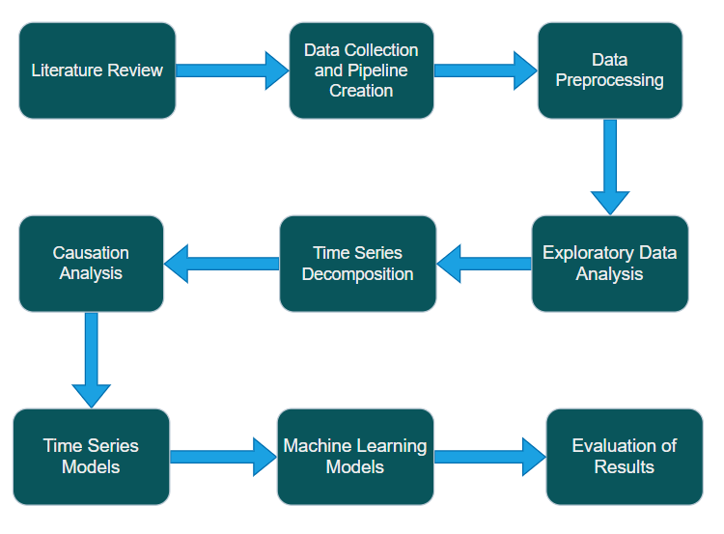

Figure 3.1: Project Workflow

# Data Preprocessing Tasks:

To address the research questions comprehensively and gain a holistic understanding of the intricate dynamics within the United States, I have engaged with two distinct datasets aimed at different geographic levels: state-level and national-level data. For the state wise dataset analysis, a broad span of 20 years’ worth of data was employed to extract insights. This process involved the creation of a structured data pipeline within the Azure environment and leveraging Tableau/Power BI to create visualizations to elucidate patterns and trends within the state-level data. On the other hand, the national-level dataset with an extensive timeframe of 50 years, consisting of monthly records with wide range of variables including various climate, socioeconomic factors, and energy metrics. This dataset collected and collaborated from US government websites like EIA, FRED and NOAA was employed to implement machine learning algorithms, allowing for a deeper understanding of correlations and predictive modeling across diverse variables at a national scale. Let’s now have a detailed exploration of individual variables encapsulated within the datasets, aiming for a comprehensive understanding of their characteristics and significance.

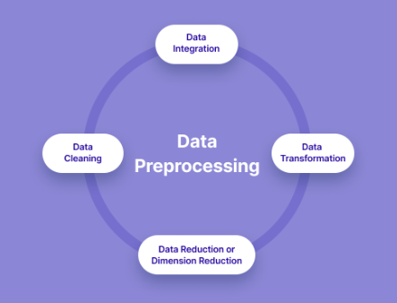

Figure 4.1: Data Preprocessing Steps (V7labs)

## Data Understanding:

### **State Level Datasets**:

**CO2 Emissions dataset**:

The dataset includes columns which collectively provide information on CO2 emissions, detailing various parameters such as time periods, sectors, fuels, states, and associated quantities, aiding in the analysis and understanding of carbon emissions across different dimensions.

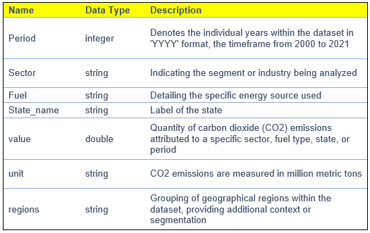

Figure 4.2: Data Description for CO2 emissions Dataset (State Level)

**Energy Dataset:**

This dataset offers a comprehensive range of information covering states, sectors, and energy aspects through various Key Performance Indicators (KPIs). Spanning from 2000 to 2021, it includes data on energy production, usage, electricity generation, pricing, and more. It allows us to analyze trends and connections across different areas and provides a robust foundation for a thorough understanding of how energy dynamics have evolved over the past two decades.

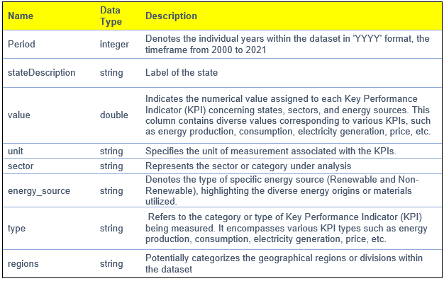

Figure 4.3: Data Description for Energy Dataset (State Level)

**Climate Dataset:**

These columns collectively provide diverse meteorological data for different states across the specified period, offering insights into temperature variations, precipitation, drought severity, and metrics related to energy consumption estimation (HDD and CDD) for heating and cooling purposes.

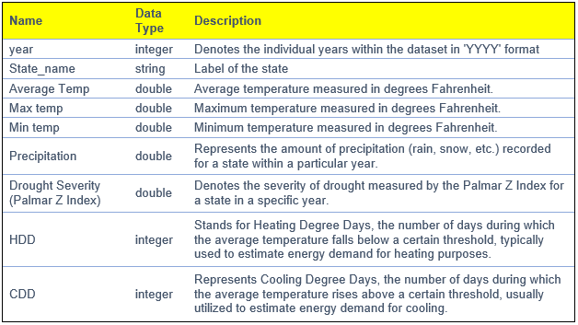

Figure 4.4: Data Description for Climate Dataset (State Level)

### National Level Dataset:

**USA Monthly Dataset**: This dataset offers a diverse range of information on energy usage, production, climate indicators, and economic factors at the national level. It enables a comprehensive analysis of how these interconnected elements influence each other. The process of identifying these influential features involved a comprehensive review of existing studies within the literature. Moreover, I expanded upon this by introducing additional climate-related variables that haven't been previously addressed in similar studies, thereby contributing a unique perspective to this research.

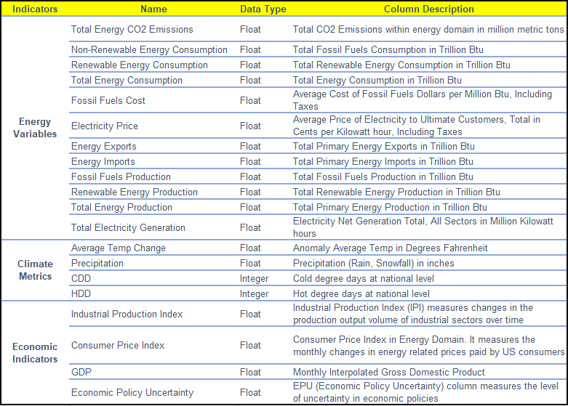

Figure 4.5: Data Description for USA Monthly Dataset (National Level)

## Data Pipeline Using Azure:

The data, organized under the SEDS schema encompassing CO2 emissions and energy data across various tables, was retrieved through an API using Python from EIA. Subsequently, an Azure-based data pipeline was created to automate the retrieval, transformation, and storage of this data, enhancing accessibility and usability.

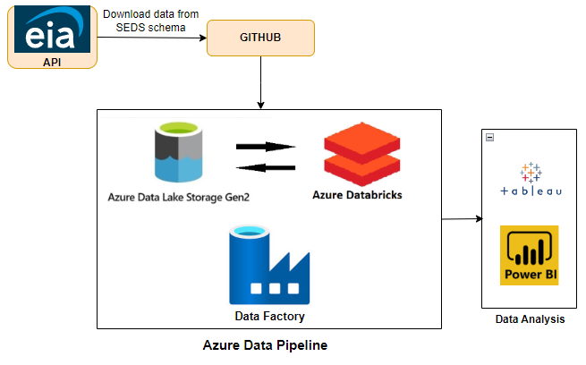

Figure 4.6: Data Pipeline Using Azure

The initial phase involved the utilization of Python to access the EIA API and retrieve data in manageable batches of 5000 records per request, adhering to the API's maximum retrieval limit. Retrieved data was structured in JSON format and efficiently stored in a Data Frame. These files were then securely stored within the GitHub repository for easy access and version control. The next step is the establishment of a data pipeline using Azure services to facilitate seamless data movement. **Azure Data Factory** was employed to connect with the GitHub repository and extract the stored data files. Within the **ADLS Gen 2** containers, two distinct folders were created - one for raw data and another for transformed data, ensuring a well-organized data storage approach.

The below figures highlight the Azure resources used to create a resource group, the data pipeline created in Azure Data Factory and the blob containers in ADLS to implement the solution. Also, the various preprocessing steps performed in data bricks will be shown in the next section.



Figure 4.7: List of Azure Resources Utilized

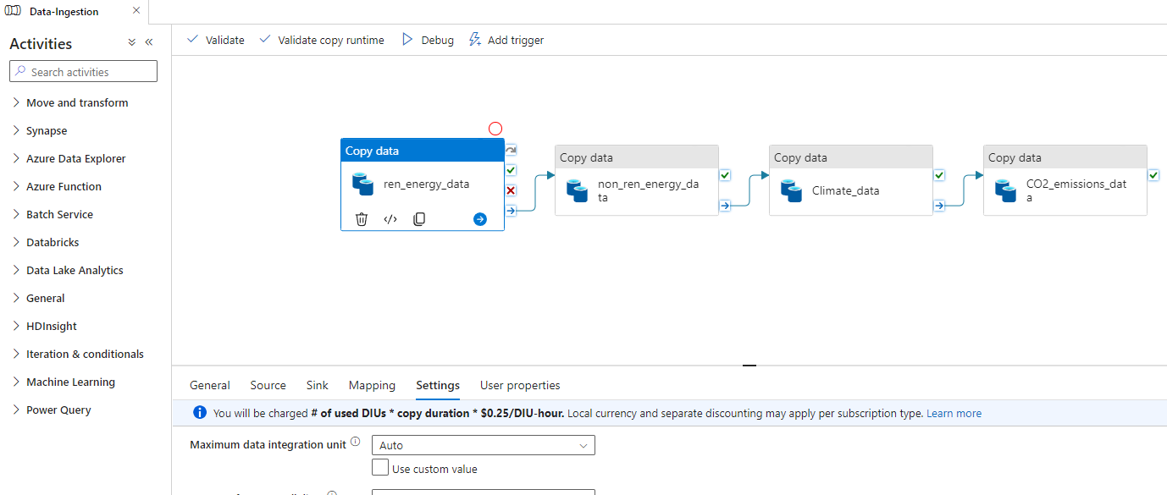

Figure 4.8: Illustration of Data Pipeline Created in Data Factory

The raw data was processed and transformed within **Azure Databricks** which is a powerful bigdata processing tool that works on spark framework that helps us mount and access the data directly from the ADLS storage containers within the data bricks which supports various high-level languages for processing such as pyspark, scala and SQL. Various preprocessing steps were executed to transform the data, enhancing its quality and utility for analytical purposes. The transformed data files, available in the Azure ADLS Blob Storage, are accessible for further analysis and visualization through popular BI tools such as Power BI or Tableau.

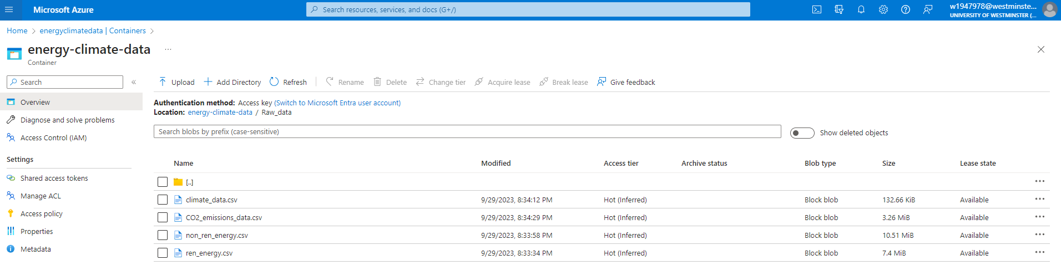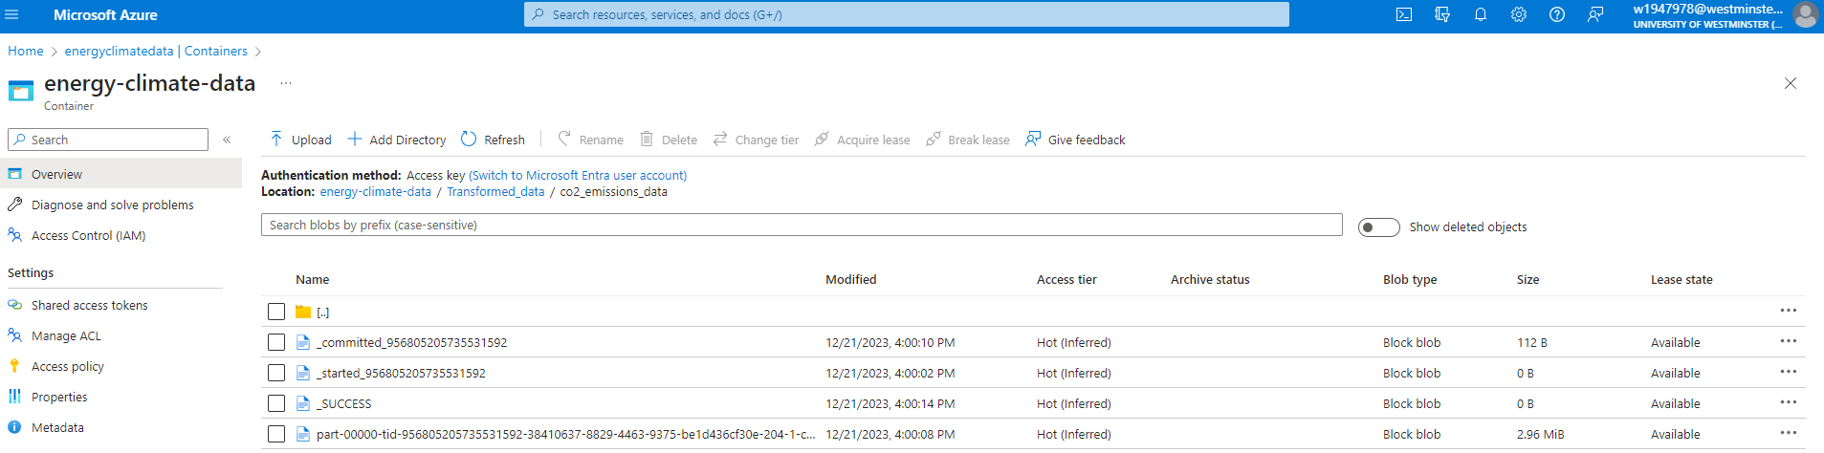

Figure 4.9: Azure Data Lake Storage Gen 2 (Raw and Transformed folders in Blob Container)

Specifically, the figure below depicts the process of mounting the Azure data lake storage within data bricks to access the datafiles from the containers so that we can read and store it into a data frame and do the required transformations. The transformed data frame can be converted into blob blocks and placed into the mounted storage by providing the required path to store the file.

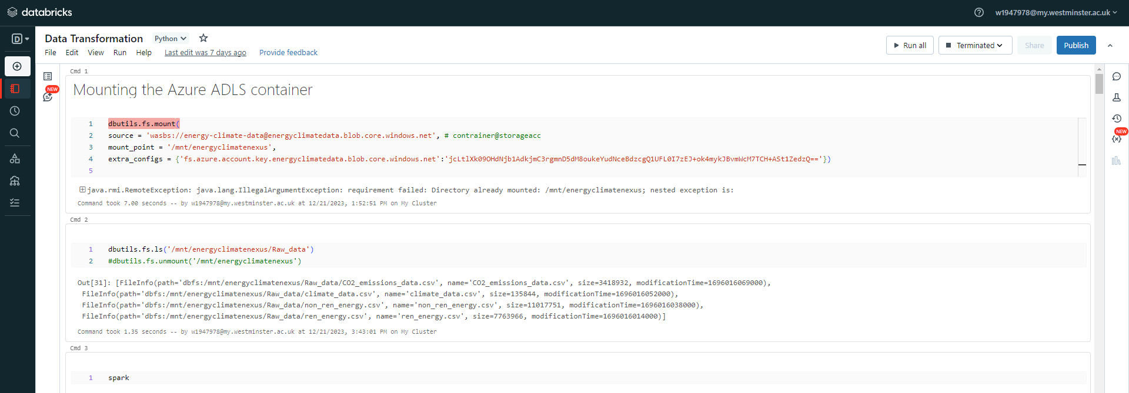

Figure 4.10: How to mount ADLS within Data Bricks

## Data Preprocessing:

Preprocessing steps play a vital role in ensuring data accuracy, consistency, and integrity by performing crucial tasks like cleaning, formatting, and refining the dataset. This process enables us to uncover deeper insights, supporting informed decision-making based on high-quality and dependable data. I started by checking for missing values (nulls) and duplicates in all the datasets I gathered, both at the state and national levels and each dataset has individual transformations that need to be applied as listed below.

### Statewide datasets:

**Missing data**: There is no missing data in these datasets.

**Duplicated rows**: There were 1178 duplicated records in the energy dataset. It might be a result of data retrieval in batches using API. It turned out that the last set of data I fetched had some info that was already in the previous batch. To rectify this, I have removed these duplicates, ensuring that the data remained consistent and avoided redundancy.

**Unique Unit per KPI**: I discovered that each key performance indicator (KPI) had multiple units of measurement. For instance, energy consumption was recorded in both BTUs and thousand barrels. To maintain consistency and clarity, I standardized each KPI to have a single unit of measurement, ensuring uniformity across the data.

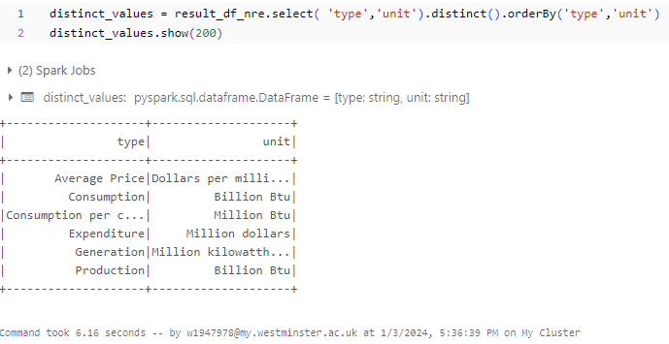

Figure 4.11: Unique Unit per KPI

**Data aggregation** **Columns:** The raw dataset had only one column seriesDescription which has all the KPI’s. It would be tougher to aggregate variable parameters that we need to do the analysis on. So, to handle this, I have created separate columns such as “sector”, “energy source” and “KPI type” based on matching content from series description. Additionally, I have added regions column based on states to find regional patterns as well. The data after this transformation is shown in Figure 3.11.

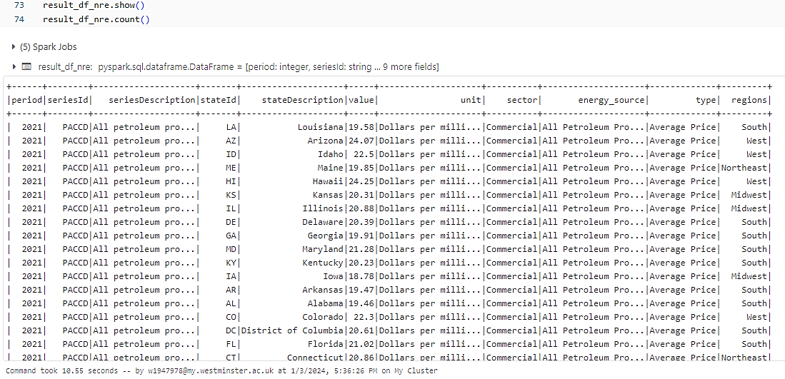

Figure 4.12: Creation of Data Aggregation Columns

### National datasets:

Interpolation is a widely used technique in time series analysis to estimate missing values between known data points. It's crucial for filling gaps caused by missing data or irregular sampling intervals. Various methods like linear, polynomial, and cubic spline interpolation help estimate these missing points by assuming straight lines, curves, or a series of curves between adjacent data points, respectively.

**Missing Values**: I have encountered a few columns with missing data, and some have rows containing strings like “Not Available” or “Withheld”. Firstly, I converted these string values to null and then applied linear interpolation techniques to fill the missing values as we can’t impute them since it’s a time series data. This approach was supported by the research conducted by (Abdullah, 2014) which discusses the effect of fitting distribution after filling missing data with various interpolation methods and concludes the linear interpolation method as a very good fit to the data and it’s equation can be described as shown in below fig.

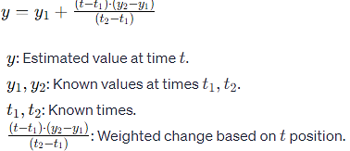

Figure 4.13: Linear Interpolation Formula

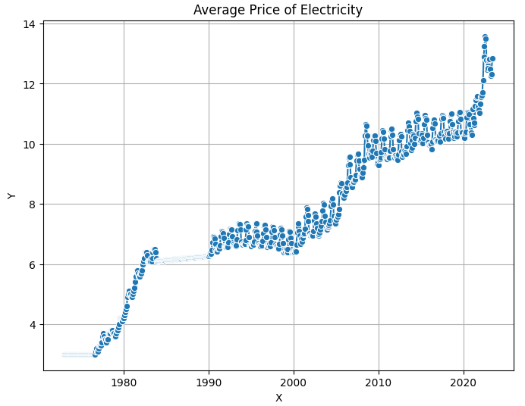

Figure 4.14: Result after Filling Missing Values with Linear Interpolation

**Interpolate GDP** : I have performed cubic spline interpolation to convert quarterly GDP values into monthly GDP figures as supported by studies conducted by (Ajao, 2012) which confirms cubic spline as a robust method for disaggregation. This technique allowed for the estimation of GDP data for months within a quarter, enhancing the granularity of the dataset and matching with other variables which have data at monthly level.

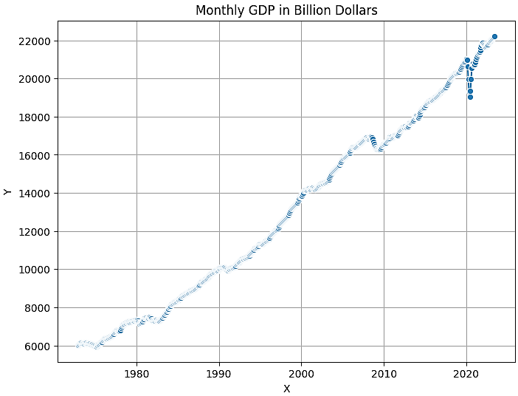

Figure 4.15: Quarterly to Monthly GDP using Cubic Spline Interpolation

**Outliers**: To identify outliers, I employed box distribution analysis and time series decomposition. This dual approach allowed me to examine the residuals and detect extreme outliers that significantly deviated from the original trend, aiding in identifying and addressing potential anomalies within the dataset.

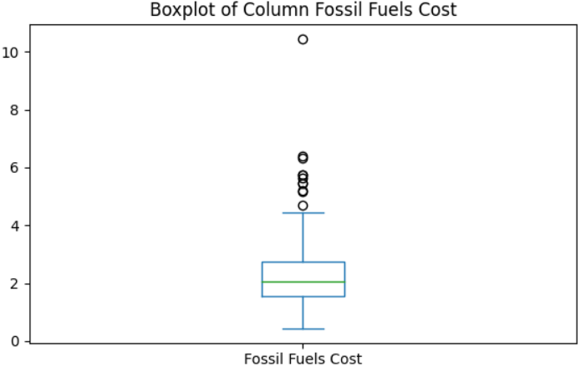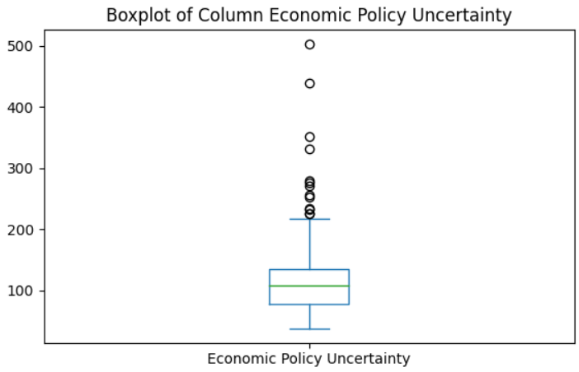

Figure 4.16: Box Plots to Identify Extreme Outliers

I noticed that there were extreme values in two columns (fossil fuel cost and EPU) as shown in fig corresponding with the onset of the COVID-19 pandemic in 2020. These anomalies disrupted the usual trend observed in the dataset, likely attributable to the exceptional circumstances surrounding the pandemic. To mitigate the impact of these extreme outliers, I employed winsorization techniques which was discussed in studies conducted by (Kwak and Kim, 2017) along with interpolation. This involved capping the extreme values at the 99th and 1st percentile thresholds. By applying this method, I managed to mitigate the influence of these outliers, ensuring a more robust and stable dataset for analysis.

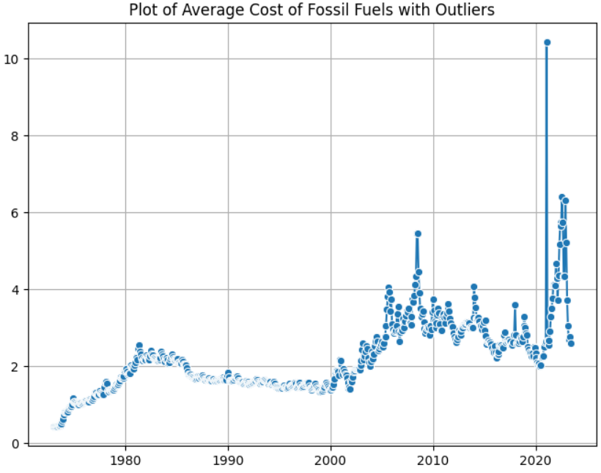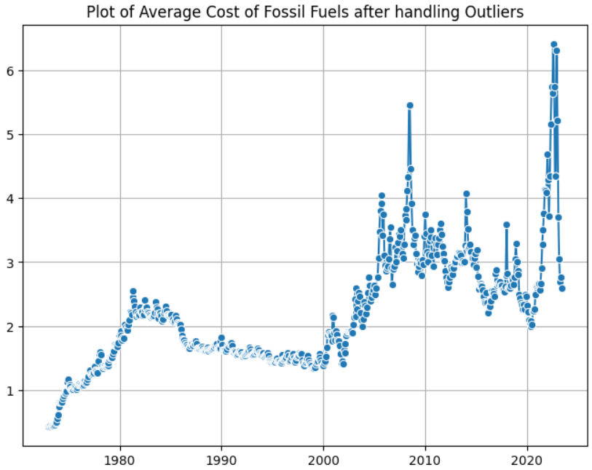

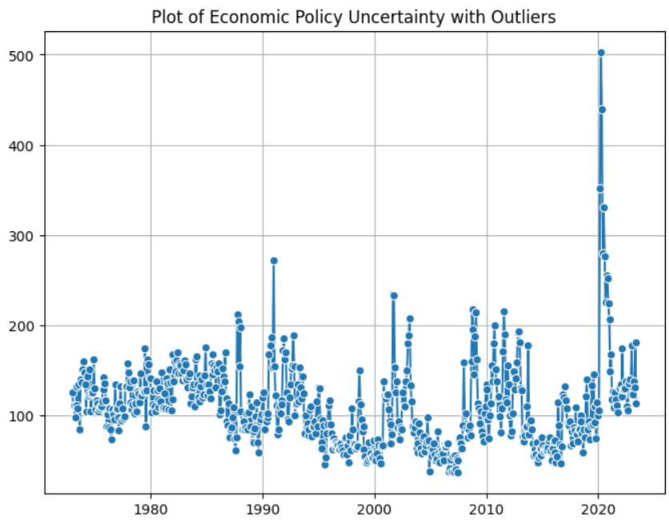 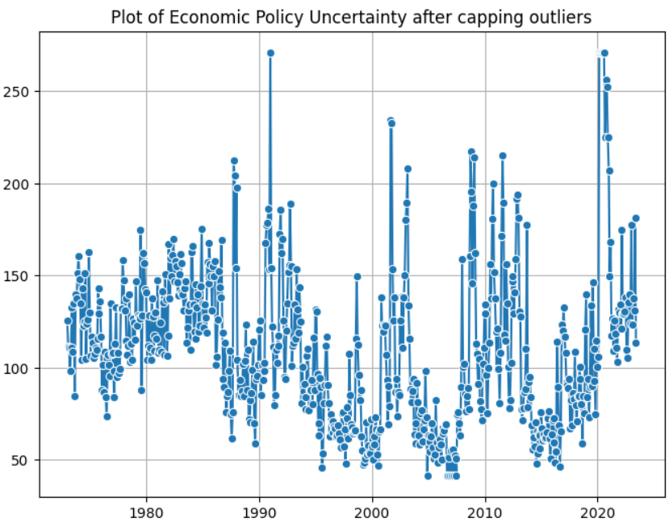

Figure 4.17: Time Series Plots Comparing before and after Capping Outliers

**Scaling**:

Feature scaling, the process of normalizing feature ranges in a dataset, is crucial when dealing with features of varying units. Standard scaling is employed in this research to ensure uniform interpretation of features by machine learning models on a consistent scale.

**Final Dataframe after handling nulls and outliers** :

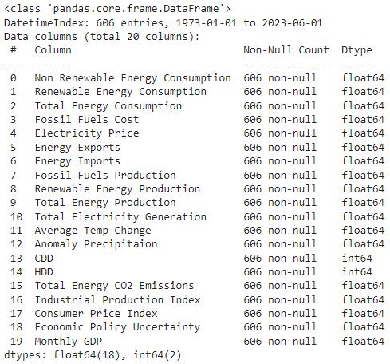

Figure 4.18: Final Data frame

**Statistical Description** :

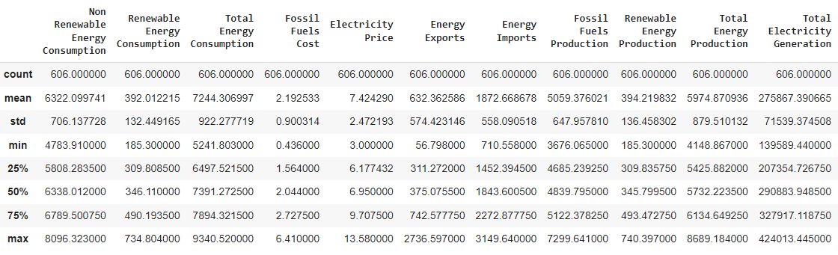

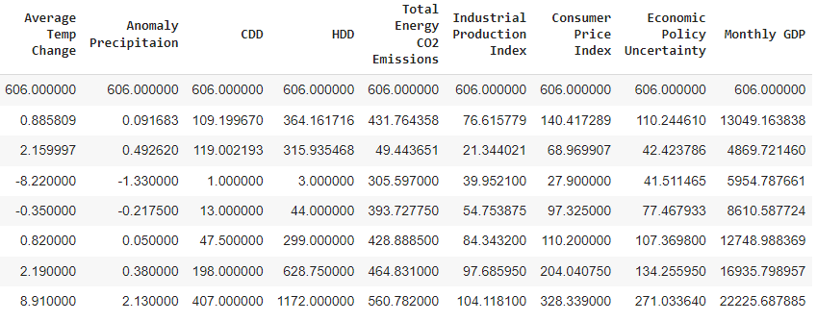

Figure 4.19: Statistical Description of National Level Data used for Machine Learning

# Exploratory Data Analysis

**Exploratory data analysis** is usually the first step we apply to the dataset: it involves a comprehensive investigation into the data to reveal its patterns and hidden insights. The primary goal of EDA is to thoroughly examine the data before making any assumptions. This process can help identify obvious errors, detect outliers or anomalous events, and find interesting relations among the variables.

Beginning the EDA with CO2 emissions data lays a foundational understanding of this crucial aspect. As we progress, we'll dive deeper into diverse analyses and visualizations, aiming to uncover patterns, trends, and key factors associated with CO2 emissions. This initial step enables us to explore correlations with other variables, understand temporal trends, and investigate variations across different regions.

### **CO2 emissions Analysis**

To highlight the variations in CO2 emissions across different regions, I have used stacked area chart. It’s evident that the **south region** exhibits the highest CO2 emissions among all regions followed by **west**.

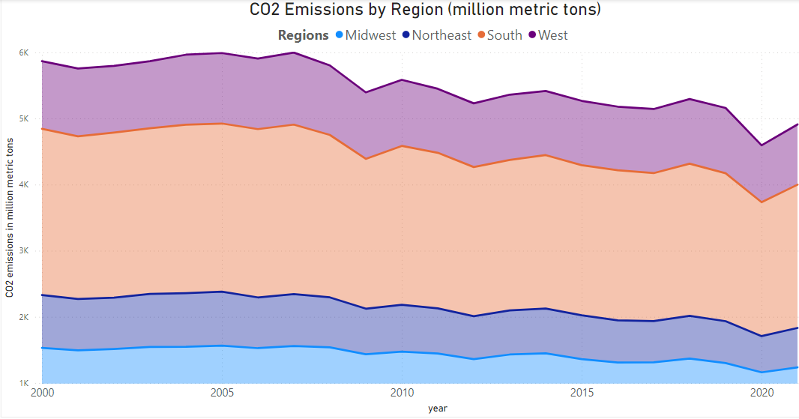

Figure 5.1: CO2 Emissions by Region

Further, I wanted to investigate regional hotspots i.e. states within the regions that are producing the highest emissions. In order to achieve this, I have incorporated maps which are visually more engaging to represent geographical data and easy to grasp regional variations and concentration of emissions across different areas. I have built **Interactive dashboards** which not only help us find overall emissions but also allow us to delve deeper by filtering states or regions based on diverse sectors and various fuel types.

The map below reveals that **Texas** is the top state followed by **California** in overall CO2 emission including all sectors and fuels.

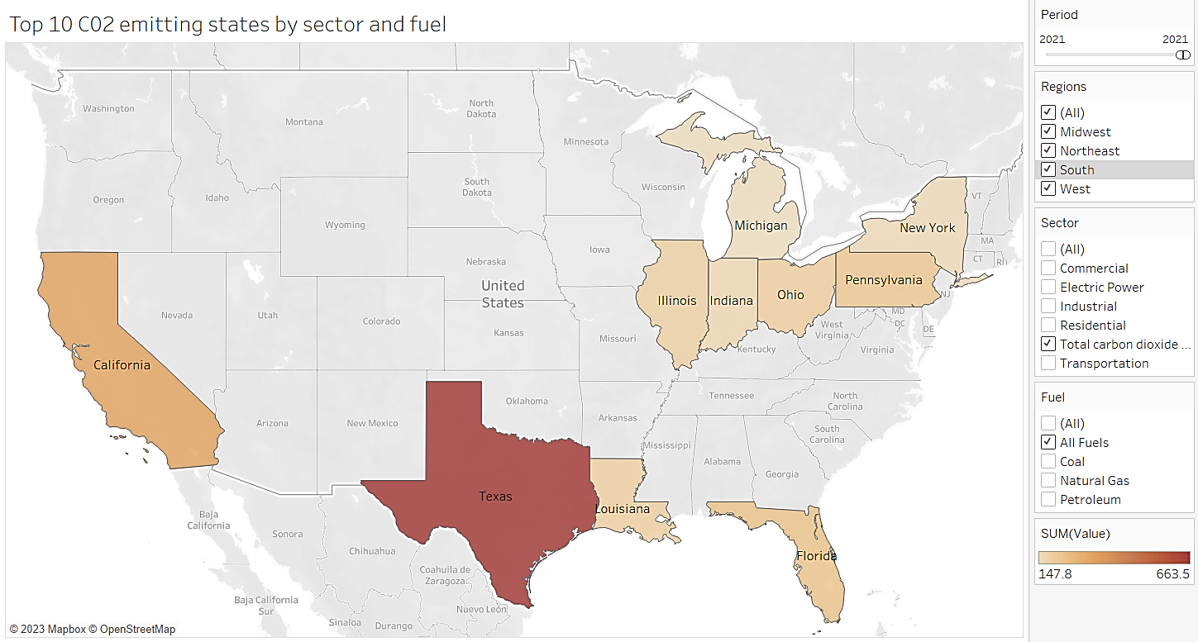

Figure 5.2: Interactive Workbook for Top CO2 Emitting States by Sector and Fuel

**Regional Hotspots**:

Northeast : Pennsylvania, New York

Midwest : Ohio, Illinois, Indiana, and Michigan.

West : California

South : Texas, Louisiana, Florida

The bar chart below illustrates CO2 emissions across different sectors and the primary energy sources employed within each sector. Upon analysis, it becomes apparent that in 2021, the transportation sector emerged as the largest contributor to CO2 emissions, closely followed by the electric power sector. Furthermore, the analysis highlights how the primary fuel source driving CO2 emissions varies across different sectors.

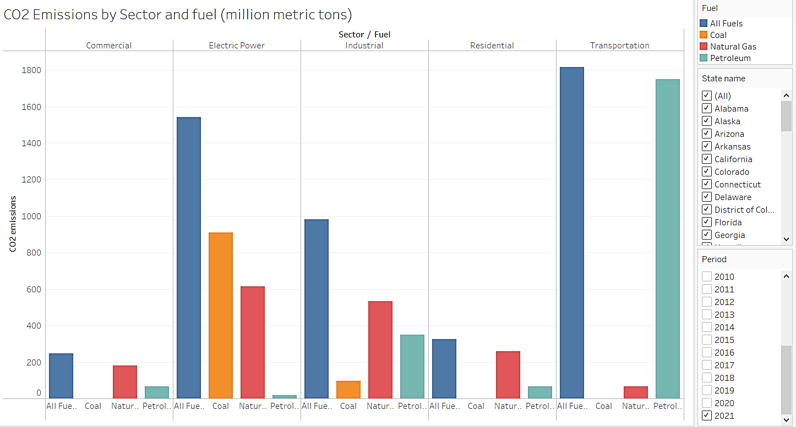

Figure 5.3: Interactive Workbook for Overall CO2 Emissions by Sector and Fuel

Specifically, coal remains the primary driver for the electric power sector and is not extensively used by other sectors, except for the industrial sector, where natural gas and petroleum are the top sources. Notably, the transportation sector relies heavily on petroleum as its main fuel source. On the other hand, the residential sector primarily utilizes natural gas, predominantly for cooking purposes, distinguishing its use from that in other sectors. This insightful analysis demonstrates the diverse and sector-specific utilization of different fuel sources, contributing uniquely to CO2 emissions across sectors.

### Energy Analysis

The overall share of renewable energy and non renewable energy is highlighted in pie chart.It signifies that 91 percent of consumption is still dependent on non renewable sources and there is a very little portion using renewable sources.

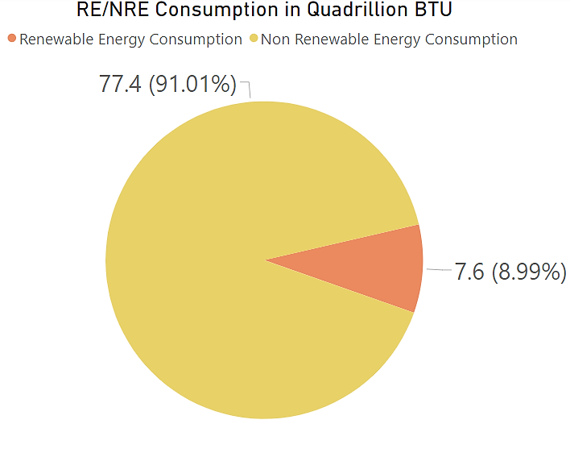

Figure 5.4: Total RE/NRE Share (2021)

As we compare the share over the last 50 years we see that the adoption of renewable sources is increasing in a gradual trend but still needs a significant improvement which helps mitigate the adverse affects caused by fossil fuel buring like temperature raise,climate change and extreme weather events.

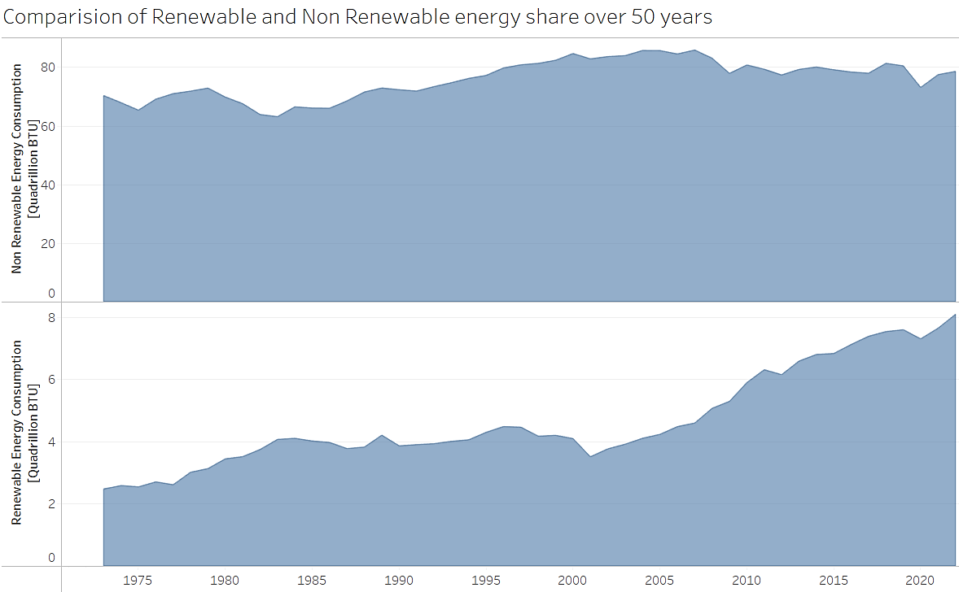

Figure 5.5: Comparision of Renewable and Non Renewable Energy share over 50 years

Before delving further, let’s grasp the climate zones across the USA using Cooling Degree Days (CDDs) and Heating Degree Days (HDDs). Cooling degree days (CDDs) are used as an indicator of how warm a given location was on a given day or during a couple of days. For example, a day with a mean outdoor temperature of 80°F has 15 Cold degree days. If the mean temperature for the next day is 84°F, it is 19 CDDs. The total for the two days is 34 CDDs.(CDD no date)

Heating degree days (HDDs) are used as an indicator of how cold a given location was on a given day or during a couple of days. For example, a day with a mean outdoor temperature of 40°F has 25 Hot degree days. If the next has the same temperature then we have 50 HDDs for the two-day period. (CDD no date)

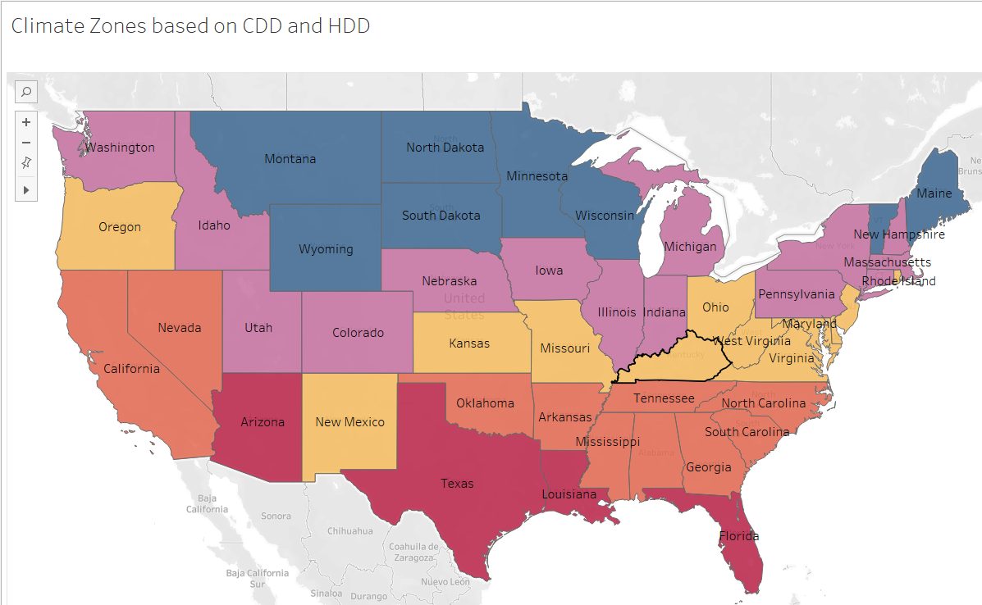

Figure 5.6: Various Climate Zones of USA

Identifying various temperature zones is essential to understand the energy demands.

**Hot Zone**: The states to the south which are in **red** color are Hot or Very Hot regions demanding significant energy consumption for cooling purposes.

**Warm Zone**: The states colored **orange** are warm regions.

**Mixed Mild Zone**: The states in **yellow** are Mixed mild zones which are slightly warm and cool.

**Cool** **Zone**: The states in **purple** fall under cool zone.

**Cold or very cold zone**: The states to the north colored in **dark blue** are the coolest regions likely requiring more consumption for heating.

Also, examining population density across states is crucial as it sheds light on human-related activities potentially influencing CO2 emissions. Higher population density often indicates increased human presence and activities such as transportation, infrastructure development, and industrial operations, which can contribute significantly to CO2 emissions. States with denser populations tend to have higher energy demands for homes, businesses, and transportation, leading to elevated emissions.

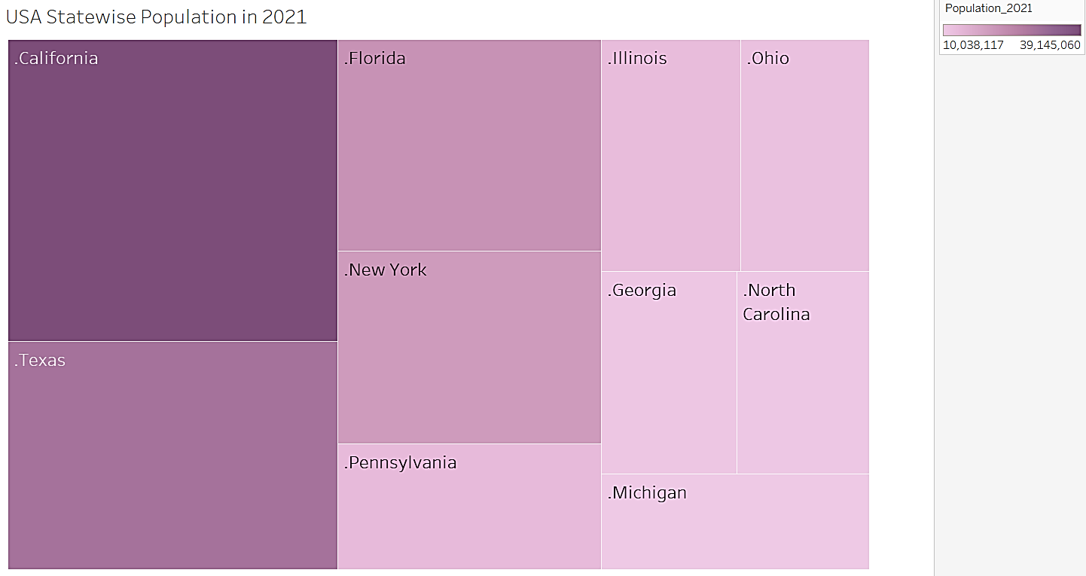

Figure 5.7: Most Populated States in USA (2021)

As anticipated, 8 out of the top 10 carbon-emitting states exhibit higher population densities, aligning with our initial assumptions. This observation solidifies the correlation between population density and carbon emissions, highlighting the influence of human-related activities on emissions.

Now, let's examine the states with the highest consumption of nonrenewable energy sources and identify the leading states in the adoption of renewable energy.

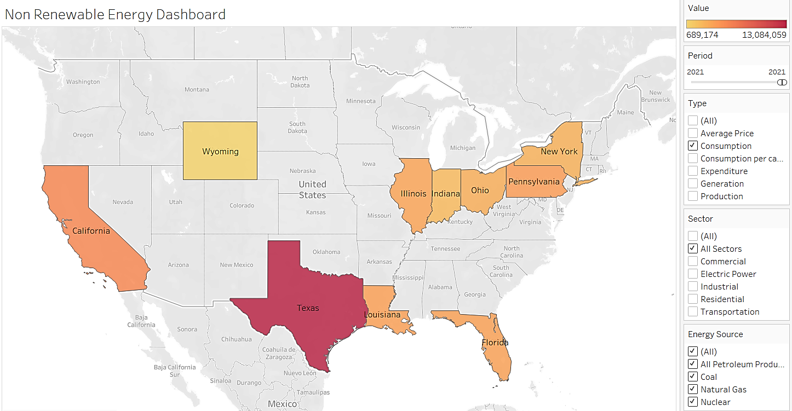

Figure 5.8: Interactive Dashboard to Highlight Top States in Fossil Fuels Usage (2021)

As we see, 9 of the top 10 carbon emitting states have the highest non-renewable energy consumption which highlights the fossil fuels consumption as the primary contributor for the emissions. Also, it’s found that the hotter regions demand more energy in comparison to the colder regions.

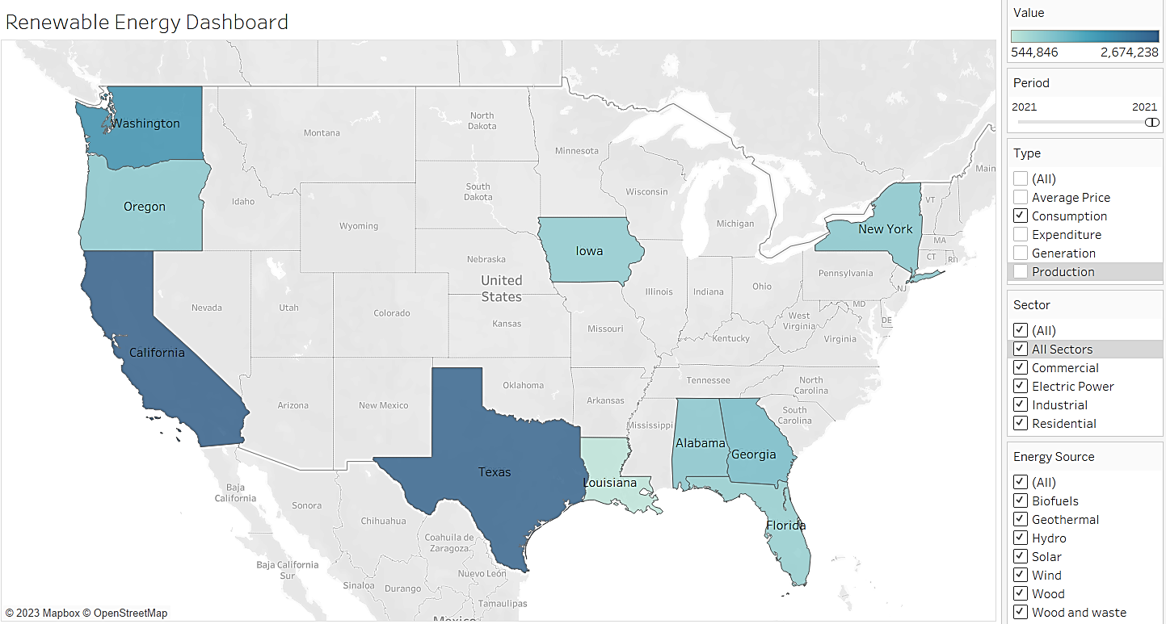

Figure 5.9: Interactive Dashboard to Highlight Adoption of Renwable Energy Sources (2021)

Interestingly, Texas and California are having significant adoption of renewable energy consumption. Although these states are top emitters and densely populated, they are trying to move towards renewable energy and these regions also have geographical advantages such as vast land areas that are suitable for wind farms and are hotter regions that can benefit from abundant sunshine which promotes solar energy generation.

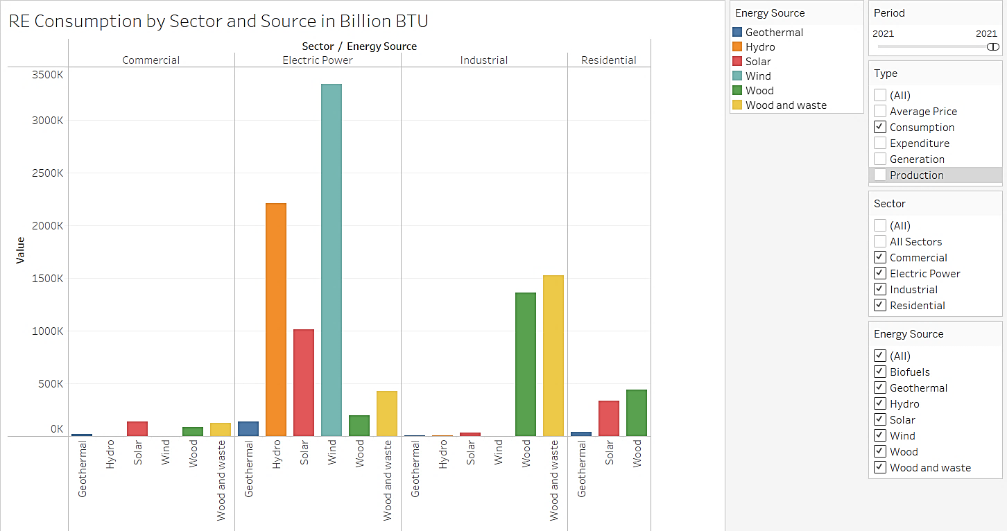

Figure 5.10: Adoption of Clean Energy Sources in Various Sectors

In the analysis of renewable energy consumption across sectors and energy sources, it's evident that the electric power sector stands out as the primary sector exploring diverse energy sources. Among these, wind, hydro, and solar energy emerge as significant contributors, with wind energy notably generating substantial electricity. In contrast, the industrial sector predominantly relies on wood and waste for electricity generation from available renewable sources. The residential sector exhibits an attempt to utilize solar and wood as energy sources; however, it appears to face reliability challenges in this regard. Conversely, the commercial sector shows minimal utilization of renewable energy sources compared to other sectors, indicating a lower adoption rate within this sector.

The results obtained from Exploratory Data Analysis (EDA) highlight top contributing states, sectors and major fuel types within the sector and also indicate that energy consumption, population dynamics, and climatic factors as primary drivers of CO2 emissions. However, beyond these significant contributors, other factors also hold potential impact over CO2 emissions. Various research studies in existing literature have analyzed these additional factors, highlighting their potential influence on CO2 emissions. These factors, though not as prominently featured, are considered notable and require further investigation due to their potential impact on shaping CO2 emission patterns.

Certainly, to delve into the various influencing factors affecting CO2 emissions, a comprehensive data set at the national level has been gathered. This extensive dataset covers multiple variables spanning over 50 years. Due to the complexity and length of this data, visualizations alone may not effectively represent the interrelations among these factors.

Hence, employing time series analysis becomes essential to explore the interrelationships and causation among these variables. By conducting multiple time series tests and analyses, the aim is to decipher the causal links between these factors and their effectiveness in forecasting future CO2 emissions. This robust analytical approach helps to uncover how these variables interact over time, providing valuable insights into their impact and predictability of future CO2 emissions.

# Time series Analysis

## Time series decomposition

The time series decomposition method segregates data into three key components: trend, seasonality, and residuals, unveiling distinct insights into each element.

**Trend**: A trend exists in the time series when there is either a long-term increase or decrease in the data. It’s not necessary that the trend must be linear. Sometimes the trend would be referred to as “changing direction” when it might go from an increasing to a decreasing trend. This is shown in the below figure for time series plot of CO2 emissions where the direction changed from around year 2009.

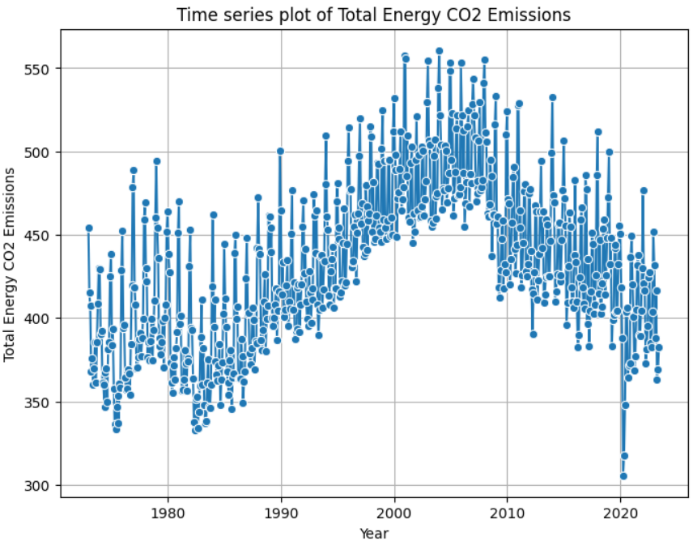

Figure 6.1: Time Series Plot of CO2 Emissions

**Seasonality**: Seasonality occurs when a time series data experiences regular changes that are affected by seasonal factors such as specific time of the year that recur every calendar year contributing to predictable patterns. These seasonal changes maintain a consistent and identifiable frequency.

**Residuals**: Lastly, the residuals signify the irregular or random elements unaccounted for by the trend or seasonality, providing a glimpse into unexpected fluctuations or noise within the data as shown in below figure.

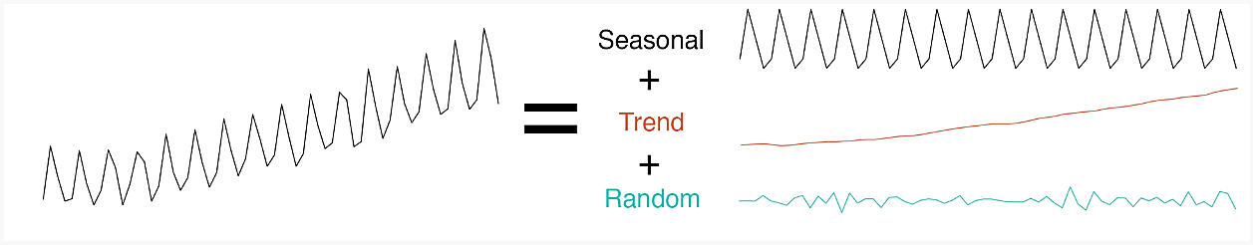

Figure 6.2: Time Series Decomposition

The time series decomposition is of two types: it can be **additive** and **multiplicative**. So, the selection of the suitable decomposition method requires analyzing the series to check how strong the seasonal patterns are and whether they increase as the time series increases. The difference between these two approaches is clearly highlighted in the table below (Time Series Decomposition, 2015) .

|  |  |
| --- | --- |
| **ADDITIVE** | **MULTIPLICATIVE** |
| Seasonality remains constant over time | Seasonality increases as time increases |
| Time series = Seasonal + Trend + Random | Time series = Trend * Seasonal *Random |
|  |  |

Table 6.1: Additive and Multiplicative Decomposition Techniques

After investigating the time series plots of all the variables considered for this project, I see the seasonality is constant for all the variables except “Total Electricity Generation” Column in which the seasonality increases as time increases. So, I have applied the multiplicative decomposition for “Total Electricity Generation” column and additive decomposition for the remaining variables to understand trend seasonality and residual analysis.

**Variables with clear trend and seasonality:**

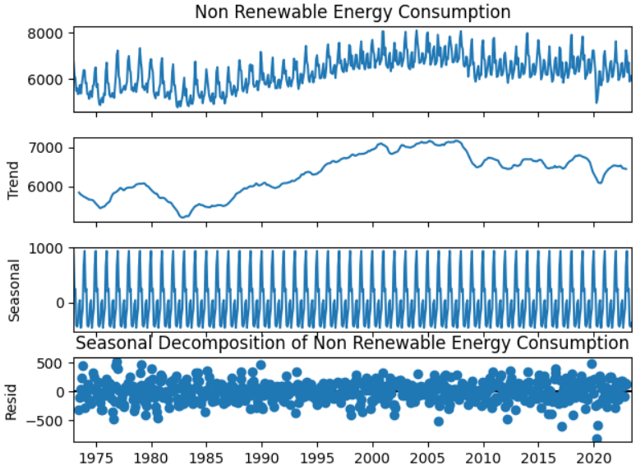 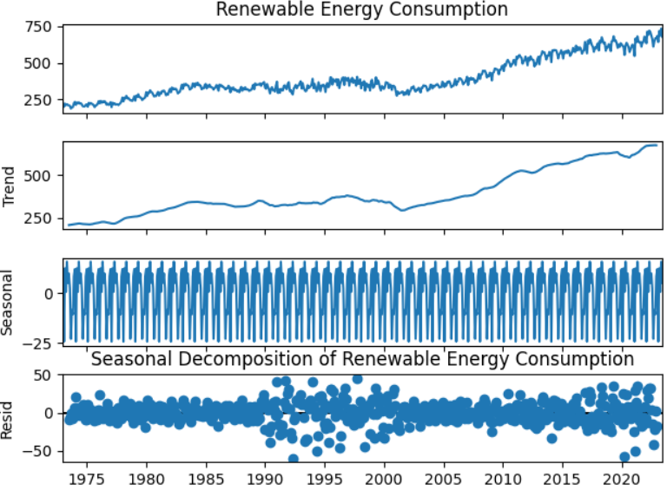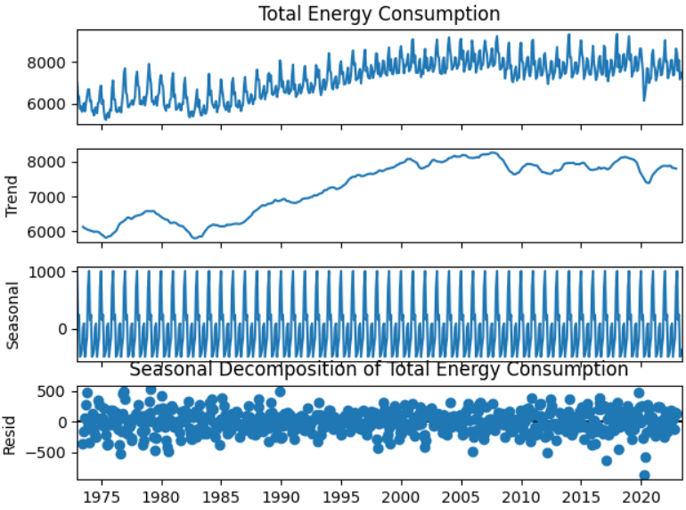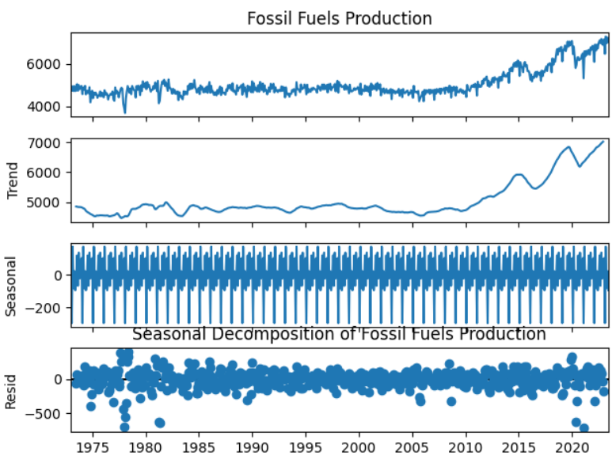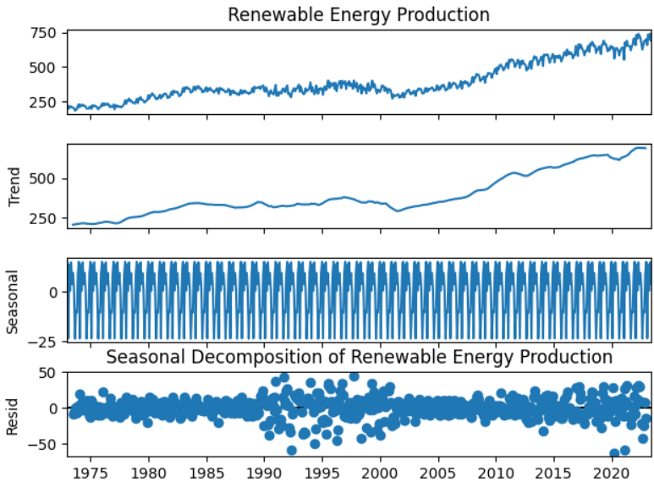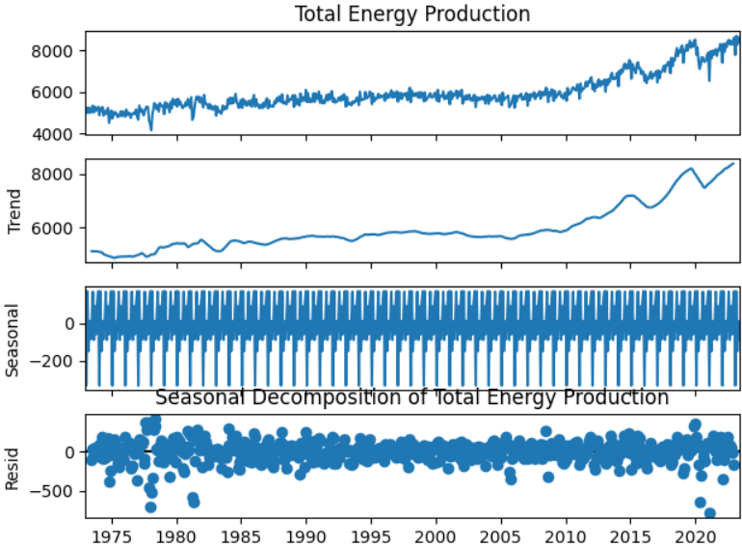 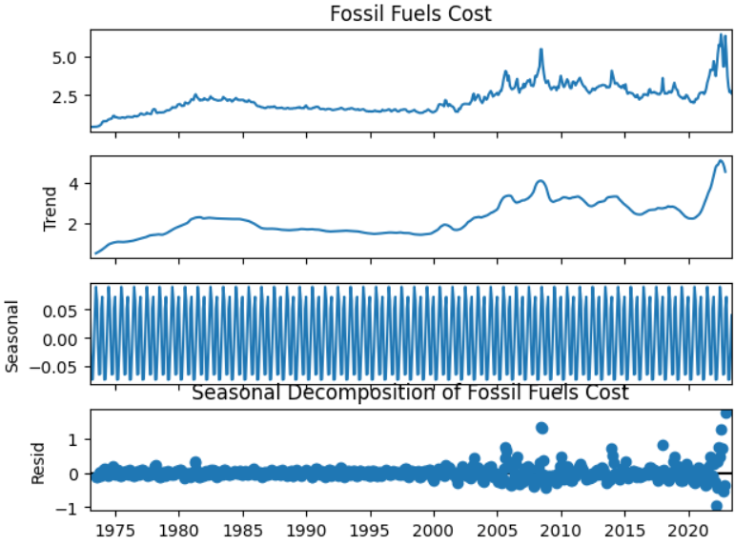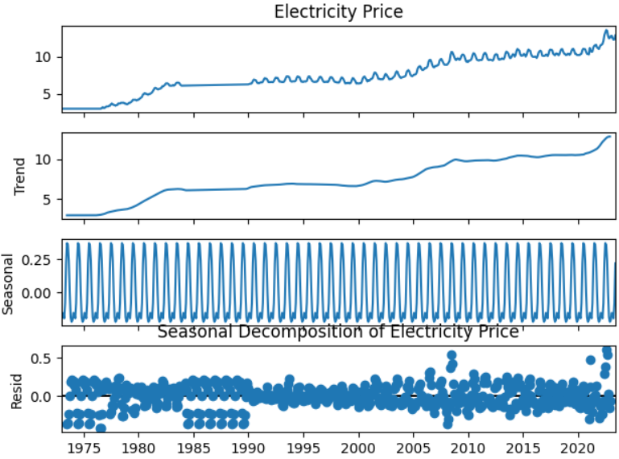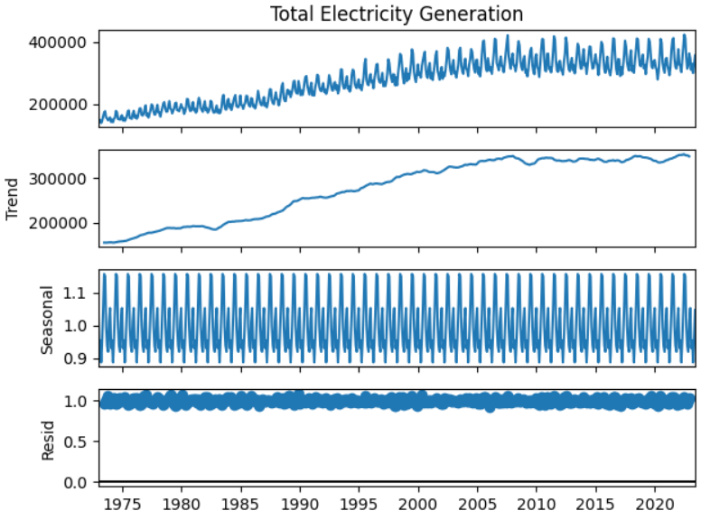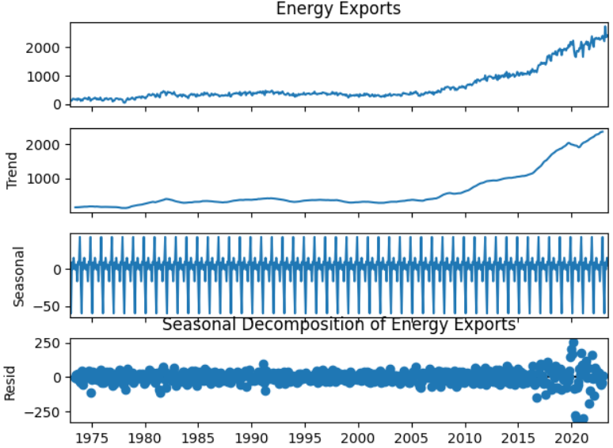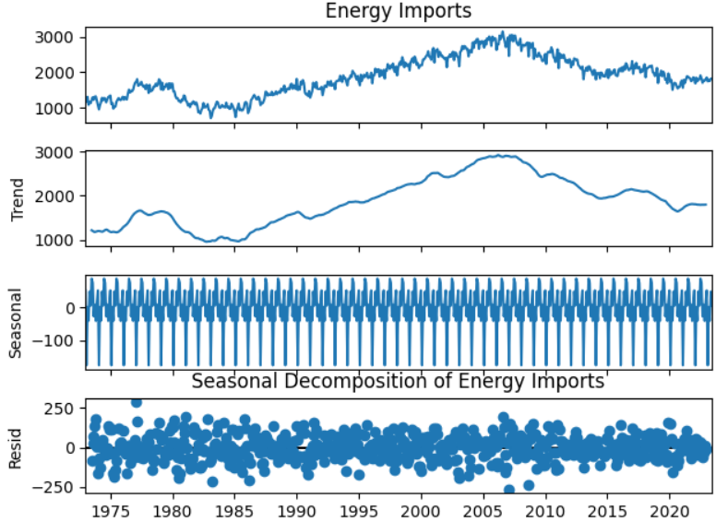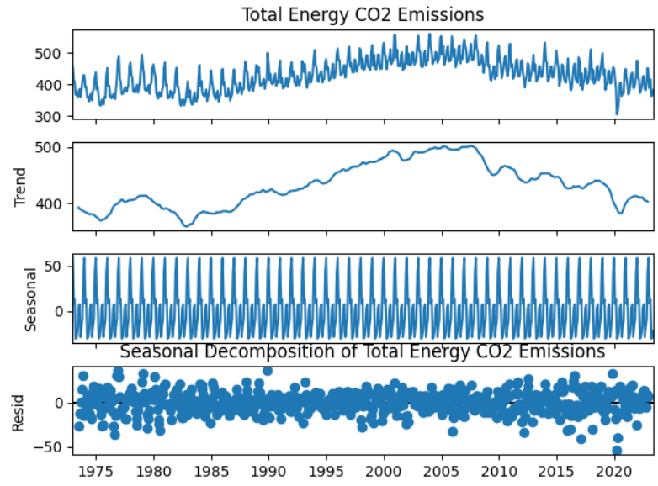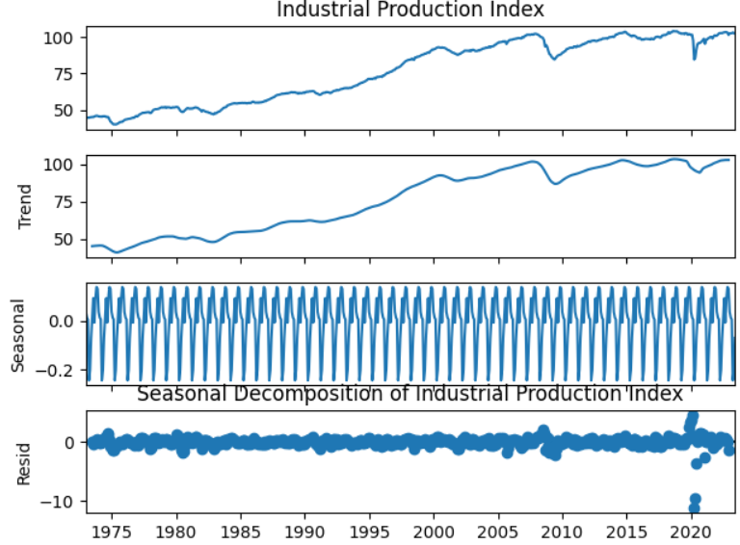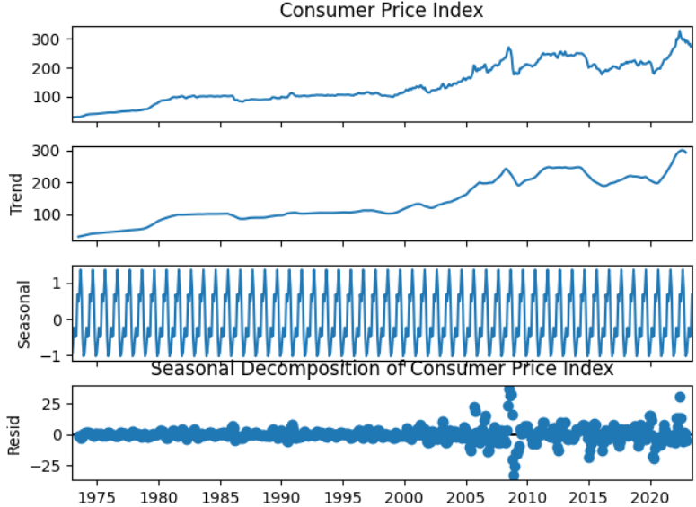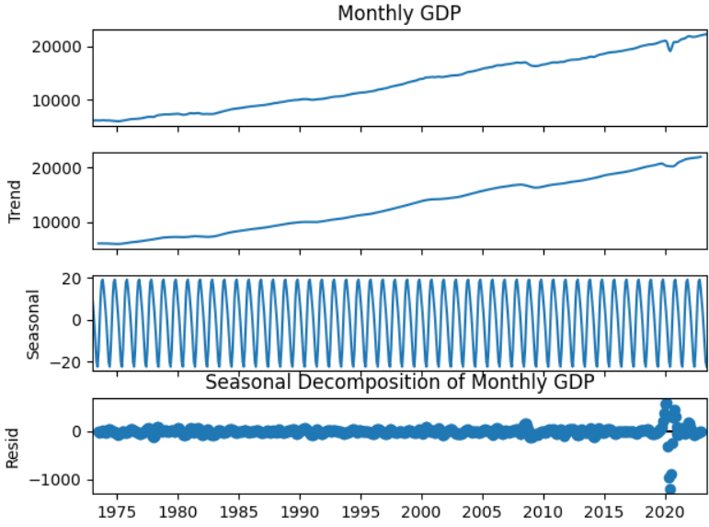

Figure 6.3: Variables Highlighting Clear Trend and Seasonality

**Variables with no clear trend but with yearly seasonality**:

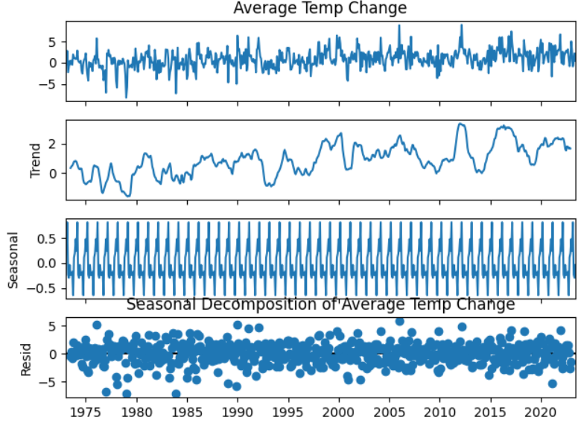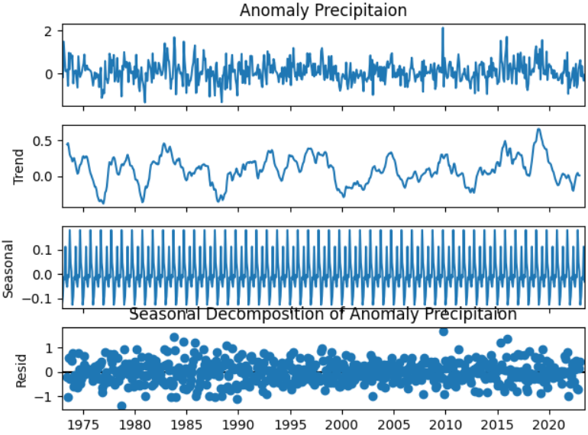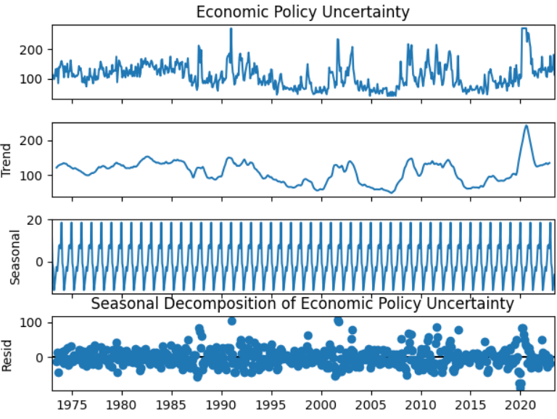

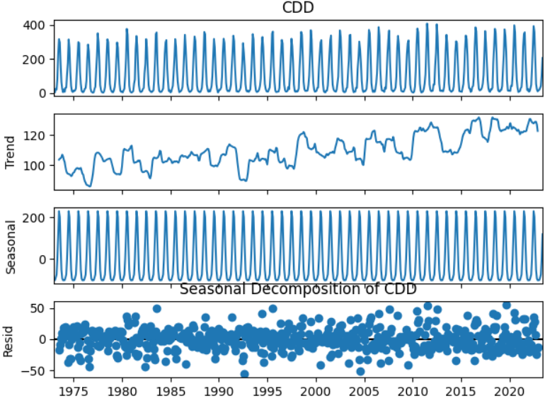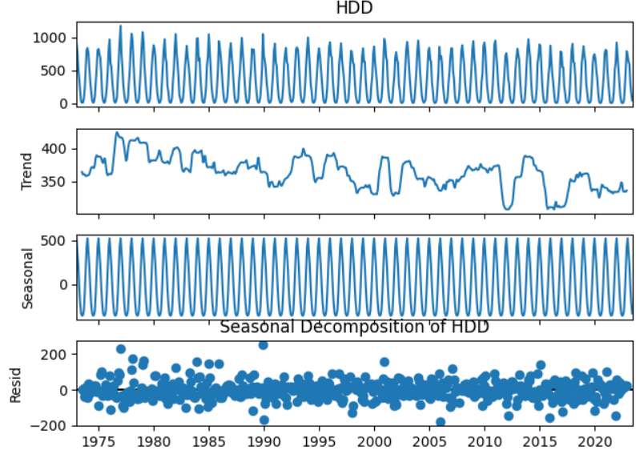

Figure 6.4: Variables with No Clear Trend but with Seasonality

Seasonal decomposition analysis revealed prevalent trends and seasonal fluctuations across most energy and socio-economic variables. Notably, all climate-related metrics such as Average Temperature, Precipitation, Cooling Degree Days (CDD), and Heating Degree Days (HDD) display yearly seasonality without clear trends. Additionally, the Economic Policy Uncertainty (EPU) metric lacks the trend but exhibits annual seasonality in its patterns as shown in fig 4.2.1.

## Correlation Analysis:

Correlation Analysis is a statistical approach utilized to determine whether there exists a relationship between two variables of a dataset, unveiling the degree of strength and direction in that association. It is often measured by the correlation coefficient and the values range between -1 to +1. Positive correlation mean that both the variables move in same direction i.e. when one variable value increase the other variable also increases whereas negative correlation mean they move in opposite direction i.e. when one variable value increases the other variable value decreases and vice versa. The coefficient value close to 1 signifies a strong positive correlation and -1 defines and strong negative correlation.

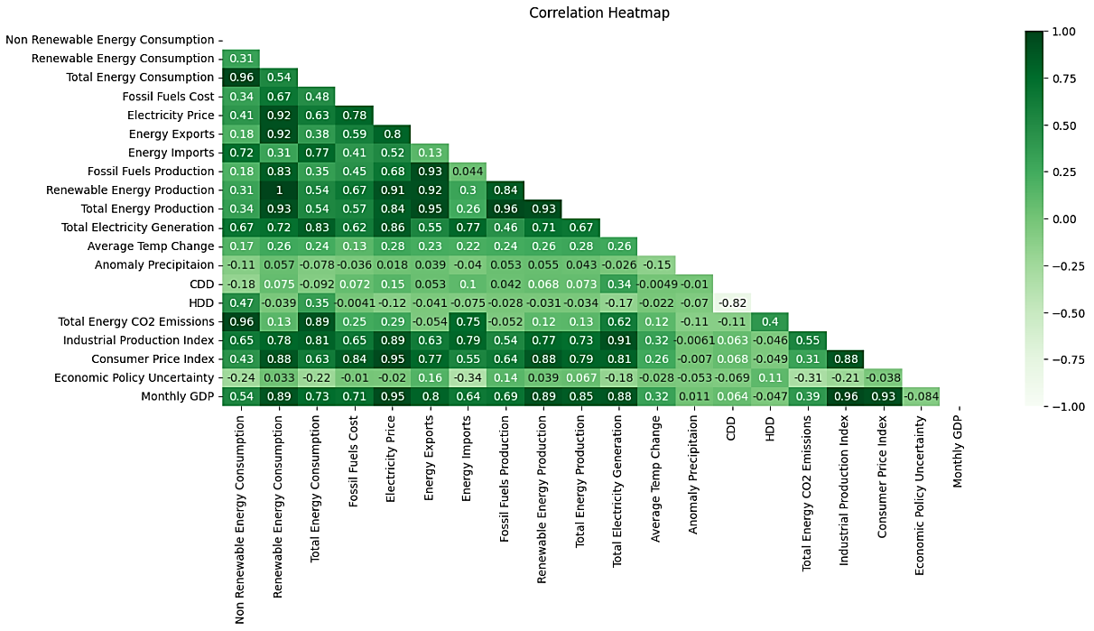

Figure 6.5: Correlation Heatmap for All Features

Upon sorting the columns by their correlation values with CO2 emissions, a clear pattern emerges in the relationship between certain factors and CO2 emissions. Notably, fossil fuel consumption, energy imports, electricity generation, and industrial production display a strong positive correlation with CO2 emissions. However, it's important to note that various other influential aspects, highlighted in existing literature, like renewable energy consumption and economic policy uncertainty, despite being recognized as influential, do not demonstrate a strong correlation with CO2 emissions based on this analysis. Furthermore, indirect influences such as the Consumer Price Index, electricity prices, and fossil fuel costs also do not seem to exhibit a notably strong correlation with CO2 emissions in this specific analysis.

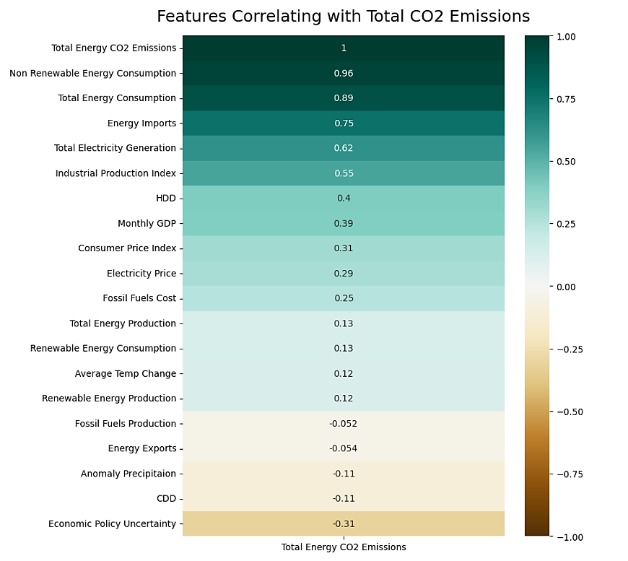

Figure 6.6: Features Correlating with Total CO2 Emissions

These findings require a need to further investigation beyond the scope of correlation analysis. However, it's crucial to understand that **correlation alone does not imply causation**. To truly comprehend the impact of various factors on CO2 emissions, establishing causation becomes imperative. Causation aims to determine a **cause-and-effect relationship** between variables. It involves rigorous analysis or applying advanced statistical methods like regression analysis or causal inference techniques.

# Causation Analysis

To explore the causality of diverse energy, climate, and socio-economic variables with CO2 emissions, we utilize a sequential testing approach comprising three steps: Stationary test, Cointegration test, and Granger Causality test.

## Stationary test

The stationarity of a time series significantly influences its statistical properties and predictive capability. Failing to achieve stationarity in a time series may lead to spurious regressions which produces inaccurate outcomes. Hence, ensuring stationarity is a fundamental prerequisite before initiating any analysis involving time series data (Greunen et al., 2014). Stationarity implies that a time series statistical properties (like mean, variance, and covariance) remain constant over time. However, a unit root indicates that these statistical properties change and evolve over time, making it challenging for the model to predict the behavior of the series accurately.

While there are several ways to make a non-stationary series stationary, differencing is the most widely used method which is done by computing the differences between consecutive observations (Greunen et al., 2014). To see if there's a unit root in a time series variable or not, we'll use the Augmented Dickey-Fuller (ADF) test.

**Augmented Dickey fuller test**:

The Augmented Dickey-Fuller (ADF) test, an extension of the Dickey-Fuller test, assesses whether a unit root is present in a time series or not. The null hypothesis of the ADF test is that the series has a unit root, indicating non-stationarity. The alternative hypothesis is generally stationarity or trend stationarity but can be different depending on the version of the test that is being used. This test includes lagged differences of the variable, aiming to address higher-order autocorrelation by incorporating additional lags on the right-hand side of the regression equation(Dickey-Fuller Test,1979).

The below equations represent the ADF test. The first equation represents the ADF test with no trend and intercept while the second equation adds the intercept, and the third equation includes both trend and the intercept.

Δyt ​= δ y(t−1) ​+ εt​

Δyt ​= α +δ y(t−1) ​+ εt​

Δyt ​= α + θt +δ y(t−1) ​+ εt​

Where Δyt​ represents the differenced time series data at time t, εt​ represents the error term, α represents the intercept, θt represents the trend, δ is the coefficient for lagged dependent variable y(t-1). Here the coefficient δ is vital in identifying whether the time series variable has a unit root or is stationary. If the δ value is below zero, any shocks in the time series variable tend to be short-lived and diminish over time, indicating that the series is stationary. Conversely, if the δ value equals zero, disturbances in the value persist indefinitely, suggesting a unit root in the series. This is known as the unit root hypothesis.

### ADF Test Results:

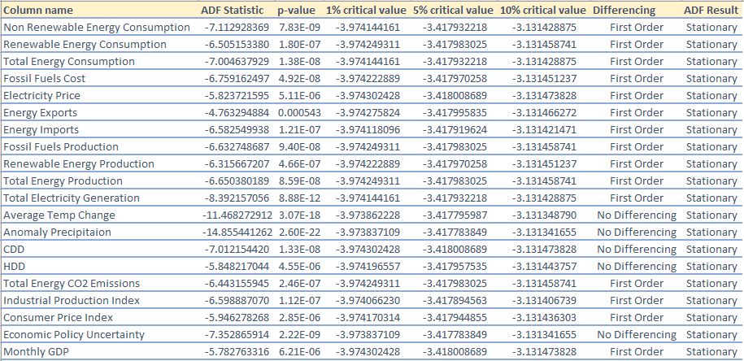

Figure 7.1: ADF Test Results

The analysis indicates that most of the columns, excluding the climate-related variables and Economic Policy Uncertainty (EPU), were non-stationary. Also, the findings from the seasonal decomposition align with the results we obtained through the ADF test, showcasing a prevalent presence of trends across the data. To transform them into stationary time series, I applied first-order differencing, referred to as I(p). A time series variable is considered integrated of order p if it requires p differences to attain stationarity. In the Augmented Dickey-Fuller (ADF) test results, the significance levels at 1%, 5%, and 10% represent thresholds used for hypothesis testing to ascertain the probability of rejecting the null hypothesis when true. When the ADF statistic falls below these critical values and the associated p-value is less than 0.5, it implies that the time series data is stationary. Therefore, for our analysis, columns with ADF statistics lower than the critical values and p-values under 0.5 after differencing are considered to have achieved stationarity.

## Cointegration Test:

Cointegration is a statistical concept that explores the long-term equilibrium relationship between variables. In time series analysis, it suggests that although individual variables may wander apart in the short term, they tend to move together in the long run. This concept is crucial in understanding relationships among variables that are non-stationary and share a common stochastic trend. (Sørensen, 2005). Engle-Granger test, one of the widely used methods for cointegration, involves regressing one variable on another and examining the residual series for stationarity(Engle and Granger, 1987). If the residuals are stationary, it implies cointegration and a long-term relationship between the variables. When two variables, say x and y, are considered for cointegration, this method assesses if they are cointegrated of order I (1,1), given that they are both integrated of order 1. This means that both variables individually tend to change over time but could have a stable relationship in the long term.

### Cointegration Results:

The null hypothesis for the Engle-Granger test proposes that there is no cointegration between the variables, suggesting they are non-stationary or have a stochastic trend. Conversely, the alternative hypothesis assumes the existence of cointegration, indicating that the variables move together in the long run despite short-term fluctuations.

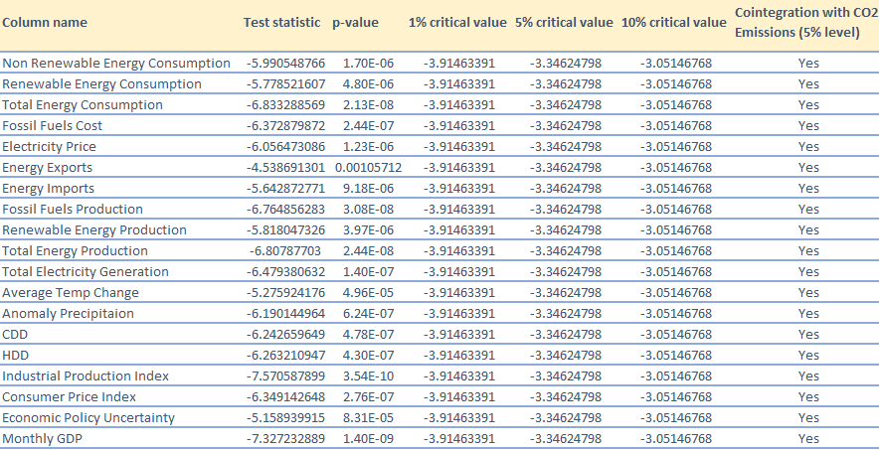

Figure 7.2: Engle-Granger Cointegration Results

In my analysis, the obtained test statistics for the variables show values significantly lower than the critical values at the 1%, 5%, and 10% levels. This outcome provides evidence to reject the null hypothesis at these significance levels and the observed p-value is also very less, indicating cointegration between the analyzed variables and CO2 emissions supporting the notion that they share a stable, long-term relationship.

## Granger Causality Test:

Granger causality is a statistical concept used to determine if one time series data can forecast another(Granger, 1969). It examines whether past values of one variable can predict the future values of another. This test assesses the causal relationship between two variables by evaluating whether the inclusion of past observations of one series improves the prediction of another. The theorem of Granger representation implies the presence of Granger causality in at least one direction when a cointegration relationship exists among the variables. If the past values of a variable help predict another variable, Granger causality suggests a potential causal influence between them. The test involves comparing predictive models with and without the lagged values of one variable to measure the significance of its impact on predicting the other. By examining the influence of past data on predicting future values, it also provides insights into the temporal relationships among different factors, shedding light on how past events might shape present and future occurrences. Let X and Y be two stationary time series with mean equal to zero. The simple causal model is shown below as defined by (Granger, 1969).

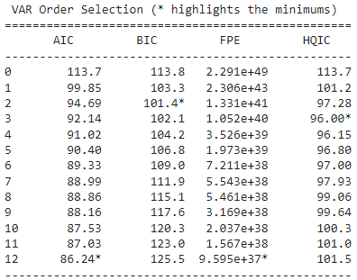

Figure 7.3: VAR Order Selection

In determining the optimal maximum lag for Granger causality analysis, various criteria were employed, including the Akaike Information Criterion (AIC), Bayesian Information Criterion (BIC), Final Prediction Error (FPE), and Hannan-Quinn Information Criterion (HQIC). The goal was to strike a balance between model complexity and performance. After careful evaluation, the Vector Autoregression (VAR) lag order selection method revealed that the AIC and FPE metrics have minimum values at a lag of 12. While the selection is influenced by these criteria, other considerations also support the choice of a maximum lag of 12. Notably, the observed yearly seasonality in all variables within the monthly data recommended for examining causal relationships over a full yearly cycle. It's important to note that Granger causality does not establish absolute real-world causation but instead measures the predictive improvement of one variable using past values of another. Therefore, exploring causal links across 12 different lags was deemed important to identify both short and long-term causation patterns.

### Causality Test Findings:

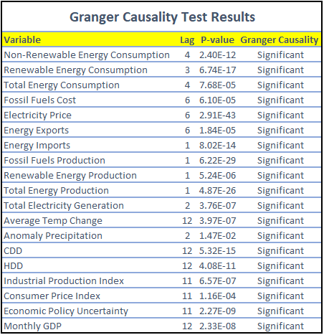

Figure 7.4: Granger Causality Test Results

The analysis of Granger causality unveils significant causal relationships between CO2 emissions and various contributing factors at distinct lag periods. Examining the results, it's apparent that different variables exhibit diverse temporal influences on CO2 emissions.

* For instance, Fossil Fuels Cost, Electricity Price, and Energy Exports showcase a six-month relationship as indicated by their significant Granger causality at lag 6.
* This highlights that alterations in these variables have a notable impact on CO2 emissions within a half year period.
* On the other hand, variables Temperature Change, CDD (Cooling Degree Days), HDD (Heating Degree Days), Industrial Production Index, Consumer Price Index, Economic Policy Uncertainty and Monthly GDP demonstrate a more prolonged relationship, supported by their significant Granger causality at lag 11 or 12.
* This implies that changes in these factors might affect CO2 emissions over a longer period, potentially over a year or more.
* Moreover, energy variables such as Non-Renewable Energy Consumption, Renewable Energy Consumption, Fossil Fuels Production, Energy Imports exhibit shorter-term influences.
* These variables affect CO2 emissions within a shorter time frame, possibly within a few months, as evidenced by their significant Granger causality at lower lag periods.

# Time Series Models

## SARIMAX

The **ARIMA** method, initially proposed by Box and Jenkins, is widely used for time series forecasting (Box et al., 2015). To address the inherent seasonal patterns in CO2 emissions, the seasonal ARIMA model (SARIMA) is employed, denoted as **SARIMA** (p, d, q) x (P, D, Q, S). Here, the integers p, d, q, P, D, Q represent the order of autoregressive (AR), integrated (I), and moving average (MA) components, both in the non-seasonal and seasonal segments of the model, respectively.

Let’s delve into individual components of Autoregression, Integration and Moving Average to gain a better understanding.

**Autoregressive** **(p)**:

The Autoregressive (AR) (Box et al., 2015) model is a significant component in time series analysis that predicts future values based on previous observations within the same series. The fundamental concept behind the AR model involves expressing a variable as a linear combination of its past values.

**Integration (d)**:

The order of integration signifies the number of times the time series needs to be differenced to make it stationary. If the first order differencing makes the data stationary then it’s defined as I(1).

**Moving Average (q)**:

The Moving Average (MA) (Box et al., 2015) model focuses on finding the relationship between the current observation and the residual errors from a moving average process applied to past observations.

These components, AR, I, and MA, can be combined in different ways to form various time series models such as ARIMA, SARIMA, or SARIMAX. These models are powerful tools for forecasting and understanding the underlying patterns in time series data, considering both temporal dependencies and statistical properties to make predictions. SARIMAX, an extension of SARIMA, accommodates additional explanatory variables to enhance forecasting accuracy. For a successful SARIMAX model, the data is assumed to be stationary so differencing of both target and exogenous variables which are non-stationary is crucial to avoid "**spurious regression**" risks.

# Machine Learning Models

Machine learning involves understanding data and the learning process to gain insights and knowledge(Antons and Breidbach, 2018). It includes various models designed with specific mathematical frameworks for different domains. What makes machine learning algorithms complex is their numerous adjustable parameters (Schratz et al., 2019). Even slight changes in these parameters can cause significant variations in results. When selecting the appropriate algorithm, it's crucial to factor in these elements, including tunable parameters, and the distinct challenges presented by CO2-related issues.

**Time Series Split:**

As our data is in time series, the test train data has been split based on date rather than percentage split like (80% test, 20% train). For CO2 emissions spanning 50 years, the temporal aspect is vital in capturing trends. Using data until 2015 for training and predicting until 2023 provides the machine learning model with insights into evolving patterns (trend shift that happened in 2009), aiding its adaptability to the dynamic nature of CO2 emissions. This approach allows the model to comprehend nuances and make informed predictions for subsequent years.

Also, I have utilized GridSearchCV employing cross-validation to fine-tune the model's parameters and discover the optimal hyperparameters. However, since our data is a time series, traditional K-fold cross-validation isn't suitable as it randomly selects data portions, potentially disrupting the temporal sequence. To address this issue, I have implemented the Time Series Split technique, a method that splits the data using an expanding time series window as shown in figure below. This approach ensures that the temporal order is preserved while conducting parameter optimization through GridSearchCV. This adjustment helps in maintaining the chronological relationship between data points, enhancing the reliability of the model evaluation process.

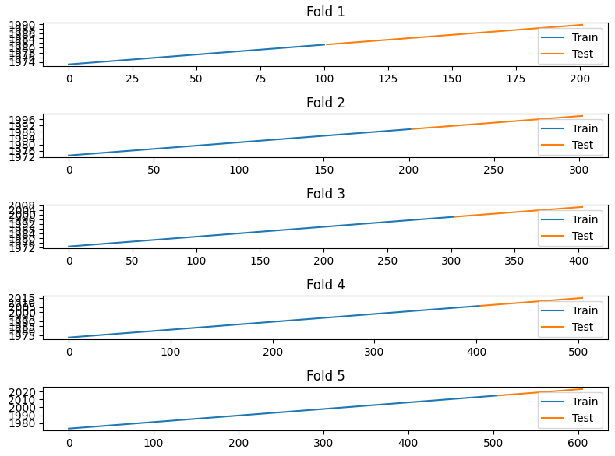

Figure 9.1: Time Series Split in Expanding Window

## Lasso Regression:

Regularization is the most widely used method to penalize complex models in machine learning. It operates under the assumption that lower weights tend to create simpler models, help prevent overfitting.

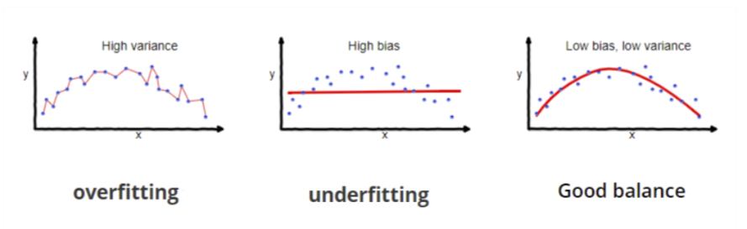

Figure 9.2: Model Fitting Scenarios (Lasso vs Ridge vs Elastic Net | ML, 2020)

Lasso Regression (Verducci, Shen d Lafferty, 2007, p59), an important technique in regression analysis, introduces an L1 penalty to constrain the size of coefficients by adding the absolute value of the magnitude of coefficients. It operates on the principle of regularization, aiming to minimize complex models by shrinking or eliminating the impact of insignificant features. This method helps in achieving a stable model fit while diminishing the influence of irrelevant variables, thereby preventing overfitting. This model is particularly useful in scenarios with a high number of features, as it encourages sparse solutions by reducing certain coefficients to zero and optimizes computational efficiency.

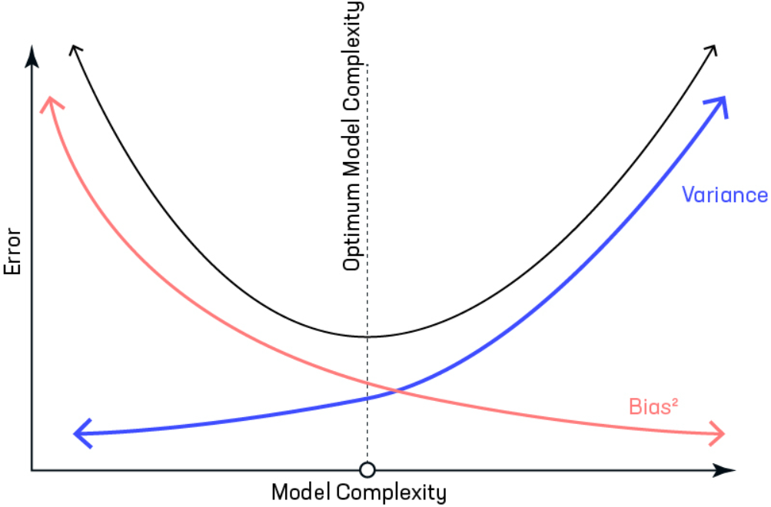

Figure 9.3: Variance/Bias vs Error (Lasso vs Ridge vs Elastic Net | ML, 2020)

I have used **alpha** as a hyperparameter to tune the lasso regression model which manages the intensity of the penalty imposed on the coefficients and facilitating automatic feature selection. The alpha value set to zero is the equivalent of linear regression and a higher value could penalize the optimization function. To identify the most suitable alpha value, cross-validation techniques are employed to tune this parameter. This process involves assessing various alpha values as shown in table below to determine the optimal one that balances model complexity reduction, minimizes multicollinearity, and retains predictive accuracy.

|  |  |
| --- | --- |
| Hyperparameter | Values |
| Alpha | [0.001, 0.01, 0.1, 1.0, 10.0] |

Table 9.1: Lasso Regression Hyperparameters

## Xgboost:

**XGBoost**, a scalable and optimized distribution gradient boosting system is widely used by data scientists to achieve state-of-the-art results on many machine learning challenges (Chen and Guestrin, 2016). The model revolves around constructing numerous CART trees, where each tree predicts independently, and their collective predictions yield the final result. The details of the model are as follows, and the structure is shown in Fig 4.4.2.1. Leveraging decision trees as base learners, multiple weaker learners are built, and the model undergoes continuous training in the direction of gradient descent(Yao, Fu and Zong, 2022). During training, XGBoost dynamically includes and trains new trees to fit residual errors from the previous iteration. Throughout this process, the model assesses node loss to identify the leaf node with the most substantial loss gain, progressively splitting features to incorporate new trees(Guo et al., 2020). Each tree learned (denoted as fk(X,θk)) is dedicated to fitting residuals from the preceding prediction. When K trees are developed through training, prediction samples features correspond to leaf nodes in each tree, where each node relates to a score. Ultimately, the combined scores from all trees contribute to generating the sample's predictive value(Chen and Guestrin, 2016).

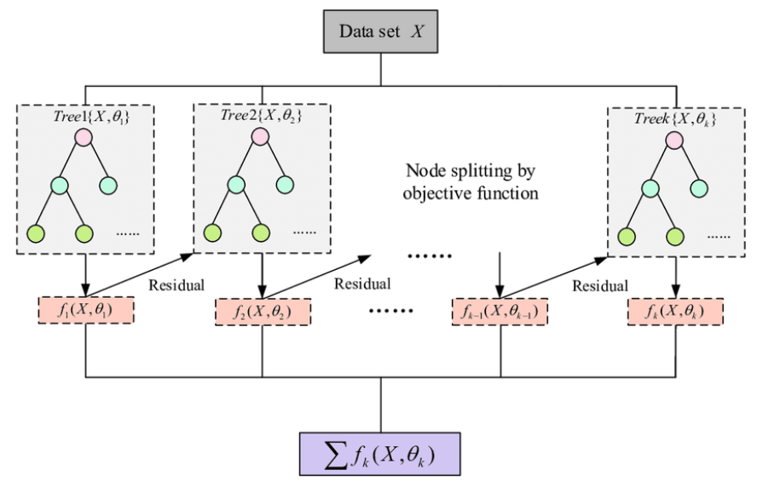

Figure 9.4: Flowchart of XGBoost Model (Guo et al., 2020)

The research paper by (Tarwidi et al., 2023) highlights the suitable parameters for hyper tuning the XGBoost algorithm. The study emphasizes specific parameters such as colsample_bytree, learning_rate, max_depth, subsample, min_child_weight, n_estimators, gamma, alpha, and lambda for model tuning and optimization. However, the parameters considered in this research are listed below.

|  |  |  |  |  |  |
| --- | --- | --- | --- | --- | --- |
| **Hyperparameter** | **Type** | **Range** | **Default** | **Range Applied** | **Description** |
| learning_rate/eta | Float | [0, 1] | 0.3 | [0.01, 0.1, 0.2,0.3] | Step size during each iteration when the objective function is being optimized |
| max_depth | Integer | [0, infinity) | 6 | [6, 7, 9] | The maximum depth of each tree; giving high number for this makes the model more complicated and probably overfit. |
| n_estimators | Integer | [0, infinity) | 100 | [100, 200, 300] | Maximum number of gradient boost trees |
| gamma | Float | [0, infinity) | 0 | [0.0, 0.1, 0.2] | Minimum loss reduction needed to create a fresh split on a leaf node. |
|
| alpha | Float | [0, infinity) | 0 | [0.0, 0.5, 1.0] | L2 regularization term |
| lambda | Float | [0, infinity) | 1 | [0.5, 1.0] | L2 regularization term. Increasing this value will carefully fine tune the model |

Table 9.2: Xgboost Hyperparameters

## Random Forest Regression

Random Forest, an ensemble learning method introduced by Leo Breiman, consists of a collection of un-pruned regression trees derived from randomly selected samples of the training data (Breiman, 2001). This method leverages random feature selection to reduce correlations between trees, thus enhancing predictive power and overall efficiency. This approach incorporates random feature selection during the induction process and aggregates predictions by employing averaging of each regression tree from the ensemble as shown in figure. Each tree is grown following specific steps(Ali et al., 2012) :

* Sampling N randomly, with replacement, from the original data to create the training set for tree growth.
* Selecting m variables randomly from M input variables at each node, where m << M, and using the best split among these m for node division.
* Growing each tree to its fullest extent without applying pruning.

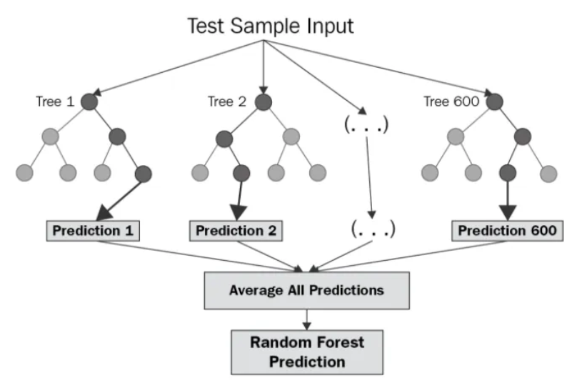

Figure 9.5: Flow Chart of Random Forest Regressor (Research Gate)

The important hyperparameters for random forest have also been clearly described in his research paper (Breiman, 2001).Below is the list of hyperparameters considered for my model with their possible values.

|  |  |  |  |
| --- | --- | --- | --- |
| **HyperParameter** | **Default** | **Range Applied** | **Description** |
| n_estimators | 100 | [100, 200, 300] | It represents the number of trees in the forest |
| max_depth | None | None | There is no specific default value set for max_depth. By default, trees in the Random Forest grow until all leaves are pure. |
| min_samples_split | 2 | [2, 5, 10] | Minimum number of samples required to split an internal node. |
| min_samples_leaf | 1 | [1, 2, 4] | Minimum number of samples required to be at a leaf node. |

Table 9.3: Random Forest Hyperparameters

## Support Vector Machine

Support Vector Machine (SVM) was initially proposed by (Cortes and Vapnik, 1995) is a powerful machine supervised machine learning algorithm and is used for both classification and regression tasks. The support vector has been applied to various regression problems across various domains such as fault diagnosis(Aliramezani, Norouzi and Koch, 2020), and image processing(Guo et al., 2023).Support Vector Machine Regression (SVR) operates by transforming data into a high-dimensional feature space through a nonlinear mapping, where the relationships between independent and dependent variables demonstrate linear regression traits (Guo et al., 2023). This transformed feature space is used for fitting purposes before being reverted to the original space. The model learns an 'f(x)' that aims to be as close as possible to 'y', using 'w' and 'b' as adjustable parameters. The SVR approach introduces a loss function with a tolerance threshold 'ε', calculating loss when the absolute difference between 'f(x)' and 'y' exceeds 'ε'. This is like constructing an interval band centered on 'f(x)' and considering training samples falling within this band as correctly predicted.

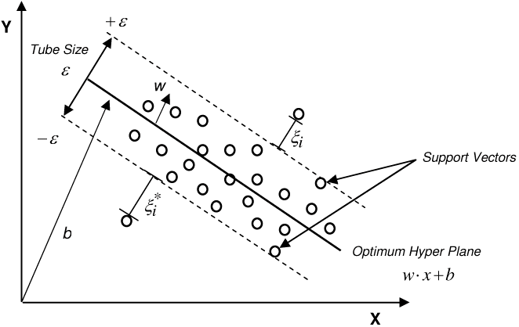

Figure 9.6: Schematic Illustration SVM for Regression

The choice of kernel functions and their parameters, such as the regularization parameter 'C', RBF kernel width 'γ', and threshold value 'ε', significantly affects model accuracy (Ergun et al., 2010). Thus, determining the optimal values for these parameters becomes pivotal and often involves methods like grid search using time series cross-validation approaches. This allows the selection of parameter values offering the highest cross-validation accuracy, ensuring robust and effective SVR modeling.

|  |  |  |  |
| --- | --- | --- | --- |
| **HyperParameter** | **Default** | **Range Applied** | **Description** |
| C | 1 | [0.1, 1.0, 10.0] | Regularization parameter that controls the trade-off between maximizing the margin and minimizing the error |
| Gamma | scale | [0.1, 1.0, 'scale', 'auto'] | Higher gamma values would consider only nearby points, whereas lower values consider points further away, impacting the model's flexibility. |
| Kernel | rbf | ['linear', 'rbf', ‘poly’,‘sigmoid’] | The kernel type to be used in the algorithm |

Table 9.4 : SVM Hyperparameters

## LSTM (DEEP Learning)

LSTM falls under the category of Recurrent Neural Networks (RNN). The main feature of LSTM is its distinctive capability to retain memory over extended durations, owing to their unique memory cell. These cells maintain memory states, facilitated by gates regulating data flow(Lindemann et al., 2021). They effectively modify previous state information based on gate unit significance. In simple words, the model remembers the previous information and uses it for processing the current input. LSTM architecture consists of a single unit known as memory unit or LSTM unit. Each unit consists of four distinct feedforward neural networks each containing an input layer and an output layer. Within these neural networks input neurons are connected to all output neurons which results in four fully connected layers within the LSTM unit. Among these four, three networks are dedicated to information selection named as the forget gate, the input gate, and the output gate. These gates facilitate essential memory operations such as removing information from memory (forget gate), adding new information to memory (input gate), and utilizing stored information (output gate). The fourth neural network is referred to as the candidate memory which generates new information intended for insertion into the memory. LSTM is very effective in understanding and forecasting patterns within sequential data types such as time series, texual information and speech.

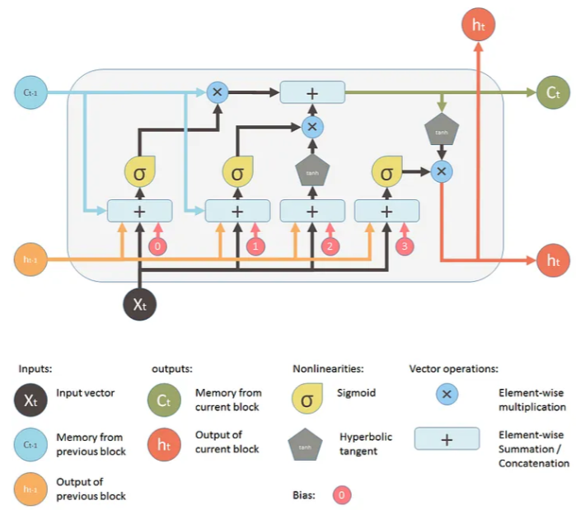

Figure 9.7: LSTM Architecture

**Hyper Parameters in LSTM**:

**Batch Size**: This parameter determines the number of samples used before updating the model's internal parameters. Larger sizes result in more substantial gradient steps compared to smaller ones for the same observed samples. The common default batch size is 32, yet for experimentation, multiples of 32 like 64, 128, and 256 are often tried.

**Epoch**: It refers to the process of traversing through all training samples once, with each iteration or step involving training over a single minibatch. For instance, if there are 1,000,000 training samples and a batch size of 100 is utilized, one epoch would equate to 10,000 steps, encompassing 100 samples per step.

**Loss Function**: This function calculates the discrepancy between the predicted and actual values. Specifically, Mean Square Error (MSE) is employed to compute the loss while utilizing the LSTM model.

**Optimizer**: An essential component significantly enhancing model accuracy and overall performance. Various optimizer variants, such as Stochastic Gradient Descent (SGD), Nesterov accelerated gradient, Adagrad, AdaDelta, RMSProp, and Adam, are available. According to research by (purutheguru, 2016), RMSProp, AdaDelta, and Adam display similarities. However, Adam generally outperforms RMSProp and is commonly considered the optimal choice.

# Evaluation of Results

This section presents an analysis of experiments conducted using a comprehensive dataset that encompasses energy, economic, and climate variables, aiming to predict the target CO2 emissions. The initial assessment through Granger causality emphasized the significance of all these variables, contributing to enhanced CO2 emission forecasting. The selection of ML, time series, and deep learning models for CO2 prediction was guided by theoretical insights from diverse literature sources. Furthermore, this section outlines the best hyperparameters utilized for each model and evaluates their performance using metrics like MAE, RMSE, and R Square.

## Evaluation Metrics:

Assessing the performance metrics holds greater significance than just the model application. To accurately evaluate these metrics, various statistical measures such as MSE, RMSE, R2, and MAE are used. Employing these metrics helps us in effectively monitoring the performance of different prediction models used for forecasting CO2 emissions.

**MAE**: It is a simple metric which computes the average of the absolute difference between the actual and the forecasted values by the model. Basically, it represents the total error sum divided by the overall number of observations.

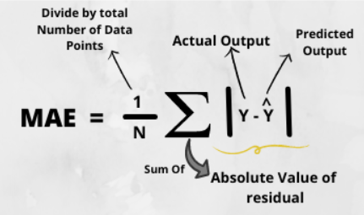

Figure 10.1 : MAE

**MSE**: It is defined as the average of the squared differences between the actual and forecasted values and serves as an important measure in assessing the effectiveness of a forecasting model or predictor. It incorporates both variance (the difference between predicted values) and bias (the distance of forecasted from its original values).

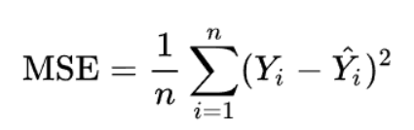

Figure 10.2: MSE

**RMSE**: It is defined as square root of the mean squared error (MSE). Comparing RMSE to MAE helps identify infrequent but significant inaccuracies in forecasts. A larger difference between RMSE and MAE indicates greater variability in error magnitude.

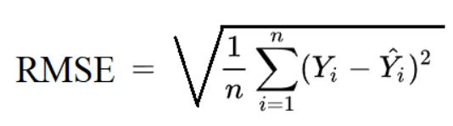

Figure 10.3: RMSE

**R-Square**: This metric helps us to gauge how well the model is a good fit for the actual values. A higher R2 value indicates that the actual and predicted values have a strong association.

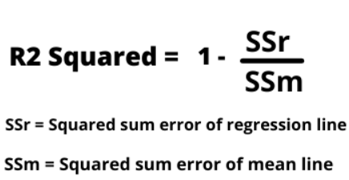

Figure 10.4: R Squared

## Experimentation Outcome:

After performing all the preprocessing steps mentioned in the preprocessing section and causality analysis, I came up with ready to use data to implement the Machine Learning models. The final dataset contained monthly intervals of all the direct and indirect impacting variables such as energy consumption, production, trade, temperature, precipitation, Economic Policy uncertainty, Industrial production, GDP among other 19 independent variables as an input to predict CO2. Also, we have found all these variables have a potential influence on increasing the predictability of CO2 emissions. As it is a time series data, the date column is set as an index.

### Lasso Regression

The algorithm is initially trained with the default parameter values and training data was used to fit the model and evaluated using the test dataset to predict the CO2 emissions. The interpretation of Results is highlighted in the table below and the best hyperparameter obtained is alpha = 0.001 which helped in improving the prediction accuracy as shown in figure below.

|  |  |  |  |  |
| --- | --- | --- | --- | --- |
| Performance Metric | MSE | RMSE | MAE | R2 |
| Before Hypertuning | 0.1170 | 0.3421 | 0.3271 | 0.7892 |
| After Hypertuning | 0.1051 | 0.1250 | 0.0156 | 0.9718 |

Table 10.1: Lasso Regression Results

**Lasso Regression Plots Before and After Hyper tuning**:

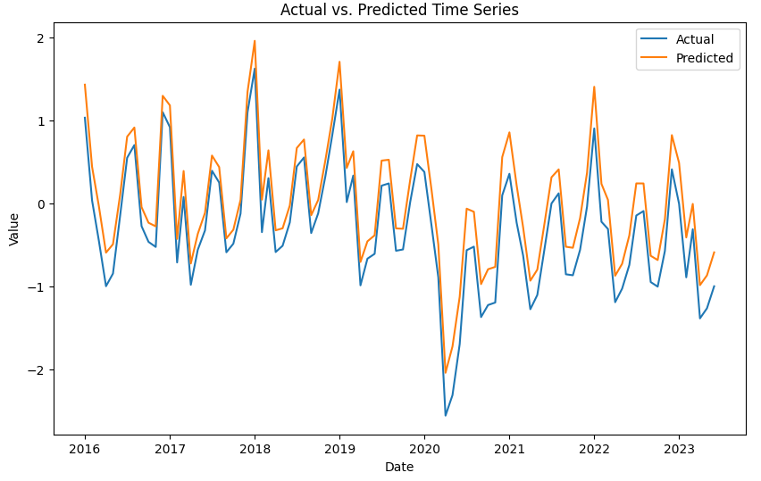

Figure 10.5: Lasso Regression Plot before parameter tuning

Initially, the model struggled to accurately predict the high and low points occurring in different months. However, through fine-tuning its hyperparameters, the model has shown improvement by successfully capturing these peaks and troughs, demonstrating enhanced performance in predicting variations across different periods.

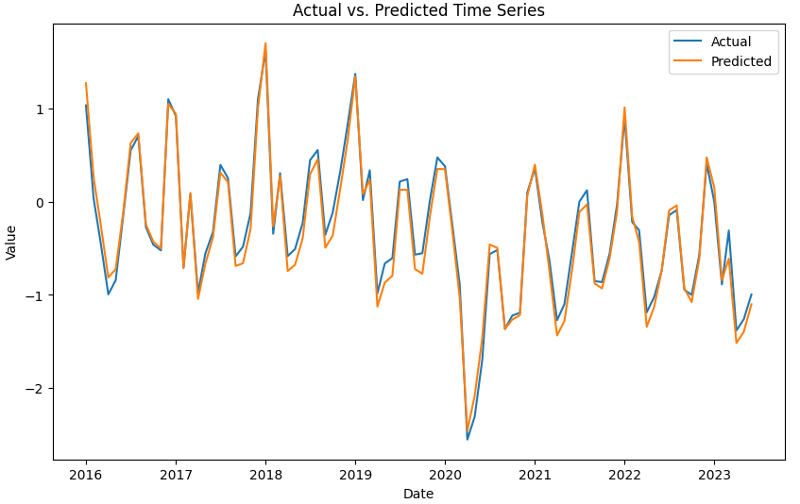

Figure 10.6: Lasso Regression Plot after parameter tuning

**Residual Analysis**:

The scatter plot below shows the residuals which are calculated as the difference between actual and the predicted values. The x-axis defines the predicted values and y-axis has values deviated from the original ones(residuals). The distance from line 0 shows how bad the prediction was for that specific data point.

**Findings**:

* The distribution of residuals exhibits symmetry, mainly concentrating around the midsection of the plot. This is a favorable characteristic for a regression model to highlight it’s not over or under fitting.
* Residuals tend to cluster closer to lower digit values on the y-axis (-0.1 to +0.2)
* Overall, there are no evident discernible patterns observed in the residuals.

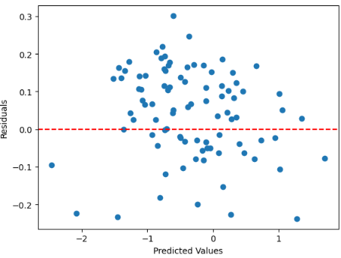 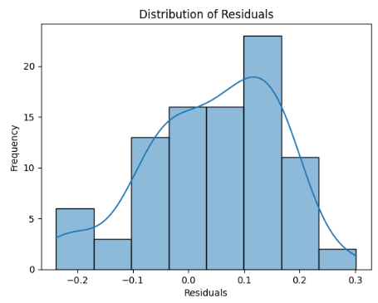

Figure 10.7: Lasso Regression Residual Analysis

Feature importance from Lasso regression shows that non-renewable energy consumption, renewable energy production, electricity generation, energy exports and imports, fossil fuels costs, and electricity price are most influential in predicting CO2 emissions.

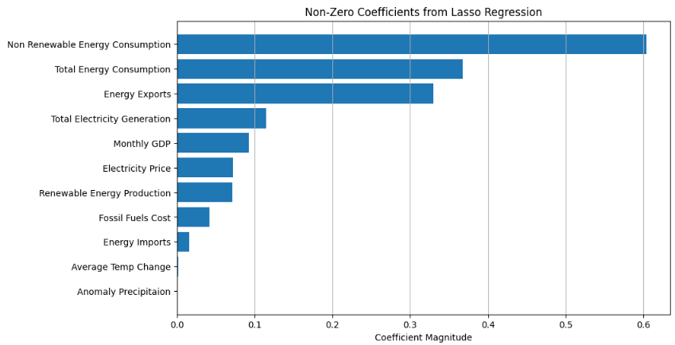

Figure 10.8: Feature Importance for Lasso Regression

### XGboost:

The following table showcases the highlighted outcomes before and after hyperparameter tuning fitted on training data. The best hyperparameters obtained for this model are **{'alpha': 0.0, 'gamma': 0.0, 'lambda': 0.5, 'learning_rate': 0.2, 'max_depth': 6, 'n_estimators': 200}**

|  |  |  |  |  |
| --- | --- | --- | --- | --- |
| Performance Metric | MSE | RMSE | MAE | R2 |
| Before Hypertuning | 0.3357 | 0.5794 | 0.5322 | 0.3956 |
| After Hypertuning | 0.2411 | 0.4910 | 0.4296 | 0.5659 |

Table 10.2: XGboost Results

Initially, when the model was fitted, it struggled to predict accurately, displaying significant errors. Subsequent hyperparameter tuning led to improved accuracy, yet the model still falls short in capturing dynamic trends and sudden dips resulting from unforeseen circumstances such as the impact of events like the COVID-19 pandemic.

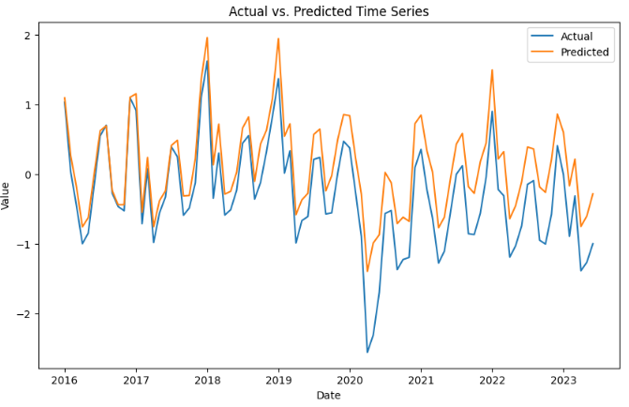

Figure 10.9: XGboost Plot after parameter tuning

**Residual analysis** shows that the model is failing to fully grasp the subtle patterns or sudden changes in the time series, leading to higher residuals and a skewed distribution.

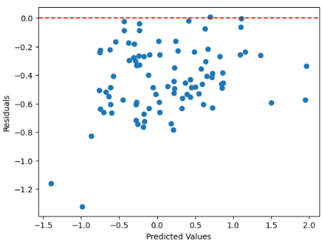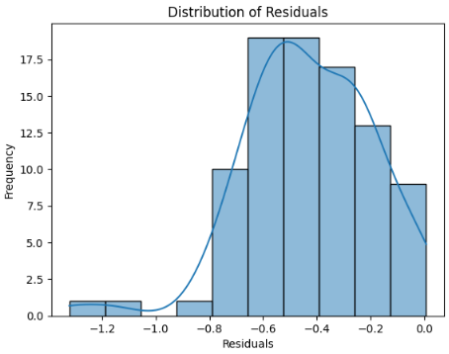

Figure 10.10: XGboost Residual Analysis

### Random Forest

The below table demonstrates the highlighted results before and after hyperparameter tuning on the training dataset. The best hyperparameters obtained for this model are **{'min_samples_leaf': 1, 'min_samples_split': 2, 'n_estimators': 200}**

|  |  |  |  |  |
| --- | --- | --- | --- | --- |
| Performance Metric | MSE | RMSE | MAE | R2 |
| Before Hypertuning | 0.5065 | 0.7117 | 0.6600 | 0.0883 |
| After Hypertuning | 0.3171 | 0.5631 | 0.5077 | 0.4291 |

Table 10.3: Random Forest Results

The considerably high errors observed in this model strongly indicate that it may not be the most suitable choice for accurately forecasting CO2 emissions.

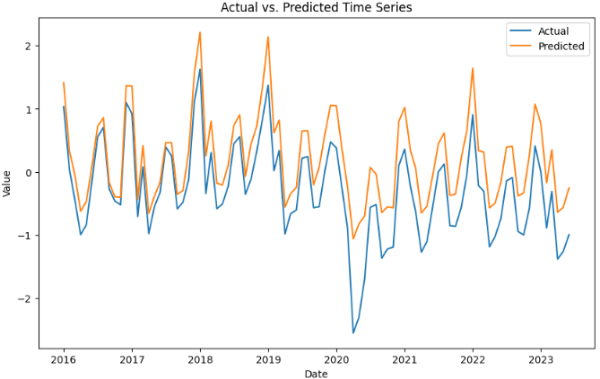

Figure 10.11: Random Forest Plot after parameter tuning

As compared with XGboost, Random Forest also has high valued residuals and a skewed distribution which highlights that it’s not able to capture underlying patterns in the data.

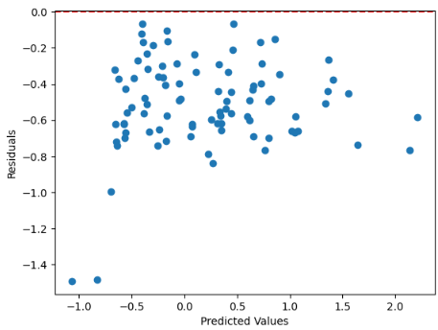 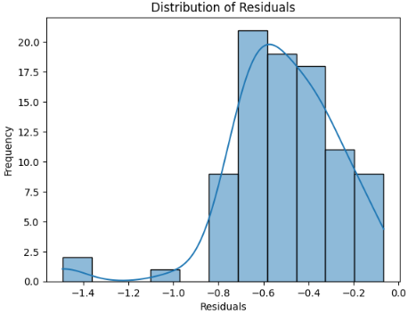

Figure 10.12: Random Forest Residual Analysis

### Support Vector Machine

The following table showcases the highlighted outcomes before and after hyperparameter tuning fitted on training data. The best hyperparameters obtained for this model are **{'C': 0.1, 'gamma': 0.1, 'kernel': 'linear'}**

|  |  |  |  |  |
| --- | --- | --- | --- | --- |
| Performance Metric | MSE | RMSE | MAE | R2 |
| Before Hypertuning | 0.6369 | 0.7980 | 0.5800 | -0.1463 |
| After Hypertuning | 0.0121 | 0.1101 | 0.0926 | 0.9781 |

Table 10.4: SVM Results

**SVM Regression Plots before and after Hyperparameter Tuning**:

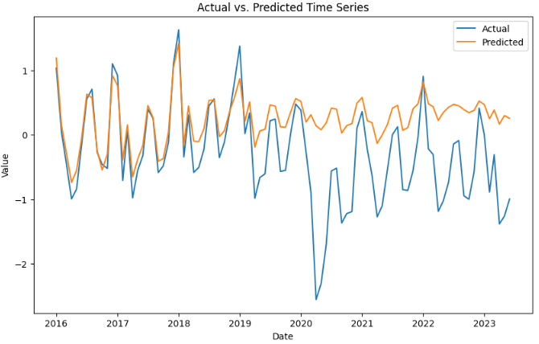

Figure 10.13: SVM Plot before parameter tuning

Initially, the Support Vector Machines (SVM) model using its default settings with the RBF kernel, performed poorly, showing notable errors and an inadequate fit. However, through careful adjustment of these settings specifically by choosing a linear kernel the model's performance significantly improved, achieving the highest level of accuracy. This emphasizes how selecting the right settings can greatly enhance a model's effectiveness, showcasing the substantial impact of tuning these parameters on improving predictions as shown in figure below.

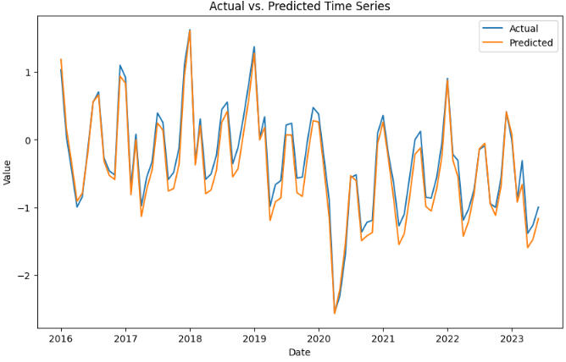

Figure 10.14: SVM Plot after parameter tuning

As explained in the lasso regression, the residuals for SVM are also symmetric with most residuals centered around zero and cluster closer to lower digit values. This describes that the SVM model has the best fit and can be considered as a suitable model to predict CO2 emissions.

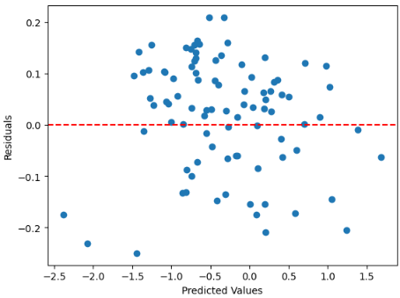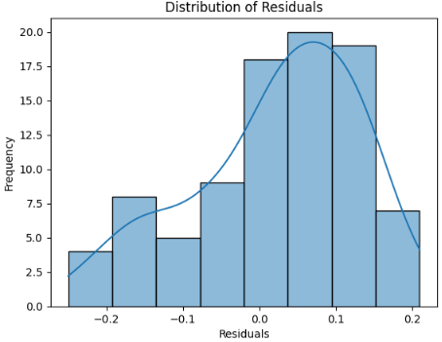

Figure 10.15: SVM Residual Analysis

### SARIMAX

The main hyperparameters of SARIMAX are the seasonal (P, D, Q) and non-seasonal (p, d, q) terms and selection of best hyperparameters was mainly based on AIC, which is known as Akaike Information Criteria (Burnham and Anderson, 2003), but the observations from the autocorrelation (ACF) and partial autocorrelation (PACF) plots were also analyzed to select the best order. The model was run using various combinations of (P, D, Q) and (p, d, q) generated using itertools library in python.

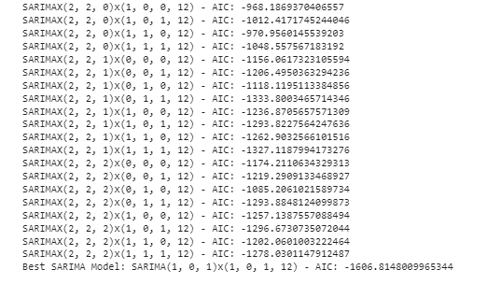

Figure 10.16: Best Order using AIC for SARIMAX

The chosen SARIMAX model provided the best fit for SARIMAX (1, 0, 1) x (1, 0, 1, 12) with least AIC, and these values can be related to the ACF and PACF plots as follows:

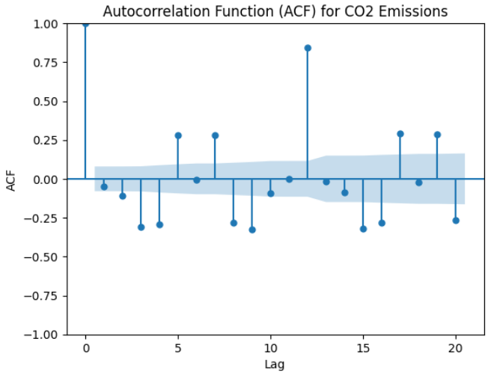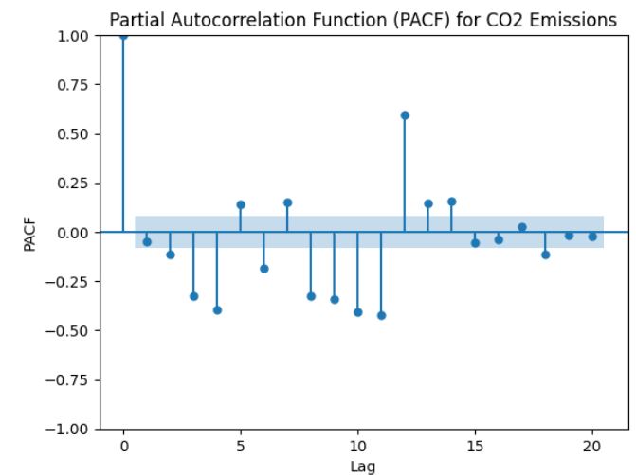

Figure 10.17: ACF and PACF Plot for CO2 Emissions

**Non-Seasonal Part (p, d, q)**:

* **p = 1** (Autoregressive term): There's a significant spike at lag 1 in the PACF plot, suggesting that one autoregressive term could be sufficient to model the non-seasonal part.
* **d = 0** (Differencing): No differencing required as d = 0, indicating that the original series had either been differenced to make it stationary or a stationary series is used (i.e., no differencing). We got this result as zero because the time series has already been transformed into a stationary form by implementing first-order differencing before feeding it into the model.
* **q = 1** (Moving Average term): There's a significant decay in the ACF plot, slowly trailing off after lag 1, indicating the need for one moving average term.

**Seasonal Part (P, D, Q, s)**:

* **P = 1** (Seasonal Autoregressive term): A significant spike at lag 12 in the seasonal PACF plot suggests one seasonal autoregressive term.
* **D = 0** (Seasonal Differencing): When D = 0, it signifies that no seasonal differencing is required. The seasonal component of the time series displays a relatively constant pattern, suggesting that additional differencing isn't required to attain stationarity within the seasonal component.
* **Q = 1** (Seasonal Moving Average term): A significant decay in the seasonal ACF plot, slowly trailing off after lag 12, indicates the need for one seasonal moving average term.
* **s = 12** (Seasonal Periodicity): A seasonal pattern is observed with a periodicity of 12 in the data (likely monthly data), hence s = 12 for the seasonal part of the model.

The following table highlights the results for the SARIMAX model fitted using best hyperparameters as explained in above section.

|  |  |  |  |  |
| --- | --- | --- | --- | --- |
| Performance Metric | MSE | RMSE | MAE | R2 |
| Before Hypertuning | 0.0241 | 0.1555 | 0.1239 | 0.9814 |

Table 10.5: SARIMAX Results

The graphs displayed below demonstrate SARIMAX's ability to capture the complex trends and seasonal patterns present in CO2 emissions accurately. The residuals centered around zero indicate the model’s effectiveness in modeling these dynamics. SARIMAX is widely acknowledged for its strength in handling time-dependent data, making it a dependable choice for such analyses.

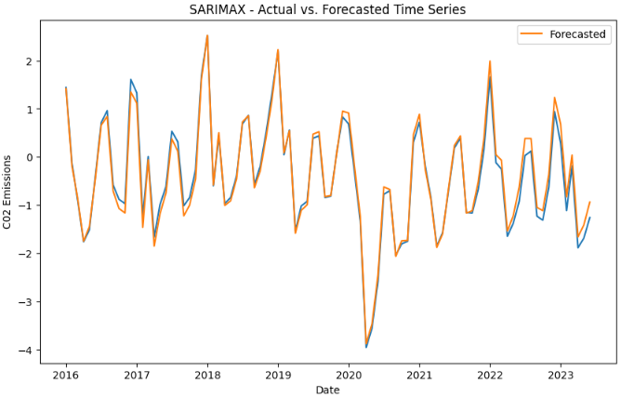

Figure 10.18: SARIMAX Plot after parameter tuning

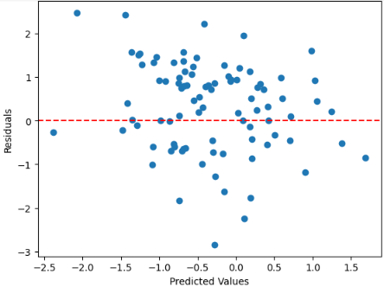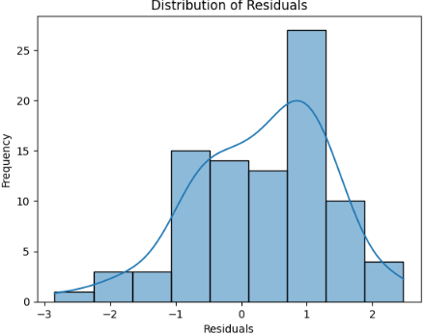

Figure 10.19: SARIMAX Residual Analysis

### LSTM

The following table showcases the highlighted results for LSTM after hyperparameter tuning fitted on training data. The best hyperparameters obtained for this model are **{'units': 150, 'batch_size': 64, 'epochs': 100, optimizer='adam', loss='mean_squared_error'}.** I've utilized Min-Max scaling, which is advantageous for LSTM models, as it normalizes data within a defined range (typically 0 to 1). This aligns well with the operational functions of LSTMs, particularly their activation processes and memory mechanisms. Conversely, for other ML algorithms and time series models, I've applied standard scaling. This choice is based on its suitability for ensemble methods like Random Forest and Gradient Boosting. Standard scaling ensures balanced feature contributions within the ensemble, leading to enhanced overall performance. Due to these distinct scaling methods, I'm assessing the LSTM model separately to determine its effectiveness in capturing the intricate dynamics inherent in CO2 data.

|  |  |  |  |  |
| --- | --- | --- | --- | --- |
| Performance Metric | MSE | RMSE | MAE | R2 |
| Before Hypertuning | 0.0085 | 0.0923 | 0.0740 | 0.6123 |

Table 10.6: LSTM Results

The LSTM model showcases a reasonably good fit but not fully capturing the underlying patterns within the data. However, to enhance the efficacy of deep learning models like LSTMs in predicting complex patterns, a larger volume of data is crucial. Additionally, utilizing data with a finer granularity such as daily or weekly records would notably aid in capturing the internal dynamics more comprehensively. These shorter intervals provide a more detailed view of the data's temporal changes, offering a potential solution to improve the model's ability to grasp and predict complex underlying patterns effectively.

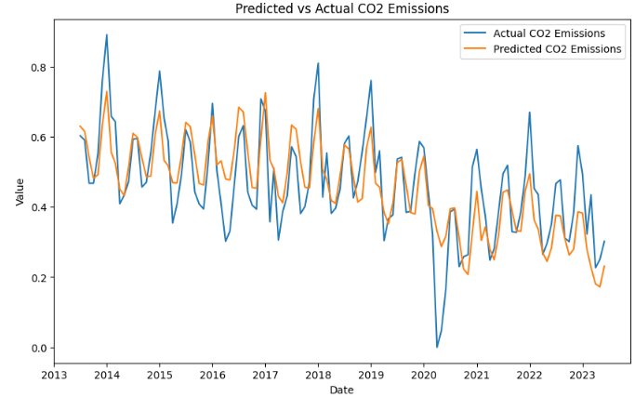

Figure 10.20: LSTM Plot after parameter tuning

### Comparing Various Machine Learning Models:

The evaluation of various models based on multiple performance metrics presents a comprehensive view of their predictive capabilities for CO2 emissions.

|  |  |  |  |  |
| --- | --- | --- | --- | --- |
| **Performance Metric** | **MSE** | **RMSE** | **MAE** | **R2** |
| **SARIMAX** | 0.0241 | 0.1555 | 0.1239 | 0.9814 |
| **SVM** | 0.0121 | 0.1101 | 0.0926 | 0.9781 |
| **LASSO** | 0.1051 | 0.125 | 0.0156 | 0.9718 |
| **XGBOOST** | 0.2411 | 0.491 | 0.4296 | 0.5659 |
| **RANDOM FOREST** | 0.3171 | 0.5631 | 0.5077 | 0.4291 |

Table 10.7: Comparison of Various Model Results

Figure 10.21: Evaluation for Best Model

Among the models, SARIMAX exhibits an impressive performance, showcasing a remarkably higher accuracy with low mean squared error (MSE) of 0.0241, alongside low RMSE and MAE scores, signifying its adeptness in capturing the complexities of CO2 emissions. The symmetric distribution of residuals clustered around zero further supports its accuracy and effectiveness in modeling the complex seasonal and trend dynamics present in the data.

Within Machine learning Models, Support Vector Machines (SVM), specifically configured with a linear kernel after hyperparameter tuning, demonstrated superior accuracy (R2 of 0.9781) and lower MSE, RMSE and MAE, showcasing the substantial impact of parameter adjustments on predictive performance. This emphasizes the importance of choosing appropriate settings to enhance model effectiveness. LASSO also exhibits considerable accuracy in comparison to SVM with an R2 of 0. 9718. Although initially struggled to predict peaks and troughs, fine-tuning its hyperparameters led to improved performance, showcasing its ability to capture variations across different periods. The feature importance analysis derived from Lasso regression reveals that several key variables significantly contribute to predicting CO2 emissions. Among these, non-renewable energy consumption, renewable energy production, electricity generation, energy exports and imports, fossil fuels costs, and electricity price emerge as the most influential factors. The high importance assigned to these variables by the Lasso model underscores their substantial impact on the CO2 emission prediction, providing valuable insights into the key drivers that shape the environmental impact in the context of energy consumption and production dynamics.

Conversely, ensemble methods like XGBoost and Random Forest, while not performing as strongly as other models, still provide valuable insights. In the realm of deep learning, the LSTM model demonstrates a reasonable fit with an R2 of 0.61. However, it falls short in fully capturing underlying patterns, highlighting the need for more extensive and granular data, such as daily or weekly records, to enhance predictive accuracy.

In summary, SARIMAX, SVM, and LASSO emerge as promising models, each showcasing accuracy with low error metrics, making them valuable choices for predicting CO2 emissions. The limitations observed in ensemble methods and the need for more granular data for deep learning models underscore the importance of selecting models tailored to the specific characteristics of the CO2 emission dataset.

# Conclusion and Future Work

## Conclusion

In this study, we have conducted literature review and identified the direct and indirect influencing factors for CO2 emissions and also identified some machine learning algorithms to forecast the CO2 emissions. To understand the complete dynamics of USA,I have employed both state and national level data to get the insights using BI solutions, Causality analysis and Machine Learning approach. For the state level data, I have created an Azure data pipeline which helps us to retrieve and update our data in regular intervals of time for real time analytics. It started with preprocessing the data and comprehensive analysis of CO2 emissions dynamics, revealing that the southern region of the USA, particularly Texas, stands out as a major emitter. The transportation and electric power sectors were identified as the leading contributors, primarily driven by petrol, coal, and natural gas. Additionally, the examination of population density across states revealed its significant role in influencing CO2 emissions, highlighting the correlation between human-related activities, population density, and emissions. The analysis of renewable energy use across different sectors has provided valuable insights. The electric power sector stands out for its exploration of renewable sources like wind, hydro, and solar energy. However, there is still considerable room for improvement to increase reliance on renewables and decrease dependence on fossil fuels. Such a shift holds the potential for a significant impact on reducing CO2 emissions. This underscores the importance of ongoing efforts to promote sustainable and environmentally friendly energy practices. Challenges in reliability were observed in the residential sector's attempts to utilize solar and wood energy, while the commercial sector lagged in adopting renewable sources. These comprehensive findings contribute valuable knowledge for informed policy decisions and sustainable emissions management.

Granger causality tests exposed intricate relationships between CO2 emissions and various contributing factors, showcasing distinct temporal influences. Significant findings include the shorter-term impacts of energy variables and the longer-term effects of economic and climate-related variables. Moving to machine learning models, SARIMAX exhibited exceptional accuracy in capturing the complexities of CO2 emissions, while SVM and LASSO also emerged as promising models with high precision and low error metrics. The Lasso regression's feature importance analysis highlighted key variables influencing CO2 predictions. Despite limitations in ensemble methods and the LSTM model's need for more granular data, this study emphasizes the significance of tailoring model choices to the unique characteristics of the CO2 emission dataset. Overall, SARIMAX, SVM, and LASSO prove to be valuable models for accurate CO2 emission predictions.

## Future Work

In this study, real-time data was collected to establish a data pipeline for state-level Business Intelligence (BI) solutions. This pipeline, initially designed for BI, holds the potential for extension to Machine Learning (ML) applications, offering enhanced predictive performance and a deeper understanding of the underlying dynamics. By implementing ML models on state-level data, a nuanced understanding of regional dynamics can be achieved, paving the way for the development of targeted policies to mitigate CO2 emissions in high-emitting states. This methodology can be replicated for other countries, emphasizing a novel approach that first identifies causal relations before predictive modeling. Additionally, the exploration of ensemble methods, such as causal dependency algorithms, can be explored to assess causality before delving into ML applications. This holistic approach can be further expanded to examine interrelations between various variables, going beyond the impact of variables on CO2 emissions. For instance, understanding how economic growth influences energy consumption and other variables or reciprocally exploring the influence of energy on economic growth can provide valuable insights. These future directions not only broaden the scope of the study but also offer a comprehensive framework for more in-depth analyses and informed decision-making.

# Project Management:

I dedicated substantial effort to conducting an extensive literature review and meticulous data collection, aiming to identify the diverse impacting features essential for comprehensive analysis. Given the multifaceted nature of my project, which involves tasks such as creating a data pipeline, conducting causality analysis, and implementing machine learning models, a well-structured project plan was imperative to ensure timely completion. The Gantt chart effectively delineates the allocated time for each task, facilitating the successful and timely execution of the entire project.

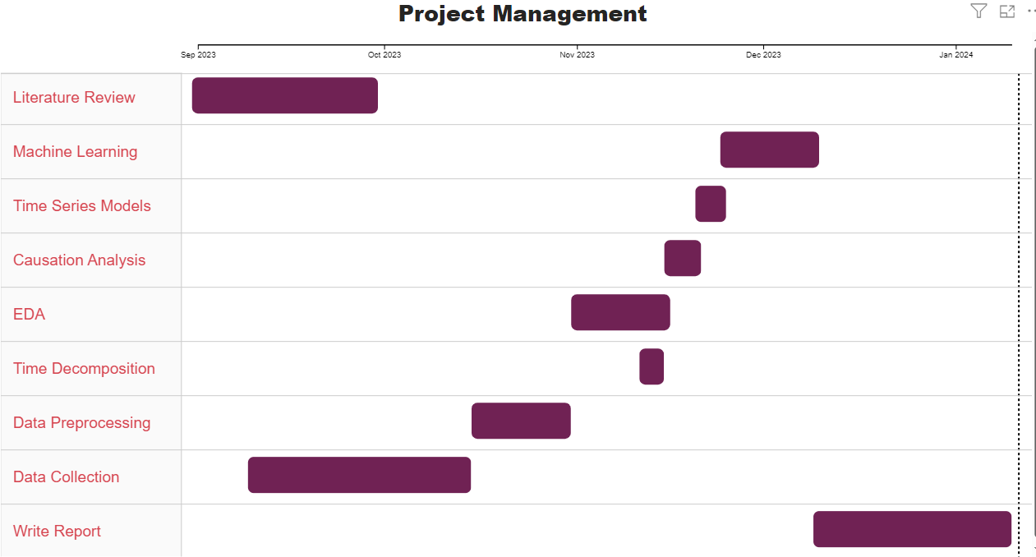

Figure 12.1 Project Management using Gantt Chart

# References:

Abdullah, M.M.A.B. (2014). Filling Missing Data Using Interpolation Methods: Study on the Effect of Fitting Distribution. *Key Engineering Materials*, 594–595, 889–895. Available from https://doi.org/10.4028/www.scientific.net/KEM.594-595.889.

Adebayo, T. (2023). Towards unlocking the chain of sustainable development in the BRICS economies: Analysing the role of economic complexity and financial risk. *Geological Journal*, 58. Available from https://doi.org/10.1002/gj.4694.

Agboola, M.O., Bekun, F.V. and Joshua, U. (2021). Pathway to environmental sustainability: Nexus between economic growth, energy consumption, CO2 emission, oil rent and total natural resources rent in Saudi Arabia. *Resources Policy*, 74, 102380. Available from https://doi.org/10.1016/j.resourpol.2021.102380.

Ağbulut, Ü. (2022). Forecasting of transportation-related energy demand and CO2 emissions in Turkey with different machine learning algorithms. *Sustainable Production and Consumption*, 29, 141–157. Available from https://doi.org/10.1016/j.spc.2021.10.001 [Accessed 29 November 2023].

Ahmad, M. et al. (2018). Does financial development asymmetrically affect CO2 emissions in China? An application of the nonlinear autoregressive distributed lag (NARDL) model. *Carbon Management*, 9 (6), 631–644. Available from https://doi.org/10.1080/17583004.2018.1529998 [Accessed 25 November 2023].

Ahmad, T. et al. (2021). Artificial intelligence in sustainable energy industry: Status Quo, challenges, and opportunities. *Journal of Cleaner Production*, 289, 125834. Available from https://doi.org/10.1016/j.jclepro.2021.125834 [Accessed 29 November 2023].

Ajao, I. (2012). CUBIC SPLINE INTERPOLATION: A ROBUST METHOD OF DISAGGREGATING ANNUAL DATA TO QUARTERLY SERIES 1. *Journal of Physical Sciences and Environmental Safety*, 2, 1–8.

Ali, J. et al. (2012). Random Forests and Decision Trees. *International Journal of Computer Science Issues(IJCSI)*, 9. Available from https://www.researchgate.net/publication/259235118_Random_Forests_and_Decision_Trees.

Aliramezani, M., Norouzi, A. and Koch, C. (2020). Support vector machine for a diesel engine performance and NO x emission control-oriented model. *IFAC Proceedings Volumes (IFAC Papers-OnLine)*, 53, 13976–13981. Available from https://doi.org/10.1016/j.ifacol.2020.12.916.

Alola, A.A. and Adebayo, T.S. (2023). Are green resource productivity and environmental technologies the face of environmental sustainability in the Nordic region? *Sustainable Development*, 31 (2), 760–772. Available from https://doi.org/10.1002/sd.2417.

Alola, A.A., Bekun, F.V. and Sarkodie, S.A. (2019). Dynamic impact of trade policy, economic growth, fertility rate, renewable and non-renewable energy consumption on ecological footprint in Europe. *Science of The Total Environment*, 685, 702–709. Available from https://doi.org/10.1016/j.scitotenv.2019.05.139 [Accessed 25 November 2023].

Amarpuri, L. et al. (2019). Prediction of CO2 emissions using deep learning hybrid approach: A Case Study in Indian Context. *2019 Twelfth International Conference on Contemporary Computing (IC3)*. August 2019. 1–6. Available from https://doi.org/10.1109/IC3.2019.8844902 [Accessed 29 November 2023].

Antons, D. and Breidbach, C.F. (2018). Big Data, Big Insights? Advancing Service Innovation and Design With Machine Learning. *Journal of Service Research*, 21 (1), 17–39. Available from https://doi.org/10.1177/1094670517738373 [Accessed 1 January 2024].

Auffhammer, and Steinhauser. (2012). Auffhammer: Forecasting the path of US CO2 emissions... - Google Scholar. Available from https://scholar-google-com.uow.idm.oclc.org/scholar_lookup?title=Forecasting%20the%20path%20of%20U.S%2C%20CO2%20emissions%20using%20state-level%20information&journal=Rev%20Econ%20Stat&volume=94&issue=1&pages=172-185&publication_year=2012&author=Auffhammer%2CM&author=Steinhauser%2CR [Accessed 29 November 2023].

Awosusi, A.A. et al. (2022). How Do Renewable Energy, Economic Growth and Natural Resources Rent Affect Environmental Sustainability in a Globalized Economy? Evidence From Colombia Based on the Gradual Shift Causality Approach. *Frontiers in Energy Research*, 9. Available from https://www.frontiersin.org/articles/10.3389/fenrg.2021.739721 [Accessed 27 November 2023].

Awosusi, A.A. et al. (2023). Can green resource productivity, renewable energy, and economic globalization drive the pursuit of carbon neutrality in the top energy transition economies? *International Journal of Sustainable Development & World Ecology*, 30 (7), 745–759. Available from https://doi.org/10.1080/13504509.2023.2192007.

Basso, R., Kulcsár, B. and Sanchez-Diaz, I. (2021). Electric vehicle routing problem with machine learning for energy prediction. *Transportation Research Part B: Methodological*, 145, 24–55. Available from https://doi.org/10.1016/j.trb.2020.12.007 [Accessed 29 November 2023].

Bennedsen, M., Hillebrand, E. and Koopman, S.J. (2021). Modeling, forecasting, and nowcasting U.S. CO2 emissions using many macroeconomic predictors. *Energy Economics*, 96, 105118. Available from https://doi.org/10.1016/j.eneco.2021.105118.

Bhowmik, R. et al. (2022). Applying a dynamic ARDL approach to the Environmental Phillips Curve (EPC) hypothesis amid monetary, fiscal, and trade policy uncertainty in the USA. *Environmental Science and Pollution Research*, 29 (10), 14914–14928. Available from https://doi.org/10.1007/s11356-021-16716-y.

Bhowmik, R. et al. (2023). Does sectoral energy consumption depend on trade, monetary, and fiscal policy uncertainty? Policy recommendations using novel bootstrap ARDL approach. *Environmental Science and Pollution Research*, 30 (5), 12916–12928. Available from https://doi.org/10.1007/s11356-022-22869-1.

Bilgili, F. (1998). *Stationarity and cointegration tests: Comparison of Engle - Granger and Johansen methodologies*. University Library of Munich, Germany. Available from https://econpapers.repec.org/paper/pramprapa/75967.htm [Accessed 29 December 2023].

Boontome, P., Therdyothin, A. and Chontanawat, J. (2017). Investigating the causal relationship between non-renewable and renewable energy consumption, CO2 emissions and economic growth in Thailand11This is a preliminary work. Please do not quote or cite without permission of the authors. *Energy Procedia*, 138, 925–930. Available from https://doi.org/10.1016/j.egypro.2017.10.141 [Accessed 17 November 2023].

Box, G.E.P. et al. (2015). *Time Series Analysis: Forecasting and Control*. John Wiley & Sons. Available from https://books.google.co.uk/books?hl=en&lr=&id=rNt5CgAAQBAJ&oi=fnd&pg=PR7&dq=+Time+Series+Analysis,+Forecasting+and+Control&ots=DL12BUmVWD&sig=hrUPZilj-WFgyYqeUWQKA2bWxXA&redir_esc=y#v=onepage&q=Time%20Series%20Analysis%2C%20Forecasting%20and%20Control&f=false.

Breiman, L. (2001). Random Forests. *Machine Learning*, 45 (1), 5–32. Available from https://doi.org/10.1023/A:1010933404324 [Accessed 2 January 2024].

Burnham, K.P. and Anderson, D.R. (2003). *Model Selection and Multimodel Inference: A Practical Information-Theoretic Approach*. Springer Science & Business Media. Available from https://books.google.ca/books?id=fT1Iu-h6E-oC&printsec=frontcover#v=onepage&q&f=false.

Chen, P. et al. (2022). Do Artificial Intelligence Applications Affect Carbon Emission Performance?—Evidence from Panel Data Analysis of Chinese Cities. *Energies*, 15 (15), 5730. Available from https://doi.org/10.3390/en15155730 [Accessed 29 November 2023].

Chen, T. and Guestrin, C. (2016). XGBoost: A Scalable Tree Boosting System. *arXiv.org*. Available from https://doi.org/10.1145/2939672.2939785 [Accessed 2 January 2024].

Cortes, C. and Vapnik, V. (1995). Support-vector networks. *Machine Learning*, 20 (3), 273–297. Available from https://doi.org/10.1007/BF00994018 [Accessed 2 January 2024].

Data Preprocessing in Machine Learning [Steps & Techniques]. (no date). Available from https://www.v7labs.com/blog/data-preprocessing-guide, https://www.v7labs.com/blog/data-preprocessing-guide [Accessed 5 January 2024].

de Bruin, K. and Yakut, A.M. (2023). The Impacts of Removing Fossil Fuel Subsidies and Increasing Carbon Taxation in Ireland. *Environmental and Resource Economics*, 85 (3), 741–782. Available from https://doi.org/10.1007/s10640-023-00782-6 [Accessed 3 January 2024].

Degree-days - U.S. Energy Information Administration (EIA). (no date). Available from https://www.eia.gov/energyexplained/units-and-calculators/degree-days.php [Accessed 28 December 2023].

Dickey-Fuller Test - an overview | ScienceDirect Topics. (no date). Available from https://www-sciencedirect-com.uow.idm.oclc.org/topics/economics-econometrics-and-finance/dickey-fuller-test [Accessed 29 December 2023].

Du, L. et al. (2022). Asymmetric effects of high-tech industry and renewable energy on consumption-based carbon emissions in MINT countries. *Renewable Energy*, 196, 1269–1280. Available from https://doi.org/10.1016/j.renene.2022.07.028.

Duan, H. et al. (2022). Valuing the impact of climate change on China’s economic growth. *Economic Analysis and Policy*, 74, 155–174. Available from https://doi.org/10.1016/j.eap.2022.01.019 [Accessed 29 November 2023].

Emami Javanmard, M. and Ghaderi, S.F. (2022). A Hybrid Model with Applying Machine Learning Algorithms and Optimization Model to Forecast Greenhouse Gas Emissions with Energy Market Data. *Sustainable Cities and Society*, 82, 103886. Available from https://doi.org/10.1016/j.scs.2022.103886 [Accessed 29 November 2023].

Engle, R.F. and Granger, C.W.J. (1987). Co-Integration and Error Correction: Representation, Estimation, and Testing. *Econometrica*, 55 (2), 251–276. Available from https://doi.org/10.2307/1913236 [Accessed 29 December 2023].

Ergun, B. et al. (2010). Data filtering with support vector machines in geometric camera calibration. *Optics express*, 18, 1927–1936. Available from https://doi.org/10.1364/OE.18.001927.

Extracting Seasonality and Trend from Data: Decomposition Using R. (2015). *Anomaly*. Available from https://anomaly.io/seasonal-trend-decomposition-in-r/index.html [Accessed 29 December 2023].

Fahdi, S., Elkhechafi, M. and Hachimi, H. (2021). Machine learning for cleaner production in port of Casablanca. *Journal of Cleaner Production*, 294, 126269. Available from https://doi.org/10.1016/j.jclepro.2021.126269 [Accessed 29 November 2023].

Fig. A10. Random Forest Regressor. The regressor used here is formed of... (no date). *ResearchGate*. Available from https://www.researchgate.net/figure/Fig-A10-Random-Forest-Regressor-The-regressor-used-here-is-formed-of-100-trees-and-the_fig3_313489088 [Accessed 2 January 2024].

Filimonova, I.V. et al. (2021). Relationship of renewable energy consumption to economic, environmental, and institutional factors in Europe. *Energy Reports*, 7, 358–365. Available from https://doi.org/10.1016/j.egyr.2021.07.115.

Gillham, J. (2020). *How AI can enable a Sustainable Future*. Available from https://doi.org/10.13140/RG.2.2.20681.49763.

Gozgor, G., Lau, C.K.M. and Lu, Z. (2018). Energy consumption and economic growth: New evidence from the OECD countries. *Energy*, 153, 27–34. Available from https://doi.org/10.1016/j.energy.2018.03.158 [Accessed 26 November 2023].

Granger, C.W.J. (1969). Investigating Causal Relations by Econometric Models and Cross-spectral Methods. *Econometrica*, 37 (3), 424–438. Available from https://doi.org/10.2307/1912791 [Accessed 29 December 2023].

Greunen, J. et al. (2014). The Prominence of Stationarity in Time Series Forecasting. *Journal for Studies in Economics and Econometrics*, 38, 1–16. Available from https://doi.org/10.1080/10800379.2014.12097260.

Guo, R. et al. (2020). Degradation state recognition of piston pump based on ICEEMDAN and XGBoost. *Applied Sciences*, 10, 6593. Available from https://doi.org/10.3390/app10186593.

Guo, Y. et al. (2023). Comparison and Transferability of Nitrogen Content Prediction Model-Based in winter wheat from UAV Multispectral Image Data. Available from https://doi.org/10.5772/intechopen.1002212.

Halicioglu, F. (2009). An econometric study of CO2 emissions, energy consumption, income, and foreign trade in Turkey. *Energy Policy*, 37 (3), 1156–1164. Available from https://doi.org/10.1016/j.enpol.2008.11.012 [Accessed 29 December 2023].

Hamrani, A., Akbarzadeh, A. and Madramootoo, C.A. (2020). Machine learning for predicting greenhouse gas emissions from agricultural soils. *Science of The Total Environment*, 741, 140338. Available from https://doi.org/10.1016/j.scitotenv.2020.140338 [Accessed 29 November 2023].

He, Y. et al. (2014). The Optimal Price Ratio of Typical Energy Sources in Beijing Based on the Computable General Equilibrium Model. *Energies*, 7, 2961–2984. Available from https://doi.org/10.3390/en7052961.

Huang, Y., Shen, L. and Liu, H. (2019). Grey relational analysis, principal component analysis and forecasting of carbon emissions based on long short-term memory in China. *Journal of Cleaner Production*, 209, 415–423. Available from https://doi.org/10.1016/j.jclepro.2018.10.128.

Jane Goodall. (2021). How to Reduce Carbon Emissions: 6 Ways to Reduce Emissions - 2023. *MasterClass*. Available from https://www.masterclass.com/articles/how-to-reduce-carbon-emissions [Accessed 29 November 2023].

Kumari, S., and Singh, S.K. (2023). Machine learning-based time series models for effective CO2 emission prediction in India. *Environmental Science and Pollution Research*, 30 (55), 116601–116616. Available from https://doi.org/10.1007/s11356-022-21723-8 [Accessed 29 November 2023].

Kwak, S.K. and Kim, J.H. (2017). Statistical data preparation: management of missing values and outliers. *Korean Journal of Anesthesiology*, 70 (4), 407–411. Available from https://doi.org/10.4097/kjae.2017.70.4.407 [Accessed 28 December 2023].

Lasso vs Ridge vs Elastic Net | ML. (2020). *GeeksforGeeks*. Available from https://www.geeksforgeeks.org/lasso-vs-ridge-vs-elastic-net-ml/ [Accessed 1 January 2024].

Lindemann, B. et al. (2021). A survey on long short-term memory networks for time series prediction. *Procedia CIRP*, 99, 650–655. Available from https://doi.org/10.1016/j.procir.2021.03.088.

Liu, S. et al. (2022). Exploring the Dynamic Relationship Between Energy Efficiency, Trade, Economic Growth, and CO2 Emissions: Evidence From Novel Fourier ARDL Approach. *Frontiers in Environmental Science*, 10. Available from https://www.frontiersin.org/articles/10.3389/fenvs.2022.945091 [Accessed 27 November 2023].

Magazzino, C., Mele, M. and Schneider, N. (2021). A machine learning approach on the relationship among solar and wind energy production, coal consumption, GDP, and CO2 emissions. *Renewable Energy*, 167, 99–115. Available from https://doi.org/10.1016/j.renene.2020.11.050.

Mardani, A. et al. (2020). A multi-stage method to predict carbon dioxide emissions using dimensionality reduction, clustering, and machine learning techniques. *Journal of Cleaner Production*, 275, 122942. Available from https://doi.org/10.1016/j.jclepro.2020.122942 [Accessed 29 November 2023].

Mendonça, A.K. de S. et al. (2020). Hierarchical modeling of the 50 largest economies to verify the impact of GDP, population, and renewable energy generation in CO2 emissions. *Sustainable Production and Consumption*, 22, 58–67. Available from https://doi.org/10.1016/j.spc.2020.02.001 [Accessed 25 November 2023].

Mutascu, M. (2022). CO2 emissions in the USA: new insights based on ANN approach. *Environmental Science and Pollution Research*, 29 (45), 68332–68356. Available from https://doi.org/10.1007/s11356-022-20615-1.

NRDC. (2020). NRDC 8th Annual Energy Report: Slow & Steady Won’t Win the Climate Race. Available from https://www.nrdc.org/press-releases/nrdc-8th-annual-energy-report-slow-steady-wont-win-climate-race [Accessed 29 November 2023].

Pao, H.-T. and Tsai, C.-M. (2011). Multivariate Granger causality between CO2 emissions, energy consumption, FDI (foreign direct investment) and GDP (gross domestic product): Evidence from a panel of BRIC (Brazil, Russian Federation, India, and China) countries. *Energy*, 36 (1), 685–693. Available from https://doi.org/10.1016/j.energy.2010.09.041.

Pörtner, H.-O. (2022). WGII Summary for Policymakers Headline Statements. Available from https://www.ipcc.ch/report/ar6/wg2/resources/spm-headline-statements/ [Accessed 29 November 2023].

Puntoon, W., Tarkhamtham, P. and Tansuchat, R. (2022). The impacts of economic growth, industrial production, and energy consumption on CO2 emissions: A case study of leading CO2 emitting countries. *Energy Reports*, 8, 414–419. Available from https://doi.org/10.1016/j.egyr.2022.10.219 [Accessed 3 January 2024].

purutheguru. (2016). LSTM Optimizer Choice ? *Data Science & Deep Learning*. Available from https://deepdatascience.wordpress.com/2016/11/18/which-lstm-optimizer-to-use/ [Accessed 9 January 2024].

Qin, J. and Gong, N. (2022). The estimation of the carbon dioxide emission and driving factors in China based on machine learning methods. *Sustainable Production and Consumption*, 33, 218–229. Available from https://doi.org/10.1016/j.spc.2022.06.027.

Rafindadi, A.A. and Ozturk, I. (2017). Impacts of renewable energy consumption on the German economic growth: Evidence from combined cointegration test. *Renewable and Sustainable Energy Reviews*, 75, 1130–1141. Available from https://doi.org/10.1016/j.rser.2016.11.093 [Accessed 26 November 2023].

Rahman, M.M., Alam, K. and Velayutham, E. (2022). Reduction of CO2 emissions: The role of renewable energy, technological innovation, and export quality. *Energy Reports*, 8, 2793–2805. Available from https://doi.org/10.1016/j.egyr.2022.01.200.

Rigas, N. and Kounetas, K.E. (no date). The impact of CO2 emissions and climate on economic growth and productivity: International evidence. *Review of Development Economics*, n/a (n/a). Available from https://doi.org/10.1111/rode.13075 [Accessed 3 January 2024].

Safaei-Farouji, M. et al. (2022). Application of robust intelligent schemes for accurate modelling interfacial tension of CO2 brine systems: Implications for structural CO2 trapping. *Fuel*, 319, 123821. Available from https://doi.org/10.1016/j.fuel.2022.123821 [Accessed 29 November 2023].

Salisu, A., Akanni, L. and Ogbonna, A. (2018). *Forecasting CO2 emissions: Does the choice of estimator matter?*

Schratz, P. et al. (2019). Hyperparameter tuning and performance assessment of statistical and machine-learning algorithms using spatial data. *Ecological Modelling*, 406, 109–120. Available from https://doi.org/10.1016/j.ecolmodel.2019.06.002 [Accessed 1 January 2024].

Sebri, M. and Ben-Salha, O. (2014). On the causal dynamics between economic growth, renewable energy consumption, CO2 emissions and trade openness: Fresh evidence from BRICS countries. *Renewable and Sustainable Energy Reviews*, 39, 14–23. Available from https://doi.org/10.1016/j.rser.2014.07.033.

Silva, E. (2013). A combination forecast for energy related CO2 emissions in the United States. *International Journal of Energy and Statistics*, 1, 269. Available from https://doi.org/10.1142/S2335680413500191.

Singh, P.K. et al. (2022). Multiple forecasting approach: a prediction of CO2 emission from the paddy crop in India. *Environmental Science and Pollution Research*, 29 (17), 25461–25472. Available from https://doi.org/10.1007/s11356-021-17487-2 [Accessed 29 November 2023].

Sørensen, B.E. (2005). Cointegration. *URL: http://141.217*, 212. Available from https://www.uh.edu/~bsorense/coint2022.pdf [Accessed 29 December 2023].

Syed, Q.R. and Bouri, E. (2022a). Impact of economic policy uncertainty on CO2 emissions in the US: Evidence from bootstrap ARDL approach. *Journal of Public Affairs*, 22 (3), e2595. Available from https://doi.org/10.1002/pa.2595.

Syed, Q.R. and Bouri, E. (2022b). Impact of economic policy uncertainty on CO2 emissions in the US: Evidence from bootstrap ARDL approach. *Journal of Public Affairs*, 22 (3), e2595. Available from https://doi.org/10.1002/pa.2595 [Accessed 26 November 2023].

Syed, Q.R. et al. (2022). Do economic policy uncertainty and geopolitical risk surge CO2 emissions? New insights from panel quantile regression approach. *Environmental Science and Pollution Research*, 29 (19), 27845–27861. Available from https://doi.org/10.1007/s11356-021-17707-9 [Accessed 26 November 2023].

Tagwi, A. (2022). The Impacts of Climate Change, Carbon Dioxide Emissions (CO2) and Renewable Energy Consumption on Agricultural Economic Growth in South Africa: ARDL Approach. *Sustainability*, 14 (24), 16468. Available from https://doi.org/10.3390/su142416468 [Accessed 3 January 2024].

Tarwidi, D. et al. (2023). An optimized XGBoost-based machine learning method for predicting wave run-up on a sloping beach. *MethodsX*, 10, 102119. Available from https://doi.org/10.1016/j.mex.2023.102119.

Ullah, S. et al. (2023). Paving the ways toward sustainable development: the asymmetric effect of economic complexity, renewable electricity, and foreign direct investment on the environmental sustainability in BRICS-T. *Environment, Development and Sustainability*. Available from https://doi.org/10.1007/s10668-023-03085-4 [Accessed 29 November 2023].

Ulussever, T. et al. (2023). Estimation performance comparison of machine learning approaches and time series econometric models: evidence from the effect of sector-based energy consumption on CO2 emissions in the USA. *Environmental Science and Pollution Research*, 30 (18), 52576–52592. Available from https://doi.org/10.1007/s11356-023-26050-0.

US EPA, O. (2016). Global Greenhouse Gas Emissions Data. Available from https://www.epa.gov/ghgemissions/global-greenhouse-gas-emissions-data [Accessed 29 November 2023].

Vafeidis, A.T., Wolff, C. and Santamaria-Aguilar, S. (2021). Chapter 13 - Assessing the social and economic impacts of sea-level rise at a global scale—State of knowledge and challenges. In: Letcher, T.M. (ed.). *The Impacts of Climate Change*. Elsevier, 351–363. Available from https://doi.org/10.1016/B978-0-12-822373-4.00002-1 [Accessed 29 November 2023].

Verducci, J.S., Shen, X. and Lafferty, J. (2007). *Prediction and Discovery: AMS-IMS-SIAM Joint Summer Research Conference, Machine and Statistical Learning : Prediction and Discovery, June 25-29, 2006, Snowbird, Utah*. American Mathematical Soc. Available from https://scholar-google-com.uow.idm.oclc.org/scholar_lookup?title=A%20robust%20hybrid%20of%20lasso%20and%20ridge%20regression&publication_year=2007&author=A.B.%20Owen.

Williamson, P. (2016). Emissions reduction: Scrutinize CO2 removal methods. *Nature*, 530 (7589), 153–155. Available from https://doi.org/10.1038/530153a [Accessed 29 November 2023].

Woetzel, J. (2020). Woetzel: Climate risk and response: Physical hazards... - Google Scholar. Available from https://scholar-google-com.uow.idm.oclc.org/scholar_lookup?title=Climate%20Risk%20and%20Response%3A%20Physical%20Hazards%20and%20Socioeconomic%20Impacts&publication_year=2020&author=J.%20Woetzel&author=D.%20Pinner&author=H.%20Samandari [Accessed 29 November 2023].

Xu, Deyi et al. (2022). Financial development, renewable energy, and CO2 emission in G7 countries: New evidence from non-linear and asymmetric analysis. *Energy Economics*, 109, 105994. Available from https://doi.org/10.1016/j.eneco.2022.105994 [Accessed 29 November 2023].

Xu, Dace et al. (2022). Load Capacity Factor and Financial Globalization in Brazil: The Role of Renewable Energy and Urbanization. *Frontiers in Environmental Science*, 9. Available from https://www.frontiersin.org/articles/10.3389/fenvs.2021.823185 [Accessed 27 November 2023].

Yao, P. et al. (2023). Application of machine learning in carbon capture and storage: An in-depth insight from the perspective of geoscience. *Fuel*, 333, 126296. Available from https://doi.org/10.1016/j.fuel.2022.126296 [Accessed 29 November 2023].

Yao, X., Fu, X. and Zong, C. (2022). Short-Term Load Forecasting Method Based on Feature Preference Strategy and LightGBM-XGboost. *IEEE Access*, 10, 1–1. Available from https://doi.org/10.1109/ACCESS.2022.3192011.

# Appendix:

## Retrieve data from EIA using API

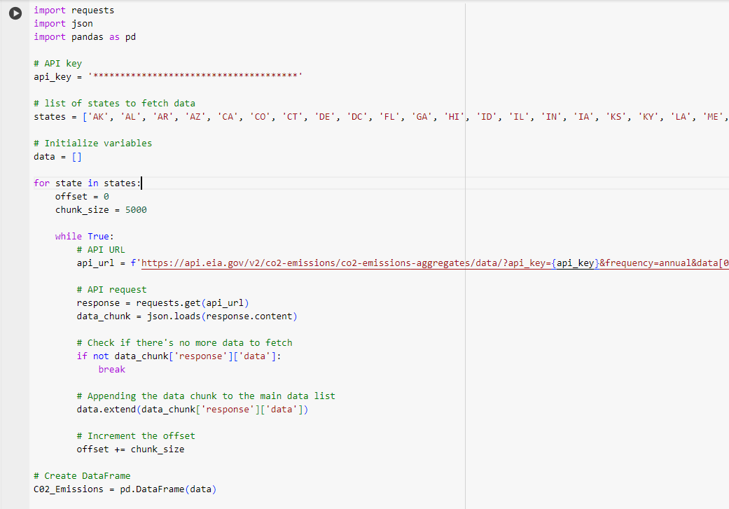

## Best order Selection in SARIMAX:

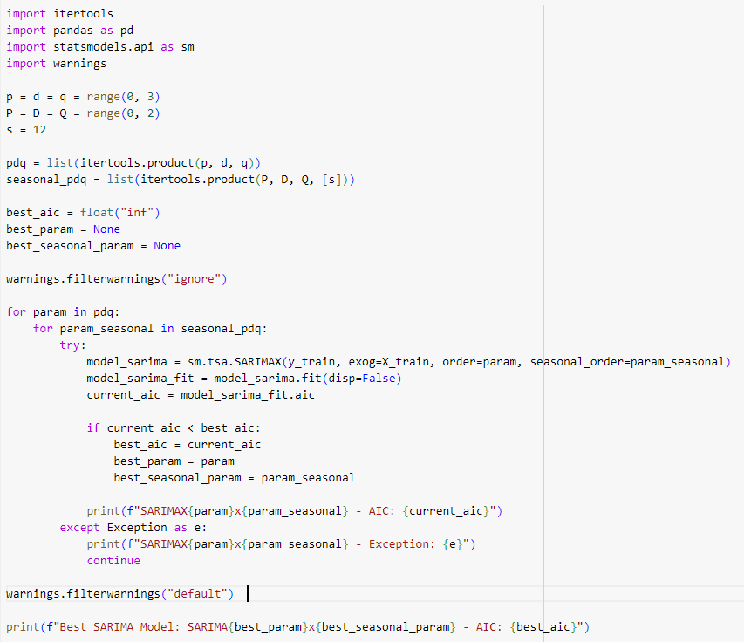

## Tabular format of Studies Related to Influencing Factors for CO2 Emissions:

|  |  |  |
| --- | --- | --- |
| **Variables added for Analysis** | **Employed Methods to find Causation with CO2 emissions** | **Literature** |
| Energy Variables | Granger Causality, Cointegration and hierarchical regression modeling, | (Pao and Tsai, 2011), (Rafindadi and Ozturk, 2017), |
| Foreign Trade  (Energy Imports and Exports) | Granger Causality , ARDL and Cointegration | (Alola, Bekun and Sarkodie, 2019) |
| GDP | Granger Causality, MMQR , ARDL | (Mendonça et al., 2020); (Alola, Bekun and Sarkodie, 2019) |
| Economic Policy Uncertainty | Bootstrap ARDL Approach | (Syed and Bouri, 2022b) |
| Consumer Price Index | Computable general equilibrium (CGE) model | (He et al., 2014) |
| Electricity Price | Computable general equilibrium (CGE) model | (He et al., 2014) |
| Fossil Fuel Cost | Analysis of Impact of Carbon Taxation to increase Fossil fuel Cost to help reduce CO2 emissions | (de Bruin and Yakut, 2023) |
| Industrial Production | Panel Regression | (Puntoon, Tarkhamtham and Tansuchat, 2022) |
| Climate Variables | ARDL, Instrumental variable approach | (Tagwi, 2022),(Rigas and Kounetas, 2023) |

## How does Cointegration work?

The process involves several steps(Bilgili, 1998).First, it examines whether x​ and y are individually stationary using statistical tests. If both variables show non-stationarity individually but their differences are stationary, it suggests a potential for cointegration. Next, regressions between these variables are performed, and the residuals (errors from the estimated model) are calculated. These residuals represent the unexplained movements in the relationship between x​ and y. The Engle-Granger methodology then checks if these residuals have any persisting patterns by analyzing their changes over time. If these changes demonstrate random behavior or don't show any predictable patterns, it suggests the presence of cointegration between the variables. Hence, aiming to identify the long-run relationship between each independent variable and CO2 emissions, employing the Engle-Granger test is instrumental. It helps us to discern whether a stable, long-term association exists between these variables and CO2 emissions despite short-term fluctuations. This understanding is crucial in comprehending how changes in factors such as energy consumption, climate variables, and socio-economic indicators might impact CO2 emissions over extended periods, aiding in informed decision-making and policy formulation for sustainable environmental strategies.

## What is AIC?

The Akaike Information Criterion (AIC) is a widely used statistical measure that aids in model selection by balancing goodness of fit against model complexity. AIC values are usually positive, although they can be shifted by an additive constant, potentially resulting in negative values. As mentioned in the book of Model Selection and Multimodel Inference by (Burnham and Anderson, 2003, sec2.2) the author clarifies calculating AIC from regression statistics may yield negative values and the range of AIC values can vary from large negative values to as large as 3,40,000. It's important to note that the absolute magnitude of the AIC value itself is not crucial as the relative differences observed among the set of models should be compared and the model with least AIC would be considered for the best model parameters.